# Introduction and Overview of Manufacturing

**1**

**1**

##### Chapter Contents

* 1. What Is Manufacturing?
     1. Manufacturing Defined
     2. Manufacturing Industries and Products
     3. Manufacturing Capability
  2. Materials in Manufacturing
     1. Metals
     2. Ceramics
     3. Polymers
     4. Composites
  3. Manufacturing Processes
     1. Processing Operations
     2. Assembly Operations
     3. Production Machines and Tooling
  4. Production Systems
     1. Production Facilities
     2. Manufacturing Support Systems
  5. Manufacturing Economics
     1. Production Cycle Time Analysis
     2. Manufacturing Cost Models
  6. Recent Developments in Manufacturing

Making things has been an essential activity of human civilizations since before recorded history. Today, the term *manufacturing* is used for this activity. For techno- logical and economic reasons, manufacturing is impor- tant to the welfare of the United States and most other developed and developing nations. ***Technology*** can be defined as the application of science to provide society and its members with those things that are needed or desired. Technology affects our daily lives, directly and indirectly, in many ways. Consider the list of products in Table 1.1. They represent various technologies that help our society and its members to live better. What do all these products have in common? They are all manufac- tured. These technological wonders would not be avail- able to our society if they could not be manufactured. Manufacturing is the critical factor that makes technol- ogy possible.

Economically, manufacturing is an important means by which a nation creates material wealth. In the Unit- ed States, the manufacturing industries account for only about 12% of gross domestic product (GDP). A country’s natural resources, such as agricultural lands, mineral deposits, and oil reserves, also create wealth. In the U.S., agriculture, mining, and similar industries account for less than 5% of GDP (agriculture alone is only about 1%). Construction and public utilities make up around 5%. The rest is service industries, which in- clude retail, transportation, banking, communication, education, and government. The service sector ac- counts for more than 75% of U.S. GDP. Government (federal, state, and local) accounts for more of GDP than the manufacturing sector; however, government services do not create wealth. In the modern global economy, a nation must have a strong manufacturing base (or it must have significant natural resources) if it is to provide a strong economy and a high standard of living for its people.

**TABLE** • **1.1** Products representing various technologies, most of which affect nearly all of us.



|  |  |
| --- | --- |
|  | Athletic shoes E-book reader One-piece molded plastic patio chair  Automatic teller machine Fax machine Optical scanner Automatic dishwasher Hand-held electronic calculator Personal computer (PC) Ballpoint pen High density PC diskette Photocopying machine  Camcorder Home security system Pull-tab beverage cans  Cell phone Hybrid gas-electric automobile Quartz crystal wrist watch  Compact disc (CD) Industrial robot Self-propelled mulching lawnmower  Compact disc player Ink-jet color printer Smart phone Compact fluorescent light bulb LCD and Plasma TVs Supersonic aircraft  Contact lenses Magnetic resonance imaging (MRI) Tablet computer  Digital camera machine for medical diagnosis Tennis racket of composite materials Digital video disc (DVD) Medicines Video games  Digital video disc player Microwave oven Washing machine and dryer |

This opening chapter considers some general topics about manufacturing. What is manufacturing? How is it organized in industry? What are the materials, processes, and systems by which it is accomplished?

### What Is Manufacturing?

**.**

The word ***manufacture*** is derived from two Latin words, ***manus*** (hand) and ***factus*** (make); the combination means made by hand. The English word manufacture is several centuries old, and “made by hand” accurately described the manual methods used when the word was first coined.1 Most modern manufacturing is accomplished by automated and computer-controlled machinery (Historical Note 1.1).



The history of manufacturing can be separated into weapons, scrolls, pottery and glassware, and other two subjects: (1) the discovery and invention of mate- products of the time, but the procedures were largely rials and processes to make things, and (2) the devel- based on handicraft.

opment of the systems of production. The materials The systems aspects of manufacturing are examined and processes to make things predate the systems here, and the materials and processes are discussed in by several millennia. Some of the processes—casting, Historical Note 1.2. ***Systems of manufacturing*** refer hammering (forging), and grinding—date back 6000 to the ways of organizing people and equipment so years or more. The early fabrication of implements and that production can be performed more efficiently. weapons was accomplished more as crafts and trades Several historical events and discoveries stand out than manufacturing as it is known today. The ancient as having had a major impact on the development of Romans had what might be called factories to produce modern manufacturing systems.

1As a noun, the word ***manufacture*** first appeared in English around 1567 A.D. As a verb, it first appeared around 1683 A.D.

Certainly one significant discovery was the principle of ***division of labor***—dividing the total work into tasks and having individual workers each become a special- ist at performing only one task. This principle had been practiced for centuries, but the economist Adam Smith (1723–1790) is credited with first explaining its eco- nomic significance in ***The Wealth of Nations***.

The ***Industrial Revolution*** (circa 1760–1830) had a major impact on production in several ways. It marked the change from an economy based on agri- culture and handicraft to one based on industry and manufacturing. The change began in England, where a series of machines were invented and steam power replaced water, wind, and animal power. These ad- vances gave British industry significant advantages over other nations, and England attempted to restrict export of the new technologies. However, the revo- lution eventually spread to other European countries and the United States. Several inventions of the Indus- trial Revolution greatly contributed to the development of manufacturing: (1) ***Watt’s steam engine***—a new power-generating technology for industry; (2) ***machine tools***, starting with John Wilkinson’s boring machine around 1775 (Historical Note 21.1); (3) the ***spinning jenny, power loom***, and other machinery for the tex- tile industry that permitted significant increases in productivity; and (4) the ***factory system***—a new way of organizing large numbers of production workers based on division of labor.

While England was leading the industrial revolu- tion, an important concept was being introduced in the United States: ***interchangeable parts*** manufacture. Much credit for this concept is given to Eli Whitney (1765–1825), although its importance had been rec- ognized by others [10]. In 1797, Whitney negotiated a contract to produce 10,000 muskets for the U.S. government. The traditional way of making guns at the time was to custom-fabricate each part for a par- ticular gun and then hand-fit the parts together by fil- ing. Each musket was unique, and the time to make it was considerable. Whitney believed that the com- ponents could be made accurately enough to permit parts assembly without fitting. After several years of development in his Connecticut factory, he traveled to Washington in 1801 to demonstrate the principle. He laid out components for 10 muskets before gov- ernment officials, including Thomas Jefferson, and proceeded to select parts randomly to assemble the guns. No special filing or fitting was required, and all of the guns worked perfectly. The secret be- hind his achievement was the collection of special machines, fixtures, and gages that he had developed in his factory. Interchangeable parts manufacture

required many years of development before becom- ing a practical reality, but it revolutionized methods of manufacturing. It is a prerequisite for mass produc- tion. Because its origins were in the United States, interchangeable parts production came to be known as the ***American System*** of manufacture.

The mid- and late 1800s witnessed the expan- sion of railroads, steam-powered ships, and other machines that created a growing need for iron and steel. New steel production methods were devel- oped to meet this demand (Historical Note 6.1). Also during this period, several consumer products were developed, including the sewing machine, bicycle, and automobile. To meet the mass demand for these products, more efficient production methods were required. Some historians identify developments dur- ing this period as the ***Second Industrial Revolution***, characterized in terms of its effects on manufacturing systems by (1) mass production, (2) scientific manage- ment movement, (3) assembly lines, and (4) electrifi- cation of factories.

In the late 1800s, the ***scientific management*** movement was developing in the United States in response to the need to plan and control the activi- ties of growing numbers of production workers. The movement’s leaders included Frederick W. Taylor (1856–1915), Frank Gilbreth (1868–1924), and his wife Lillian (1878–1972). Scientific management included several features [3]: (1) ***motion study***, aimed at find- ing the best method to perform a given task; (2) ***time study***, to establish work standards for a job; (3) exten- sive use of ***standards*** in industry; (4) the ***piece rate system*** and similar labor incentive plans; and (5) use of data collection, record keeping, and cost account- ing in factory operations.

Henry Ford (1863–1947) introduced the ***assembly line*** in 1913 at his Highland Park, Michigan plant. The assembly line made possible the mass production of complex consumer products. Use of assembly line methods permitted Ford to sell a Model T automobile for as little as $500, thus making ownership of cars feasible for a large segment of the U.S. population.

In 1881, the first electric power generating station had been built in New York City, and soon electric mo- tors were being used as a power source to operate fac- tory machinery. This was a far more convenient power delivery system than steam engines, which required overhead belts to distribute power to the machines. By 1920, electricity had overtaken steam as the principal power source in U.S. factories. The twentieth century was a time of more technological advances than in all other centuries combined. Many of these develop- ments resulted in the ***automation*** of manufacturing.

Starting material



Scrap and waste

Manufacturing process

Processed

part $ $$$

|  |  |
| --- | --- |
| Manufacturing process | |
|  | Value added $$ |

Starting material

Material in processing

Processed part

(a) (b)

**FIGURE 1.1** Two ways to define manufacturing: (a) as a technical process, and (b) as an economic process.

###### MANUFACTURING DEFINED

As a field of study in the modern context, manufacturing can be defined two ways, one technologic, and the other economic. Technologically, ***manufacturing*** is the ap- plication of physical and chemical processes to alter the geometry, properties, and/ or appearance of a given starting material to make parts or products; manufacturing also includes assembly of multiple parts to make products. The processes to accom- plish manufacturing involve a combination of machinery, tools, power, and labor, as depicted in Figure 1.1(a). Manufacturing is almost always carried out as a sequence of operations. Each operation brings the material closer to the desired final state.

Economically, ***manufacturing*** is the transformation of materials into items of greater value by means of one or more processing and/or assembly operations, as depicted in Figure 1.1(b). The key point is that manufacturing ***adds value*** to the material by changing its shape or properties, or by combining it with other materials that have been similarly altered. The material has been made more valuable through the manufacturing operations performed on it. When iron ore is converted into steel, value is added. When sand is transformed into glass, value is added. When petroleum is refined into plastic, value is added. And when plastic is molded into the complex geometry of a patio chair, it is made even more valuable.

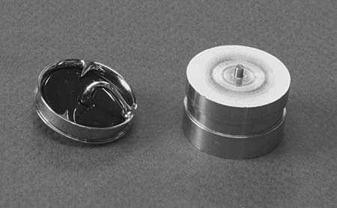Figure 1.2 shows a product on the left and the starting workpiece from which the circular frame of the product was produced on the right. The starting workpiece is

**FIGURE 1.2** A mechanical heart value on the left and the titanium workpiece from which the frame is machined on the right. (Courtesy of George E. Kane Manufacturing Technology Laboratory, Lehigh University.)

a titanium billet, and the product consists of a carbon wafer assembled to the hook that protrudes from the right of the frame. The product is an artificial heart valve costing thousands of dollars, well worth it for patients who need one. (By the way, the surgeon who installs it charges several more thousand dollars.) The titanium billet costs a small fraction of the selling price. It measures about 25 mm (1 in) in diameter. The frame was machined (a material removal process, Section 1.3.1) from the starting billet. Machining time was about one hour. Note the added value provided by this operation. Note also the waste in the unit operation, as depicted in Figure 1.1(a); the finished frame has only about 5% of the mass of the starting workpiece (although the titanium swarf can be recycled).

The words manufacturing and production are often used interchangeably. The author’s view is that production has a broader meaning than manufacturing. To illus- trate, one might speak of “crude oil production,” but the phrase “crude oil manufac- turing” seems out of place. Yet when used in the context of products such as metal parts or automobiles, either word seems okay.

###### MANUFACTURING INDUSTRIES AND PRODUCTS

Manufacturing is an important commercial activity performed by companies that sell products to customers. The type of manufacturing done by a company depends on the kinds of products it makes.

**Manufacturing Industries** Industry consists of enterprises and organizations that produce or supply goods and services. Industries can be classified as primary, second- ary, or tertiary. ***Primary industries*** cultivate and exploit natural resources, such as agriculture and mining.

***Secondary industries*** take the outputs of the primary indus-

tries and convert them into consumer and capital goods. Manufacturing is the prin-

but construction and power utilities are also included. ***Tertiary industries*** constitute the service sector of the economy. A list of specific industries in these categories is presented in Table 1.2.

**TABLE** • **1.2** Specific industries in the primary, secondary, and tertiary categories.

cipal activity in this category,

|  |  |  |  |
| --- | --- | --- | --- |
|  | **Primary** | **Secondary** | **Tertiary (service)** |
| Agriculture Forestry Fishing Livestock Quarries Mining Petroleum | Aerospace Food processing  Apparel Glass, ceramics  Automotive Heavy machinery  Basic metals Paper  Beverages Petroleum refining Building materials Pharmaceuticals Chemicals Plastics (shaping)  Computers Power utilities  Construction Publishing Consumer appliances Textiles Electronics Tire and rubber  Equipment Wood and furniture Fabricated metals | Banking Insurance  Communications Legal  Education Real estate  Entertainment Repair and  Financial services maintenance  Government Restaurant Health and medical Retail trade Hotel Tourism  Information Transportation Wholesale trade |

This book is concerned with the secondary industries in Table 1.2, which include the companies engaged in manufacturing. However, the International Standard Industrial Classification (ISIC) used to compile Table 1.2 includes several industries whose production technologies are not covered in this text; for example, beverages, chemicals, and food processing. In this book, manufacturing means production of ***hardware***, which ranges from nuts and bolts to digital computers and military weap- ons. Plastic and ceramic products are included, but apparel, paper, pharmaceuticals, power utilities, publishing, and wood products are excluded.

**Manufactured Products** Final products made by the manufacturing industries can be divided into two major classes: consumer goods and capital goods. ***Consumer goods*** are products purchased directly by consumers, such as cars, personal comput- ers, TVs, tires, and tennis rackets. ***Capital goods*** are those purchased by companies to produce goods and/or provide services. Examples of capital goods include aircraft, computers, communication equipment, medical apparatus, trucks and buses, railroad locomotives, machine tools, and construction equipment. Most of these capital goods are purchased by the service industries. It was noted in the introduction that manu- facturing accounts for about 12% of gross domestic product and services about 75% of GDP in the United States. Yet the manufactured capital goods purchased by the service sector are the enablers of that sector. Without the capital goods, the service industries could not function.

In addition to final products, other manufactured items include the materials, components, tools, and supplies used by the companies that make the final products. Examples of these items include sheet steel, bar stock, metal stampings, machined parts, plastic moldings and extrusions, cutting tools, dies, molds, and lubricants. Thus, the manufacturing industries consist of a complex infrastructure with vari- ous categories and layers of intermediate suppliers with whom the final consumer never deals.

This book is generally concerned with ***discrete items***—individual parts and assembled products rather than items produced by ***continuous processes***. A metal stamping is a discrete item, but the sheet-metal coil from which it is made is continu- ous (almost). Many discrete parts start out as continuous or semicontinuous prod- ucts, such as extrusions and electrical wire. Long sections made in almost continuous lengths are cut to the desired size. An oil refinery is a better example of a continuous process.

**Production Quantity and Product Variety** The quantity of products made by a factory has an important influence on the way its people, facilities, and procedures are organized. Annual production quantities can be classified into three ranges: (1) ***low*** production, quantities in the range 1 to 100 units per year; (2) ***medium*** produc- tion, from 100 to 10,000 units annually; and (3) ***high*** production, 10,000 to millions of units. The boundaries between the three ranges are somewhat arbitrary (author’s judgment). Depending on the kinds of products, these boundaries may shift by an order of magnitude or so.

Production quantity refers to the number of units produced annually of a particu- lar product type. Some plants produce a variety of different product types, each type being made in low or medium quantities. Other plants specialize in high production of only one product type. It is instructive to identify product variety as a parameter distinct from production quantity. Product variety refers to different product designs or types that are produced in the plant. Different products have different shapes and

**FIGURE 1.3** Relationship between product variety and production quantity in discrete product manufacturing.

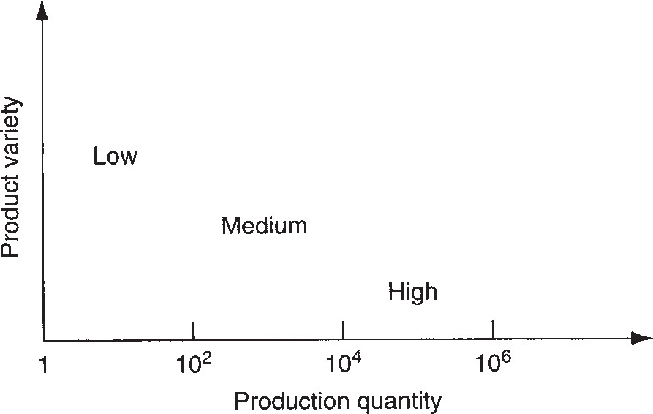

sizes; they perform different functions; they are intended for different markets; some have more components than others; and so forth. The number of different product types made each year can be counted. When the number of product types made in the factory is high, this indicates high product variety.

There is an inverse correlation between product variety and production quantity in terms of factory operations. If a factory’s product variety is high, then its produc- tion quantity is likely to be low; but if production quantity is high, then product vari- ety will be low, as depicted in Figure 1.3. Manufacturing plants tend to specialize in a combination of production quantity and product variety that lies somewhere inside the diagonal band in Figure 1.3.

Although product variety has been identified as a quantitative parameter (the number of different product types made by the plant or company), this parameter is much less exact than production quantity because details on how much the designs differ are not captured simply by the number of different designs. Differences between an automobile and an air conditioner are far greater than between an air conditioner and a heat pump. Within each product type, there are differences among specific models.

The extent of the product differences may be small or great, as illustrated in the automotive industry. Each of the U.S. automotive companies produces cars with two or three different nameplates in the same assembly plant, although the body styles and other design features are virtually the same. In different plants, the company builds heavy trucks. The terms “soft” and “hard” might be used to describe these differences in product variety. ***Soft product variety*** occurs when there are only small differences among products, such as the differences among car models made on the same production line. In an assembled product, soft variety is characterized by a high proportion of common parts among the models. ***Hard product variety*** occurs when the products differ substantially, and there are few common parts, if any. The difference between a car and a truck exemplifies hard variety.

###### MANUFACTURING CAPABILITY

A manufacturing plant consists of a set of ***processes*** and ***systems*** (and people, of course) designed to transform a certain limited range of ***materials*** into products of increased value. These three building blocks—materials, processes, and systems— constitute the subject of modern manufacturing. There is a strong interdependence among these factors. A company engaged in manufacturing cannot do everything.

It must do only certain things, and it must do those things well. ***Manufacturing ca- pability*** refers to the scope of technical and physical capabilities and limitations of a manufacturing company and each of its plants. Manufacturing capability has three dimensions: (1) technological processing capability, (2) physical size and weight of product, and (3) production capacity.

**Technological Processing Capability** The technological processing capabil- ity of a plant (or company) is its available set of manufacturing processes. Certain plants perform machining operations, others roll steel billets into sheet stock, and others build automobiles. A machine shop cannot roll steel, and a rolling mill can- not build cars. The underlying feature that distinguishes these plants is the processes they can perform. Technological processing capability is closely related to material type. Certain manufacturing processes are suited to certain materials, whereas other processes are suited to other materials. By specializing in a certain process or group of processes, the plant is simultaneously specializing in certain material types. Tech- nological processing capability includes not only the physical processes, but also the expertise possessed by plant personnel in these processing technologies. Companies must concentrate on the design and manufacture of products that are compatible with their technological processing capability.

**Physical Product Limitations** A second aspect of manufacturing capability is imposed by the physical product. A plant with a given set of processes is limited in terms of the size and weight of the products that can be accommodated. Large, heavy products are difficult to move. To move these products about, the plant must be equipped with cranes of the required load capacity. Smaller parts and products made in large quantities can be moved by conveyor or other means. The limitation on product size and weight extends to the physical capacity of the manufacturing equipment as well. Production machines come in different sizes. Larger machines must be used to process larger parts. The production and material handling equip- ment must be planned for products that lie within a certain size and weight range.

**Production Capacity** A third limitation on a plant’s manufacturing capability is the production quantity that can be produced in a given time period (e.g., month or year). This quantity limitation is commonly called ***plant capacity***, or ***production capacity***, defined as the maximum rate of production that a plant can achieve under assumed operating conditions. The operating conditions refer to number of shifts per week, hours per shift, direct labor manning levels in the plant, and so on. These factors represent inputs to the manufacturing plant. Given these inputs, how much output can the factory produce?

Plant capacity is usually measured in terms of output units, such as annual tons of steel produced by a steel mill, or number of cars produced by a final assembly plant. In these cases, the outputs are homogeneous. In cases in which the output units are not homogeneous, other factors may be more appropriate measures, such as avail- able labor hours of productive capacity in a machine shop that produces a variety of parts.

Materials, processes, and systems are the basic building blocks of manufacturing and the three broad subject areas of this book. This introductory chapter provides an overview of these three subjects before embarking on a detailed coverage in the remaining chapters.

### Materials in Manufacturing

**1.2**

Most engineering materials can be classified into one of three basic categories:

(1) metals, (2) ceramics, and (3) polymers. Their chemistries are different, their mechanical and physical properties are different, and these differences affect the manufacturing processes that can be used to produce products from them. In addi- tion to the three basic categories, there are (4) ***composites***—nonhomogeneous mix- tures of the other three basic types rather than a unique category. The classification of the four groups is pictured in Figure 1.4. This section provides a survey of these materials. Chapters 6 through 9 cover the four material types in more detail.

###### METALS

Metals used in manufacturing are usually ***alloys***, which are composed of two or more elements, with at least one being a metallic element. Metals and alloys can be divided into two basic groups: (1) ferrous, and (2) nonferrous.

|  |  |  |  |  |  |  |
| --- | --- | --- | --- | --- | --- | --- |
|  | | | | | | Ferrous Metals |
|  | | | | |  |
|  | | | Metals |  |  | |
|  | |  |  |  | Nonferrous Metals |
|  | | | |
|  | | | | |
|  | | | | Crystalline Ceramics |
|  | | |  |
|  | Ceramics |  |  | |
|  |  |  | Glasses |
|  | | | |
| Engineering Materials |  |  | | | | |
|  |  | | | | Thermoplastics |
|  | |  | | |  |
|  | |
|  | Polymers |  |  | Thermosets |
|  |  |  |
|  | | |  | |
|  | Elastomers |
|  | | | |
|  | | | | |
|  | | | | Metal Matrix Composites |
|  | | |  |
|  | |
|  | Composites |  |  | Ceramic Matrix Composites |
|  | | |  |  |
|  | | | | |  | |
|  | Polymer Matrix Composites |
|  | | | | | |

**FIGURE 1.4**

Classification of the four engineering materials.

**Ferrous Metals** Ferrous metals are based on iron; the group includes steel and cast iron. These metals constitute the most important group commercially, more than three- fourths of the metal tonnage throughout the world. Pure iron has limited com- mercial use, but when alloyed with carbon, iron has more uses and greater commer- cial value than any other metal. Alloys of iron and carbon form steel and cast iron.

***Steel*** can be defined as an iron–carbon alloy containing 0.02% to 2.11% carbon. It is the most important category within the ferrous metal group. Its composition often includes other alloying elements as well, such as manganese, chromium, nickel, and molybdenum, to enhance the properties of the metal. Applications of steel include construction (bridges, I-beams, and nails), transportation (trucks, rails, and rolling stock for railroads), and consumer products (automobiles and appliances).

***Cast iron*** is an alloy of iron and carbon (2% to 4%) used in casting (primarily sand casting). Silicon is also present in the alloy (in amounts from 0.5% to 3%), and other elements are often added also, to obtain desirable properties in the cast part. Cast iron is available in several different forms, of which gray cast iron is the most common; its applications include blocks and heads for internal combustion engines.

**Nonferrous Metals** Nonferrous metals include the other metallic elements and their alloys. In almost all cases, the alloys are more important commercially than the pure metals. The nonferrous metals include the pure metals and alloys of aluminum, copper, gold, magnesium, nickel, silver, tin, titanium, zinc, and other metals.

###### CERAMICS

A ceramic is defined as a compound containing metallic (or semimetallic) and nonme- tallic elements. Typical nonmetallic elements are oxygen, nitrogen, and carbon. Ceram- ics include a variety of traditional and modern materials. Traditional ceramics, some of which have been used for thousands of years, include: ***clay*** (abundantly available, con- sisting of fine particles of hydrous aluminum silicates and other minerals used in mak- ing brick, tile, and pottery); ***silica*** (the basis for nearly all glass products); and ***alumina*** and ***silicon carbide*** (two abrasive materials used in grinding). Modern ceramics include some of the preceding materials, such as alumina, whose properties are enhanced in various ways through modern processing methods. Newer ceramics include: ***carbides***— metal carbides such as tungsten carbide and titanium carbide, which are widely used as cutting tool materials; and ***nitrides***—metal and semimetal nitrides such as titanium nitride and boron nitride, used as cutting tools and grinding abrasives.

For processing purposes, ceramics can be divided into crystalline ceramics and glasses. Different methods of manufacturing are required for the two types. Crystalline ceramics are formed in various ways from powders and then fired (heated to a temperature below the melting point to achieve bonding between the powders). The glass ceramics (namely, glass) can be melted and cast, and then formed in proc- esses such as traditional glass blowing.

###### POLYMERS

A polymer is a compound formed of repeating structural units called ***mers***, whose atoms share electrons to form very large molecules. Polymers usually consist of carbon plus one or more other elements such as hydrogen, nitrogen, oxygen, and chlorine. Polymers are divided into three categories: (1) thermoplastic polymers,

(2) thermosetting polymers, and (3) elastomers.

***Thermoplastic polymers*** can be subjected to multiple heating and cooling cycles without substantially altering the molecular structure of the polymer. Common thermoplastics include polyethylene, polystyrene, polyvinylchloride, and nylon. ***Thermosetting polymers*** chemically transform (cure) into a rigid structure upon cooling from a heated plastic condition; hence the name thermosetting. Members of this type include phenolics, amino resins, and epoxies. Although the name “ther- mosetting” is used, some of these polymers cure by mechanisms other than heating. ***Elastomers*** are polymers that exhibit significant elastic behavior; hence the name elastomer. They include natural rubber, neoprene, silicone, and polyurethane.

###### COMPOSITES

Composites do not really constitute a separate category of materials; they are mix- tures of the other three types. A ***composite*** is a material consisting of two or more phases that are processed separately and then bonded together to achieve proper- ties superior to those of its constituents. The term ***phase*** refers to a homogeneous mass of material, such as an aggregation of grains of identical unit cell structure in a solid metal. The usual structure of a composite consists of particles or fibers of one phase mixed in a second phase, called the ***matrix***.

Composites are found in nature (e.g., wood), and they can be produced synthetically. The synthesized type is of greater interest here, and it includes glass fibers in a polymer matrix, such as fiber-reinforced plastic; polymer fibers of one type in a matrix of a sec- ond polymer, such as an epoxy-Kevlar composite; and ceramic in a metal matrix, such as a tungsten carbide in a cobalt binder to form a cemented carbide cutting tool.

Properties of a composite depend on its components, the physical shapes of the components, and the way they are combined to form the final material. Some com- posites combine high strength with light weight and are suited to applications such as aircraft components, car bodies, boat hulls, tennis rackets, and fishing rods. Other composites are strong, hard, and capable of maintaining these properties at elevated temperatures, for example, cemented carbide cutting tools.

### Manufacturing Processes

**1.3**

A ***manufacturing process*** is a designed procedure that results in physical and/or chemical changes to a starting work material with the intention of increasing the value of that material. A manufacturing process is usually carried out as a ***unit oper- ation***, which means that it is a single step in the sequence of steps required to trans- form the starting material into a final product. Manufacturing operations can be divided into two basic types: (1) processing operations and (2) assembly operations. A ***processing operation*** transforms a work material from one state of completion to a more advanced state that is closer to the final desired product. It adds value by changing the geometry, properties, or appearance of the starting material. In general, processing operations are performed on discrete work parts, but certain processing operations are also applicable to assembled items (e.g., painting a spot-welded car body). An ***assembly operation*** joins two or more components to create a new entity, called an assembly, subassembly, or some other term that refers to the joining proc- ess (e.g., a welded assembly is called a ***weldment***). A classification of manufacturing processes is presented in Figure 1.5. Some of the basic processes used in modern manufacturing date from antiquity (Historical Note 1.2).

Heat treatment

Property enhancing processes

**FIGURE 1.5**

Material removal

Solidification processes

Manufacturing processes

Processing operations

Particulate processing

Shaping processes

Assembly operations

Surface processing operations

Deformation processes

Brazing and soldering

Permanent joining processes

Adhesive bonding

Welding

Cleaning and surface treatments

Coating and deposition processes

Permanent fastening methods

Mechanical fastening

Threaded fasteners

Classification of manufacturing processes.

**Historical Note 1.2** *Manufacturing materials and processes*

Although most of the historical developments that form Gold was found by early humans in relatively pure form the modern practice of manufacturing have occurred in nature; it could be ***hammered*** into shape. Copper only during the last few centuries (Historical Note 1.1), was probably the first metal to be extracted from ores, several of the basic fabrication processes date as far thus requiring ***smelting*** as a processing technique. back as the Neolithic period (circa 8000–3000 B.C.E.). It Copper could not be hammered readily because it was during this period that processes such as the fol- strain hardened; instead, it was shaped by ***casting*** lowing were developed: carving and other ***woodwork-*** (Historical Note 10.1). Other metals used during this ***ing***, hand forming and ***firing*** of clay pottery, ***grinding*** period were silver and tin. It was discovered that cop- and ***polishing*** of stone, ***spinning*** and ***weaving*** of tex- per alloyed with tin produced a more workable metal tiles, and ***dyeing*** of cloth. than copper alone (casting and hammering could both Metallurgy and metalworking also began during be used). This heralded the important period known as

the Neolithic period, in Mesopotamia and other areas the ***Bronze Age*** (circa 3500–1500 B.C.).

around the Mediterranean. It either spread to, or de- Iron was also first smelted during the Bronze Age. veloped independently in, regions of Europe and Asia. Meteorites may have been one source of the metal,

but iron ore was also mined. Temperatures required to reduce iron ore to metal are significantly higher than for copper, which made furnace operations more difficult. Other processing methods were also more difficult for the same reason. Early blacksmiths learned that when certain irons (those containing small amounts of car- bon) were sufficiently ***heated*** and then ***quenched***, they became very hard. This permitted grinding a very sharp cutting edge on knives and weapons, but it also made the metal brittle. Toughness could be increased by reheating at a lower temperature, a process known as ***tempering***. What we have described is, of course, the ***heat treatment*** of steel. The superior properties of steel caused it to succeed bronze in many applica- tions (weaponry, agriculture, and mechanical devices). The period of its use has subsequently been named the ***Iron Age*** (starting around 1000 B.C.). It was not un- til much later, well into the nineteenth century, that the demand for steel grew significantly and more modern steelmaking techniques were developed (Historical Note 6.1).

The beginnings of machine tool technology oc- curred during the Industrial Revolution. During the peri- od 1770–1850, machine tools were developed for most of the conventional ***material removal processes***, such as ***boring***, ***turning***, ***drilling***, ***milling***, ***shaping***, and ***planing*** (Historical Note 21.1). Many of the individ- ual processes predate the machine tools by centuries; for example, drilling and sawing (of wood) date from ancient times, and turning (of wood) from around the time of Christ.

Assembly methods were used in ancient cultures to make ships, weapons, tools, farm implements,

machinery, chariots and carts, furniture, and garments. The earliest processes included ***binding*** with twine and rope, ***riveting*** and ***nailing***, and ***soldering***. Around 2000 years ago, ***forge welding*** and ***adhesive bond- ing*** had been developed. Widespread use of screws, bolts, and nuts as fasteners—so common in today’s assembly—required the development of machine tools that could accurately cut the required helical shapes (e.g., Maudsley’s screw cutting lathe, 1800). It was not until around 1900 that ***fusion welding*** proc- esses started to be developed as assembly techniques (Historical Note 28.1).

Natural rubber was the first polymer to be used in manufacturing (if we exclude wood, which is a polymer composite). The ***vulcanization*** process, discovered by Charles Goodyear in 1839, made rubber a useful engi- neering material (Historical Note 8.2). Subsequent de- velopments included plastics such as cellulose nitrate in 1870, Bakelite in 1900, polyvinylchloride in 1927, pol- yethylene in 1932, and nylon in the late 1930s (Histori- cal Note 8.1). Processing requirements for plastics led to the development of ***injection molding*** (based on die casting, one of the metal casting processes) and other polymer shaping techniques.

Electronics products have imposed unusual de- mands on manufacturing in terms of miniaturization. The evolution of the technology has been to package more and more devices into a smaller area—in some cases millions of transistors onto a flat piece of semi- conductor material that is only 12 mm (0.50 in) on a side. The history of electronics processing and pack- aging dates from around 1960 (Historical Notes 33.1, 34.1, and 34.2).

###### PROCESSING OPERATIONS

A processing operation uses energy to alter a work part’s shape, physical properties, or appearance to add value to the material. The forms of energy include mechani- cal, thermal, electrical, and chemical. The energy is applied in a controlled way by means of machinery and tooling. Human energy may also be required, but the hu- man workers are generally employed to control the machines, oversee the opera- tions, and load and unload parts before and after each cycle of operation. A general model of a processing operation is illustrated in Figure 1.1(a). Material is fed into the process, energy is applied by the machinery and tooling to transform the material, and the completed work part exits the process. Most production operations produce waste or scrap, either as a natural aspect of the process (e.g., removing material as in machining) or in the form of occasional defective pieces. It is an important objective in manufacturing to reduce waste in either of these forms.

More than one processing operation is usually required to transform the starting material into final form. The operations are performed in the particular sequence required to achieve the geometry and condition defined by the design specification.

Three categories of processing operations are distinguished: (1) shaping opera- tions, (2) property-enhancing operations, and (3) surface processing operations. ***Shaping operations*** alter the geometry of the starting work material by vari- ous methods. Common shaping processes include casting, forging, and machining. ***Property-enhancing operations*** add value to the material by improving its physical properties without changing its shape. Heat treatment is the most common example. ***Surface processing operations*** are performed to clean, treat, coat, or deposit mate- rial onto the exterior surface of the work. Common examples of coating are plating and painting. Shaping processes are covered in Parts III through VI, corresponding to the four main categories of shaping processes in Figure 1.5. Property-enhancing processes and surface processing operations are covered in Part VII.

**Shaping Processes** Most shape processing operations apply heat, mechanical force or a combination of these to effect a change in geometry of the work material. There are various ways to classify the shaping processes. The classification used in this book is based on the state of the starting material, by which there are four categories:

(1) ***solidification processes***, in which the starting material is a heated ***liquid*** or ***semif- luid*** that cools and solidifies to form the part geometry; (2) ***particulate processing***, in which the starting material is a ***powder***, and the powders are formed and heated into the desired geometry; (3) ***deformation processes***, in which the starting material is a ***ductile solid*** (commonly metal) that is deformed to shape the part; and (4) ***material removal processes***, in which the starting material is a ***solid*** (ductile or brittle), from which material is removed so that the resulting part has the desired geometry.

In the first category, the starting material is heated sufficiently to transform it into a liquid or highly plastic (semifluid) state. Nearly all materials can be processed in this way. Metals, ceramic glasses, and plastics can all be heated to sufficiently high temperatures to convert them into liquids. With the material in a liquid or semifluid form, it can be poured or otherwise forced to flow into a mold cavity and allowed to solidify, thus taking a solid shape that is the same as the cavity. Most processes that operate this way are called casting or molding. ***Casting*** is the name used for metals, and ***molding*** is the common term used for plastics. This category of shaping process is depicted in Figure 1.6. Figure 11.1 shows a cast iron casting, and a collection of plastic molded parts is displayed in Figure 13.20.

In ***particulate processing***, the starting materials are powders of metals or ceramics. Although these two materials are quite different, the processes to shape them in particulate processing are quite similar. The common technique in powder

**FIGURE 1.6** Casting and molding processes start with a work mate- rial heated to a fluid or semifluid state. The process consists of

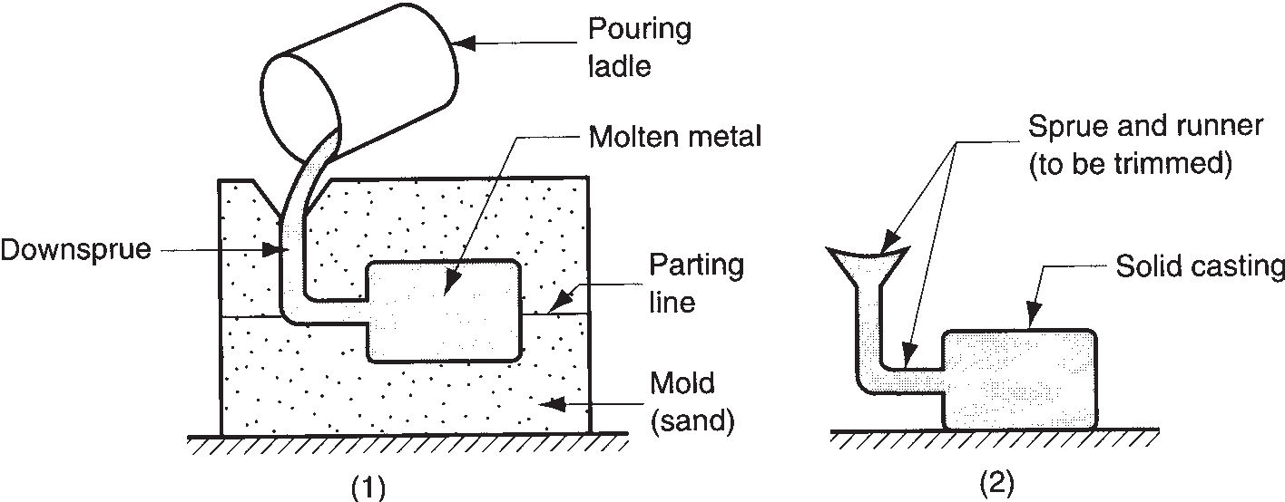

1. pouring the fluid into a mold cavity and
2. allowing the fluid to solidify, after which the solid part is removed from the mold.

**FIGURE 1.7**

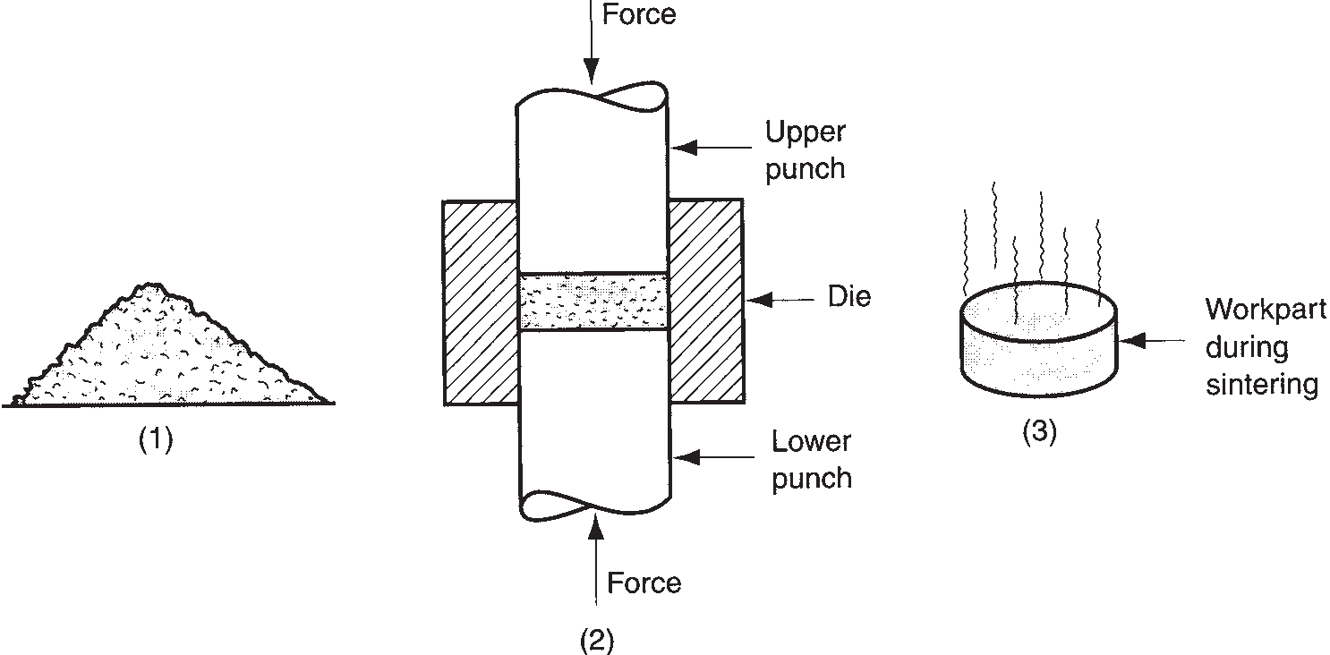

Particulate processing:

* 1. the starting material is powder; the usual process consists of
  2. pressing and
  3. sintering.

metallurgy involves pressing and sintering, illustrated in Figure 1.7, in which the powders are first squeezed into a die cavity under high pressure and then heated to bond the individual particles together. Examples of parts produced by powder metallurgy are shown in Figure 15.1.

In the ***deformation processes***, the starting work part is shaped by the application of forces that exceed the yield strength of the material. For the material to be formed in this way, it must be sufficiently ductile to avoid fracture during deformation. To increase ductility (and for other reasons), the work material is often heated before forming to a temperature below the melting point. Deformation processes are asso- ciated most closely with metalworking and include operations such as ***forging*** and ***extrusion***, shown in Figure 1.8. Figure 18.19 shows a forging operation performed by a drop hammer.

Also included within the deformation processes category is ***sheet metalworking***, which involves bending, forming, and shearing operations performed on starting blanks and strips of sheet metal. Several sheet metal parts, called stampings because they are made on a stamping press, are illustrated in Figure 19.35.

***Material removal processes*** are operations that remove excess material from the starting workpiece so that the resulting shape is the desired geometry. The most important processes in this category are ***machining*** operations such as ***turning***,

**FIGURE 1.8** Some

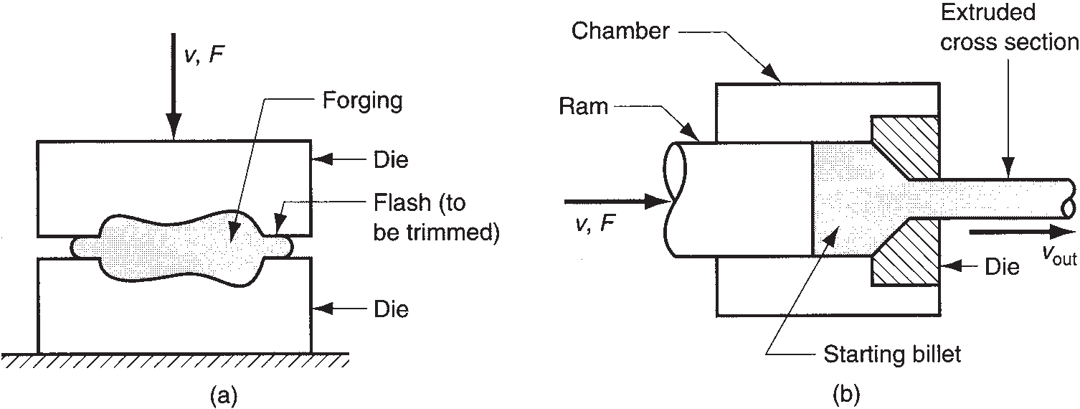

common deformation processes: (a) ***forging***, in which two halves of a die squeeze the work part, causing it to assume the shape of the die cavity; and

(b) ***extrusion***, in which a billet is forced to flow through a die orifice, thus taking the cross- sectional shape of the orifice.

Workpiece

Rotation (work)

Starting diameter Chip

Diameter after turning

Drill bit Work part



Rotation Feed

Work

Milling Rotation

Material removed

Feed tool Single point cutting tool



Hole

Feed



cutter

(a) (b) (c)

**FIGURE 1.9** Common machining operations: (a) ***turning***, in which a single-point cutting tool removes metal from a rotating workpiece to reduce its diameter; (b) ***drilling***, in which a rotating drill bit is fed into the work to create a round hole; and (c) ***milling***, in which a work part is fed past a rotating cutter with multiple edges.

***drilling***, and ***milling***, shown in Figure 1.9. These cutting operations are most com- monly applied to solid metals, performed using cutting tools that are harder and stronger than the work metal.The front cover of this book shows a turning operation. ***Grinding*** is another common material removal process. Other processes in this category are known as ***nontraditional processes*** because they use lasers, electron beams, chemical erosion, electric discharges, and electrochemical energy to remove

material rather than cutting or grinding tools.

It is desirable to minimize waste and scrap in converting a starting work part into its subsequent geometry. Certain shaping processes are more efficient than others in terms of material conservation. Material removal processes (e.g., machining) tend to be wasteful of material, simply by the way they work. The material removed from the starting shape is waste, at least in terms of the unit operation. Other processes, such as certain casting and molding operations, often convert close to 100% of the start- ing material into final product. Manufacturing processes that transform nearly all of the starting material into product and require no subsequent machining to achieve final part geometry are called ***net shape processes***. Other processes require mini- mum machining to produce the final shape and are called ***near net shape processes***.

**Property-Enhancing Processes** The second major type of part processing is performed to improve mechanical or physical properties of the work material. These processes do not alter the shape of the part, except unintentionally in some cases. The most important property-enhancing processes involve ***heat treatments***, which include various annealing and strengthening processes for metals and glasses. ***Sintering*** of powdered metals is also a heat treatment that strengthens a pressed powder metal work part. Its counterpart in ceramics is called ***firing***.

**Surface Processing** Surface processing operations include (1) cleaning, (2) sur- face treatments, and (3) coating and thin film deposition processes. ***Cleaning*** includes both chemical and mechanical processes to remove dirt, oil, and other contaminants from the surface. ***Surface treatments*** include mechanical working such as shot peen- ing and sand blasting, and physical processes such as diffusion and ion implanta- tion. ***Coating*** and ***thin film deposition*** processes apply a coating of material to the exterior surface of the work part. Common coating processes include ***electroplating***,

***anodizing*** of aluminum, organic ***coating*** (call it ***painting***), and porcelain enameling. Thin film deposition processes include ***physical vapor deposition*** and ***chemical vapor deposition*** to form extremely thin coatings of various substances.

Several surface-processing operations have been adapted to fabricate semi- conductor materials into integrated circuits for microelectronics. These processes include chemical vapor deposition, physical vapor deposition, and oxidation. They are applied to very localized areas on the surface of a thin wafer of silicon (or other semiconductor material) to create the microscopic circuit.

###### ASSEMBLY OPERATIONS

The second basic type of manufacturing operation is ***assembly***, in which two or more separate parts are joined to form a new entity. Components of the new entity are connected either permanently or semipermanently. Permanent joining processes include ***welding***, ***brazing***, ***soldering***, and ***adhesive bonding***. They form a joint be- tween components that cannot be easily disconnected. Certain ***mechanical assem- bly*** methods are available to fasten two (or more) parts together in a joint that can be conveniently disassembled. The use of screws, bolts, and other ***threaded fasten- ers*** are important traditional methods in this category. Other mechanical assembly techniques form a more permanent connection; these include ***rivets***, ***press fitting***, and ***expansion fits***. Special joining and fastening methods are used in the assembly of electronic products. Some of the methods are identical to or are adaptations of the preceding processes, for example, soldering. Electronics assembly is concerned primarily with the assembly of components such as integrated circuit packages to printed circuit boards to produce the complex circuits used in so many of today’s products. Joining and assembly processes are discussed in Part VIII, and the special- ized assembly techniques for electronics are described in Chapter 34.

###### PRODUCTION MACHINES AND TOOLING

Manufacturing operations are accomplished using machinery and tooling (and peo- ple). The extensive use of machinery in manufacturing began with the Industrial Revolution. It was at that time that metal cutting machines started to be developed and widely used. These were called ***machine tools***—power-driven machines used to operate cutting tools previously operated by hand. Modern machine tools are described by the same basic definition, except that the power is electrical rather than water or steam, and the level of precision and automation is much greater today. Machine tools are among the most versatile of all production machines. They are used to make not only parts for consumer products, but also components for other production machines. Both in a historic and a reproductive sense, the machine tool is the mother of all machinery.

Other production machines include ***presses*** for stamping operations, ***forge ham- mers*** for forging, ***rolling mills*** for rolling sheet metal, ***welding machines*** for weld- ing, and ***insertion machines*** for inserting electronic components into printed circuit boards. The name of the equipment usually follows from the name of the process. Production equipment can be general purpose or special purpose. ***General purpose equipment*** is more flexible and adaptable to a variety of jobs. It is commercially availa- ble for any manufacturing company to invest in. ***Special purpose equipment*** is usually

designed to produce a specific part or product in very large quantities. The economics

|  |  |  |  |
| --- | --- | --- | --- |
|  | **TABLE** • **1.3**  processes. | Production equipment and tooling used for various manufacturing | |
|  | **Process** | **Equipment** | **Special tooling (function)** |
| Casting Molding Rolling Forging Extrusion Stamping Machining  Grinding Welding | a  Molding machine Rolling mill  Forge hammer or press Press  Press Machine tool  Grinding machine Welding machine | Mold (cavity for molten metal) Mold (cavity for hot polymer) Roll (reduce work thickness) Die (squeeze work to shape)  Extrusion die (reduce cross-section) Die (shearing, forming sheet metal) Cutting tool (material removal) Fixture (hold work part)  Jig (hold part and guide tool) Grinding wheel (material removal) Electrode (fusion of work metal) Fixture (hold parts during welding) |

aVarious types of casting setups and equipment (Chapter 11).

of mass production justify large investments in special purpose machinery to achieve high efficiencies and short cycle times. This is not the only reason for special purpose equipment, but it is the dominant one. Another reason may be because the process is unique and commercial equipment is not available. Some companies with unique processing requirements develop their own special purpose equipment.

Production machinery usually requires ***tooling*** that customizes the equipment for the particular part or product. In many cases, the tooling must be designed specifically for the part or product configuration. When used with general purpose equipment, it is designed to be exchanged. For each work part type, the tooling is fastened to the machine and the production run is made. When the run is completed, the tooling is changed for the next work part type. When used with special purpose machines, the tooling is often designed as an integral part of the machine. Because the special purpose machine is likely being used for mass production, the tooling may never need changing except for replacement of worn components or for repair of worn surfaces.

The type of tooling depends on the type of manufacturing process. In Table 1.3, we list examples of special tooling used in various operations. Details are provided in the chapters that discuss these processes.

### Production Systems

**.4**

To operate effectively, a manufacturing firm must have systems that allow it to ef- ficiently accomplish its type of production. Production systems consist of people, equipment, and procedures designed for the combination of materials and processes that constitute a firm’s manufacturing operations. Production systems can be divided into two categories: (1) production facilities and (2) manufacturing support systems, as shown in Figure 1.10.2 ***Production facilities*** refer to the physical equipment and the arrangement of equipment in the factory. ***Manufacturing support systems*** are

2 This diagram also indicates the major topic areas covered in this book.

Production system

Manufacturing support

Manufacturing support systems

Quality control

systems

Manufacturing systems

Facilities

**FIGURE 1.10** Model of the production system and overview of major topics in the book.

Manufacturing processes and assembly operations

Finished products

Engineering materials

the procedures used by the company to manage production and solve the techni- cal and logistics problems encountered in ordering materials, moving work through the factory, and ensuring that products meet quality standards. Both categories in- clude people. People make these systems work. In general, direct labor workers are responsible for operating the manufacturing equipment; and professional staff workers are responsible for manufacturing support.

###### PRODUCTION FACILITIES

Production facilities consist of the factory and the production, material handling, and other equipment in the factory. The equipment comes in direct physical contact with the parts and/or assemblies as they are being made. The facilities “touch” the product. Facilities also include the way the equipment is arranged in the factory— the ***plant layout***. The equipment is usually organized into logical groupings. In this book they are called ***manufacturing systems***, such as an automated production line, or a machine cell consisting of an industrial robot and two machine tools.

A manufacturing company attempts to design its manufacturing systems and organize its factories to serve the particular mission of each plant in the most effi- cient way. Over the years, certain types of production facilities have come to be recognized as the most appropriate way to organize for a given combination of prod- uct variety and production quantity, as discussed in Section 1.1.2. Different types of facilities are required for each of the three ranges of annual production quantities.

**Low-Quantity Production** In the low-quantity range (1–100 units/year), the term ***job shop*** is often used to describe the type of production facility. A job shop makes low quantities of specialized and customized products. The products are typically complex, such as space capsules, prototype aircraft, and special machinery. The equipment in a job shop is general purpose, and the labor force is highly skilled.

A job shop must be designed for maximum flexibility to deal with the wide prod- uct variations encountered (hard product variety). If the product is large and heavy, and therefore difficult to move, it typically remains in a single location during its fab- rication or assembly. Workers and processing equipment are brought to the product, rather than moving the product to the equipment. This type of layout is referred to as a ***fixed-position layout***, shown in Figure 1.11(a). In a pure situation, the product



Product

Equipment

(mobile)

Workers



Departments

Work unit Production

machines

(a) (b)

Worker Workstation Equipment Conveyor



*v*



Cell Cell

(c) Workers

(d)

**FIGURE 1.11** Various types of plant layout: (a) fixed-position layout, (b) process layout, (c) cellular layout, and

(d) product layout.

remains in a single location during its entire production. Examples of such products include ships, aircraft, locomotives, and heavy machinery. In actual practice, these items are usually built in large modules at single locations, and then the completed modules are brought together for final assembly using large-capacity cranes.

The individual components of these large products are often made in factories in which the equipment is arranged according to function or type. This arrangement is called a ***process layout***. The lathes are in one department, the milling machines are in another department, and so on, as in Figure 1.11(b). Different parts, each requiring a different operation sequence, are routed through the departments in the particular order needed for their processing, usually in batches. The process layout is noted for its flexibility; it can accommodate a great variety of operation sequences for different part configurations. Its disadvantage is that the machinery and methods to produce a part are not designed for high efficiency.

**Medium Quantity Production** In the medium-quantity range (100–10,000 units annually), two different types of facility are distinguished, depending on product variety. When product variety is hard, the usual approach is ***batch production***, in which a batch of one product is made, after which the manufacturing equipment is changed over to produce a batch of the next product, and so on. The production rate of the equipment is greater than the demand rate for any single product type, and so the same equipment can be shared among multiple products. The changeover between production runs takes time—time to change tooling and set up the machin- ery. This setup time is lost production time, and this is a disadvantage of batch manu- facturing. Batch production is commonly used for make-to-stock situations, in which

items are manufactured to replenish inventory that has been gradually depleted by demand. The equipment is usually arranged in a process layout, as in Figure 1.11(b). An alternative approach to medium-range production is possible if product vari- ety is soft. In this case, extensive changeovers between one product style and the next may not be necessary. It is often possible to configure the manufacturing sys- tem so that groups of similar products can be made on the same equipment without significant lost time because of setup. The processing or assembly of different parts or products is accomplished in cells consisting of several workstations or machines. The term ***cellular manufacturing*** is often associated with this type of production. Each cell is designed to produce a limited variety of part configurations; that is, the cell specializes in the production of a given set of similar parts, according to the principles of ***group technology*** (Section 39.5). The layout is called a ***cellular layout***,

depicted in Figure 1.11(c).

**High Production** The high-quantity range (10,000 to millions of units per year) is referred to as ***mass production***. The situation is characterized by a high demand rate for the product, and the manufacturing system is dedicated to the production of that single item. Two categories of mass production can be distinguished: quantity produc- tion and flow line production. ***Quantity production*** involves the mass production of single parts on single pieces of equipment. It typically involves standard machines (e.g., stamping presses) equipped with special tooling (e.g., dies and material handling devices), in effect dedicating the equipment to the production of one part type. Typi- cal layouts used in quantity production are the process layout and cellular layout.

***Flow line production*** involves multiple pieces of equipment or workstations arranged in sequence, and the work units are physically moved through the sequence to complete the product. The workstations and equipment are designed specifically for the product to maximize efficiency. The layout is called a ***product layout***, and the workstations are arranged into one long line, as in Figure 1.11(d), or into a series of connected line segments. The work is usually moved between stations by mecha- nized conveyor. At each station, a small amount of the total work is completed on each unit of product.

The most familiar example of flow line production is the assembly line, associ- ated with products such as cars and household appliances. The pure case of flow line production occurs when there is no variation in the products made on the line. Every product is identical, and the line is referred to as a ***single model production line***. To successfully market a given product, it is often beneficial to introduce feature and model variations so that individual customers can choose the exact merchandise that appeals to them. From a production viewpoint, the feature differences represent a case of soft product variety. The term ***mixed-model production line*** applies to these situations in which there is soft variety in the products made on the line. Modern automobile assembly is an example. Cars coming off the assembly line have varia- tions in options and trim representing different models and in many cases different nameplates of the same basic car design.

###### MANUFACTURING SUPPORT SYSTEMS

To operate its facilities efficiently, a company must organize itself to design the proc- esses and equipment, plan and control the production orders, and satisfy product quality requirements. These functions are accomplished by manufacturing sup- port systems—people and procedures by which a company manages its production

operations. Most of these support systems do not directly contact the product, but they plan and control its progress through the factory. Manufacturing support func- tions are often carried out in the firm by people organized into departments such as the following:

* + - * ***Manufacturing engineering.*** The manufacturing engineering department is re- sponsible for planning the manufacturing processes—deciding what processes should be used to make the parts and assemble the products. This department is

also involved in designing and ordering the machine tools and other equipment used by the operating departments to accomplish processing and assembly.

* + - * ***Production planning and control.*** This department is responsible for solv- ing the logistics problem in manufacturing—ordering materials and purchased

parts, scheduling production, and making sure that the operating departments have the necessary capacity to meet the production schedules.

* + - * ***Quality control.*** Producing high-quality products should be a top priority of any manufacturing firm in today’s competitive environment. It means designing and

building products that conform to specifications and satisfy or exceed customer expectations. Much of this effort is the responsibility of the QC department.

### Manufacturing Economics

**.5**

In Section 1.1.1, manufacturing was defined as a transformation process that adds value to a starting work material. In Section 1.1.2, we noted that manufacturing is a commercial activity performed by companies that sell products to customers. It is appropriate to consider some of the economic aspects of manufacturing, and that is the purpose of this section. Our coverage consists of (1) production cycle time analy- sis and (2) manufacturing cost models.

###### PRODUCTION CYCLE TIME ANALYSIS

“Time is money”, as the saying goes. The total time to make a product is one of the components that determine its total cost and the price that can be charged for it. The total time is the sum of all of the individual cycle times of the unit operations needed to manufacture the product. As defined in Section 1.3, a unit operation is a single step in the sequence of steps required to make the final product. The ***cycle time*** of a unit operation is defined as the time that one work unit spends being processed or assem- bled. It is the time interval between when one work unit begins the operation and the next unit begins. A typical production cycle time consists of the actual processing time plus the work handling time, for example, loading and unloading the part in the machine. In some processes, such as machining, time is also required to periodically change the tooling used in the operation when it wears out. In equation form,

*Tc* = *To* 1 *Th* 1 *Tt* (1.1)

where *Tc* = cycle time of the unit operation, min/pc; *To* = actual processing time in the operation, min/pc; *Th* = work handling time, min/pc; and *Tt* = tool handling time if that applies in the operation, min/pc. As indicated, the tool handling time usually occurs periodically, not every cycle, so the time per workpiece must be determined by dividing the actual time associated with changing the tool by the number of pieces

between tool changes. It should be mentioned that many production operations do not include a tool change, so that term is omitted from Equation (1.1) in those cases.

Batch and job shop production are common types of manufacturing. The time to produce a batch of parts in a unit operation consists of the time to set up for the batch plus the actual run time. This can be summarized as follows:

*Tb* = *Tsu* + *QTc* (1.2)

where *Tb* = total time to complete the batch, min/batch; *Tsu* = setup time, min/batch; *Q* = batch quantity, number of pieces (pc); and *Tc* = cycle time as defined in Equa- tion (1.1), min/pc. To obtain a realistic value of the average production time per piece, the setup time is spread over the batch quantity, as follows:

*T* = *Tsu* + *T* = *Tsu* + *QTc* = *Tb* (1.3)

*p Q c Q Q*

where *Tp* = average production time per piece, min/pc; and the other terms are de- fined above.

If the batch size is one part, then Equations (1.2) and (1.3) are still applicable, and *Q* = 1. In high production (mass production), these equations can also be used, but the value of *Q* is so large that the setup time loses significance: As *Q* → oo, *Tsu*/*Q* → 0.

The average production time per piece in Equation (1.3) can be used to deter-

mine the actual average production rate in the operation:

60

*R* =

*p Tp*

(1.4)

where *Rp* = average hourly production rate, pc/hr. This production rate includes the effect of setup time. During the production run (after the machine is set up), the production rate is the reciprocal of the cycle time:

*R* = 60

*c Tc*

(1.5)

where *Rc* = hourly cycle rate, cycles/hr or pc/hr. These equations indicate that the cycle rate will always be larger than the actual production rate unless the setup time is zero (*Rc* > *Rp*).

###### MANUFACTURING COST MODELS

In this section, the cycle time analysis is used to estimate the costs of production, which include not only the cost of time but also material and overhead. The cost of time consists of labor and equipment costs, which are applied to the average produc- tion time per piece as cost rates (e.g., $/hr). Thus, our cost model for production cost per piece can be stated as follows:

*Cpc* = *Cm* + (*CL* + *Ceq*)*Tp* + *Ct* (1.6)

where *Cpc* = cost per piece, $/pc; *Cm* = starting material cost, $/pc; *CL* = labor cost rate, $/min; *Ceq* = equipment cost rate, $/min; *Ct* = cost of tooling that is used in the unit operation, $/pc; and *Tp* = average production time per piece, min/pc. If appli- cable, the cost of tooling *Ct* must be determined by dividing the actual cost of the tooling by the number of pieces between tool changes.

**Overhead Costs** The two cost rates, *CL* and *Ceq*, include overhead costs, which consist of all of the expenses of operating the company other than material, labor, and equipment. Overhead costs can be divided into two categories: (1) factory over- head and (2) corporate overhead. Factory overhead consists of the costs of running the factory excluding materials, direct labor, and equipment. This overhead category includes plant supervision, maintenance, insurance, heat and light, and so forth. A worker who operates a piece of equipment may earn an hourly wage of $15/hr, but when fringe benefits and other overhead costs are figured in, the worker may cost the company $30/hr. Corporate overhead consists of company expenses not related to the factory, such as sales, marketing, accounting, legal, engineering, research and development, office space, utilities, and health benefits.3 These functions are required in the company, but they are not directly related to the cost of manufacturing. On the other hand, for pricing the product, they must be added in, or else the company will lose money on every product it sells.

J Black [1] offers some estimates of the typical costs associated with manufac- turing a product, presented in Figure 1.12. Several observations are worth making here. First, total manufacturing costs constitute only 40% of the product’s selling price. Corporate overhead expenses (Engineering, Research and development, Administration, sales, marketing, etc.) add up to almost as much as manufacturing cost. Second, parts and materials are 50% of total manufacturing cost, so that is about 20% of selling price. Third, direct labor is only about 12% of manufacturing cost, so that is less than 5% of selling price. Factory overhead, which includes the categories Plant and machinery, depreciation, energy at 26% and Indirect labor at 12%, adds up to more than three times Direct labor cost.

The issue of overhead costs can become quite complicated. A more complete treatment can be found in [7] and most introductory accounting textbooks. Our approach in this book is simply to include an appropriate overhead expense in our labor and equipment cost rates. For example, the labor cost rate is

*C* = *RH* (1 + *R* ) (1.7)

*L LOH*

60

where *CL* = labor cost rate, $/min; *RH* = worker’s hourly wage rate, $/hr; and *RLOH* =

labor overhead rate, %.

Research and development

Manufacturing cost Engineering

Administration, sales, marketing,

etc. Profit

**FIGURE 1.12**

|  |  |  |  |  |  |  |  |
| --- | --- | --- | --- | --- | --- | --- | --- |
| 40% | | | 15% | 5% | 25% | | 15% |
| Plant and machinery,  Direct depreciation, Indirect  labor energy, etc. labor Parts and materials | | | | | | | |
| 12% | 26% | 12% | 50% | | |  | |

Typical break- down of costs for a manufactured product [1].

3Health benefits, if available from the company, are fringe benefits that apply to all regular employees, and so they would be included in the direct labor overhead in the factory as well as the corporate offices.

**Equipment Cost Rate** The cost of production equipment used in the factory is a ***fixed cost***, meaning that it remains constant for any level of production output. It is a capital investment that is made in the hope that it will pay for itself by producing a revenue stream that ultimately exceeds its cost. The company puts up the money to purchase the equipment as an initial cost, and then the equipment pays back over a certain number of years until it is replaced or disposed of. This is different from direct labor and material costs, which are ***variable costs***, meaning they are paid for as they are used. Direct labor cost is a cost per time ($/min), and Material cost is a cost per piece ($/pc).

In order to determine an equipment cost rate, the initial cost plus installation cost of the equipment must be amortized over the number of minutes it is used during its lifetime. The equipment cost rate is defined by the following:

*Ceq* =  *IC* (1 + *ROH*) (1.8) 60*NH*

where *Ceq* = equipment cost rate, $/min; *IC* = initial cost of the equipment, $; *N* = anticipated number of years of service; *H* = annual number of hours of operation, hr/yr; and *ROH* = applicable overhead rate for the equipment, %.

|  |  |
| --- | --- |
| Example 1.1 Equipment cost rate | A production machine is purchased for an initial cost plus installation of  $500,000. Its anticipated life = 7 years. The machine is planned for a two-shift operation, eight hours per shift, and five days per week. Assume 50 weeks per year. The applicable overhead rate on this type of equipment = 35%. Deter- mine the equipment cost rate.  **Solution:** The number of hours of operation per year *H* = 50(2)(5)(8) =  4000 hr/yr. Using Equation (1.8), we have  *Ceq* = 500,000 (1 + 0.35) = **$0.402/min** == **$24.11/hr**  60(7)(4000) |
|  |



The production machine in Example 1.1 is used to produce a batch of parts

that each has a starting material cost = $2.35. Batch quantity = 100. The actual processing time in the operation = 3.72 min. Time to load and unload each workpiece = 1.60 min. Tool cost = $4.40, and each tool can be used for 20 pieces before it is changed, which takes 2.0 min. Before production can begin, the machine must be set up, which takes 2.5 hr. Hourly wage rate of the opera- tor = $16.50/hr, and the applicable labor overhead rate = 40%. Determine (a) the cycle time for the piece, (b) average production rate when setup time is figured in, and (c) cost per piece.

**Solution:** (a) For Equation (1.1), processing time *To* = 3.72 min, part handling time *Th* = 1.50 min, and tool handling time *Tt* = 2.00 min/20 = 0.10 min.

*Tc* = 3.72 + 1.60 + 0.10 = **5.42 min/pc**

Example 1.2 Cycle time and cost per piece

|  |  |
| --- | --- |
|  | 100  6.92  (c) The equipment cost rate from Example 1.1 is *Ceq* = $0.402/min ($24.11/hr). The labor rate is calculated as follows:  60 |
|  |

Equipment reliability and scrap rate of parts are sometimes issues in produc- tion. Equipment reliability is represented by the term ***availability*** (denoted by the symbol *A*), which is simply the proportion uptime of the equipment. For example, if *A* = 97%, then for every 100 hours of machine operation, we would expect on aver- age that the machine would be running for 97 hours and be down for maintenance and repairs for 3 hours. Scrap rate refers to the proportion of parts produced that are defective. Let *q* denote the scrap rate. In batch production, more than the speci- fied batch quantity are often produced to compensate for the losses due to scrap. Let *Q* = the required quantity of parts to be delivered and *Qo* = the starting quan- tity. The following equation can be used to determine how many starting parts are needed on average to satisfy an order for *Q* finished parts:



*Q*

*Qo* = 1 - *q* (1.9)

|  |  |
| --- | --- |
| Example 1.3 Scrap rate | A customer has ordered a batch of 1,000 parts to be produced by a machine shop. Historical data indicates that the scrap rate on this type of part = 4%. How many parts should the machine shop plan to make in order to account for this scrap rate?  **Solution:** Given *Q* = 1,000 parts and *q* = 4% = 0.04, then the starting quan- tity is determined as follows:  *Q* = 1000 = 1000 = 1041.7 rounded to **1042 starting parts**  *o* 1 - 0.04 0.96 |
|  |

Of course, in modern manufacturing practice, every effort is made to minimize scrap rate, with the goal being zero defects. Availability and scrap rate also figure into cal- culations of production rate and part cost, as demonstrated in Example 1.4.

|  |  |
| --- | --- |
| Example 1.4 Cycle time and cost per piece | A high-production operation manufactures a part for the automotive indus- try. Starting material cost = $1.75, and cycle time = 2.20 min. Equipment cost rate = $42.00/hr, and labor cost rate = $24.00/hr, including overhead costs in  both cases. Availability of the production machine in this job = 97%, and the |
| scrap rate of parts produced = 5%. Because this is a long-running job, setup time is ignored, and there is no tooling cost to be considered. (a) Determine the production rate and finished part cost in this operation. (b) If availability could be increased to 100% and scrap rate could be reduced to 0, what would be the production rate and finished part cost? |
|  |
| **Solution:** (a) Production rate, including effect of availability |
| *R* = 60 (0.97) = 26.45 pc/hr  *p* 2.20 |
| However, because of the 5% scrap rate, the production rate of acceptable parts is |
| *Rp* = 26.45(1 - 0.05) = **25.13 pc/hr** |
| Because of availability and scrap rate, the part cost is  1.75 ( 2.20 ) |
| *Cpc* = + (24 + 42) = **$4.47/pc** |
| (1 - 0.05) (0.97) 60(1 - 0.05) |
| (b) If *A* = 100% and *q* = 0, *Rp* = 60 = **27.27 pc/hr**.  2.20 |
| Part cost *Cpc* = 1.75 + (42 + 24)(2.20/60) = **$4.17/pc**. |
| This is an 8.5% increase in production rate and a 6.7% reduction in cost. |

### Recent Developments in Manufacturing

**.6**

Manufacturing materials, processes, and systems have been the object of devel- opment for thousands of years (Historical Notes 1.1 and 1.2). In this section, we want to focus on developments that are of more recent vintage, say within the last 25 to 50 years. The discussion is organized around the following topic areas:

(1) microelectronics, (2) computerization of manufacturing, (3) flexible manufactur- ing, (4) microfabrication and nanotechnology, (5) lean production and Six Sigma,

(6) globalization, and (7) environmentally conscious manufacturing.

**Microelectronics** Microelectronics involves electronic devices that are fabri- cated on a microscopic scale. Examples include ***integrated circuits***, which consist of components such as transistors, diodes, and resistors that have been fabricated and electrically connected on a small flat chip, usually made of silicon. The remarkable feature about today’s microelectronics devices is the huge number of components that can be contained onto the chip. The capability to fabricate integrated circuits dates from the early 1960s and has advanced to the point where the current technol- ogy is called ***giga-scale integration***, meaning that chips are being produced consist- ing of billions of components. Microelectronics has become so pervasive that a large

proportion of the common items used today are based on this technology. Two thirds of the products listed in Table 1.1 are either called electronics products or their func- tion and operation depend on electronics. In this book, the fabrication of integrated circuits is covered in Chapter 33 and electronics assembly in Chapter 34.

**Computerization of Manufacturing** The first digital computers date from the mid-1940s, but their applications in manufacturing came quite a few years later. In the mid-1960s ***direct numerical control*** was developed, in which mainframe com- puters were employed to remotely control machine tools in factories. As computer technology developed, enabled by advances in microelectronics, the cost of comput- ers and data processing was reduced, leading to the widespread use of personal com- puters, not only in the office but also in the factory for tasks ranging from control of individual equipment on the shop floor to control of the information required to manage the entire enterprise. The Internet has allowed manufacturing companies to communicate among their own geographically distributed plants and offices, and it has also provided access to customers and suppliers around the world. In this book, several aspects of computerization of manufacturing are included in Parts X and XI on manufacturing systems (Chapters 37 and 38) and manufacturing support systems (Chapters 39 and 40).

**Flexible Manufacturing** During most of the twentieth century, the emphasis in the manufacturing industries in the United States was on mass production to sat- isfy the consumer demands of a rapidly growing population. Mass production is still widely used in the United States and throughout the world, but computerization has enabled manufacturing companies to develop systems that are able to cope with product variations. The reader encountered several instances of this manufacturing flexibility in Section 1.4.1 in the discussion of production facilities. Cellular manu- facturing and mixed-model assembly lines are two examples of manually operated manufacturing systems that are capable of producing a variety of parts or products without the time-consuming downtime for changeover. The automobile industry, in particular, is designing its final assembly lines so that ever-greater model variations can be accommodated on a single line to meet changing and unpredictable demand patterns. Computerization has also allowed flexibility to be designed into automated systems, examples of which are the flexible manufacturing systems discussed in Sec- tion 38.6.

Closely related to flexible manufacturing is ***mass customization***, which involves a production system that is capable of producing individualized products for each customer. The customer specifies the model and options, and the product is made to those specifications. Mass customization is discussed in Section 38.6.3.

**Microfabrication and Nanotechnology** Another recent development in manu- facturing, closely related to microelectronics, is the introduction of materials and products whose dimensions are sometimes so small that they cannot be seen by the naked eye. In extreme cases, the items cannot even be seen under an optical micro- scope. Products that are so miniaturized require special fabrication technologies. ***Microfabrication*** refers to the processes needed to make parts and products whose features sizes are in the micrometer range (1 *m*m = 10-3 mm = 10-6m). Examples include ink-jet printing heads, compact discs (CDs and DVDs), and microsensors used in automotive applications (e.g., air-bag deployment sensors). ***Nanotechnol- ogy*** refers to materials and products whose feature sizes are in the nanometer scale

(1 nm = 10-3 *m*m = 10-6 mm = 10-9m), a scale that approaches the size of atoms and molecules. Ultra-thin coatings for catalytic converters, flat screen TV monitors, and cancer drugs are examples of products based on nanotechnology. The technological and economic importance of microscopic and nanoscopic materials and products is expected to increase in the future, and processes are needed to produce them com- mercially. Chapters 35 and 36 are devoted to these technologies.

**Lean Production and Six Sigma** These are two programs aimed at improving efficiency and quality in manufacturing. They address demands by customers for products they buy to be both low in cost and high in quality. Lean production and Six Sigma are being widely adopted by companies, especially in the United States.

Lean production is based on the Toyota Production System developed by Toyota Motors in Japan. Its origins date from the 1950s and 1960s when Toyota began using unconventional approaches to improve quality, reduce inventories, and increase flexibility in its operations. ***Lean production*** can be defined simply as “doing more work with fewer resources.”4 It means that fewer workers and less equipment are used to accomplish more production in less time, and yet achieve higher quality in the final product. The underlying objective of lean production is the elimination of various forms of waste, such as producing defective parts, excessive inventories, and workers waiting. Lean production is described in Sections 39.4 and 39.5 in our chap- ter on process planning and production control.

Six Sigma was started in the 1980s at Motorola Corporation in the United States. The objective was to reduce variability in the company’s processes and products to increase customer satisfaction. Today, ***Six Sigma*** can be defined as “a quality-focused program that utilizes worker teams to accomplish projects aimed at improving an organization’s operational performance.”5 Six Sigma is discussed in more detail in Section 40.4.2.

**Globalization and Outsourcing** The world is becoming more and more inte- grated, creating an international economy in which barriers once established by national boundaries have been reduced or eliminated. This has enabled a freer flow of goods and services, capital, technology, and people among regions and countries. Globalization is the term that describes this trend, which was recognized in the late 1980s and is now a dominant economic reality. Of interest here is that once under- developed nations such as China, India, and Mexico have developed their manufac- turing infrastructures and technologies to a level such that they are now important producers in the global economy. These countries have large populations, and there- fore large workforces, and low labor costs. Hourly wages are significantly higher in the United States than in these countries, making it difficult for domestic U.S. companies to compete in many products that require high labor content. Examples include garments, furniture, toys, and electronic consumer products. The result has been a loss of manufacturing jobs in the United States and a gain of related work to these countries.

Outsourcing is closely related to globalization. In manufacturing, ***outsourc- ing***

refers to the use of outside contractors to perform work that was traditionally

4 M. P. Groover, ***Work Systems and the Methods, Measurement, and Management of Work*** [8], p. 514. The term *lean production* was coined by researchers at the Massachusetts Institute of Technology who studied the production operations at Toyota and other automobile companies in the 1980s.

5 Ibid, p. 541.

accomplished in-house. Outsourcing can be done in several ways, including the use of local suppliers. In this case the jobs remain in the United States. Alternatively,

U.S. companies can outsource to foreign countries, so that parts and products once made in the United States are now made outside the country. In this case U.S. jobs are displaced. Two possibilities can be distinguished: (1) ***offshore outsourcing***, which refers to production in China or other overseas locations and transporting the items by cargo ship to the United States, and (2) ***near-shore outsourcing***, which means the items are made in Canada, Mexico, or Central America and shipped by rail or truck into the United States.

Outsourcing has resulted in the growth of ***contract manufacturers***, companies that specialize in producing parts, subassemblies, and/or products for other com- panies. Contract manufacturers have developed expertise and efficiencies in cer- tain manufacturing operations, which means they can likely produce the contracted items at prices that are lower than the production costs of the customer company if it were the producer. Contract manufacturers include both domestic (U.S.) and foreign companies.6 Reasons why a company might prefer to use the services of a contract manufacturer include: (1) the company benefits from cost savings because it does not have to pay the factory expenses associated with production, (2) the company can focus its resources on design and marketing of products rather than manufacturing, and (3) the company may benefit from skills possessed by the con- tract manufacturer but not by itself. On the other hand, there are risks associated with contract manufacturing by the customer company. In turning over its prod- uct designs it loses control over its intellectual property, which might result in the contract manufacturer becoming a competitor. The distinction between a contract manufacturer and a supplier is perhaps subtle. A ***supplier*** is usually thought of as a company that provides materials and components for a customer who is engaged in production of a product, whereas a contract manufacturer accomplishes the whole production of the product. It may use suppliers itself.

China is of particular interest in this discussion of globalization and outsourcing because of (1) its fast-growing economy (it now boasts the second largest gross domes- tic product in the world), (2) the importance of manufacturing in that economy, and

1. the extent to which U.S. companies have outsourced work to China. To take advan- tage of the low labor rates, many U.S. companies have moved much of their production to China (and other east Asian countries). Despite the logistics problems and costs of shipping the goods back into the United States, the result has been lower costs and higher profits for the outsourcing companies, as well as lower prices and a wider variety of available products for American consumers. The downside has been the loss of well-paying manufacturing jobs in the United States. Another consequence of U.S. outsourcing to China has been a reduction in the relative contribution of the manufac- turing sector to GDP. In the 1990s, the manufacturing industries accounted for about 20% of GDP in the United States. Today, that contribution is only about 12%. At the same time, the manufacturing sector in China has grown (along with the rest of its economy), now accounting for about 35% of Chinese GDP.

Recently, there have been signs that outsourcing of production to China by American companies may be declining, and that manufacturing jobs are being brought back to the U.S. There are several reasons for this trend, which is called

6 The largest contract manufacturer at the time of this writing is Hon Hai Precision Industries (a.k.a. Foxconn, headquartered in Taiwan, but many of its factories are located in China). It ranked 60th in the Fortune Global 500 with sales of $95 billion in 2010 (***Fortune***, July 25, 2011).

***reshoring***. First, wage rates in China are increasing as the government attempts to evolve from an export-driven economy to a consumer-oriented economy, similar to the United States. Higher Chinese wage rates mean less advantage for U.S. compa- nies to offshore jobs to China. Second, logistics costs and delays involved in trans- porting products from China to North America are significant, especially as oil prices increase. Accordingly, some companies, in their analyses of costs and benefits, have decided to produce in the United States, re- opening old factories or building new ones. On the other hand,

U.S. companies producing goods for the Chinese market still have good reasons to keep their operations going in that country, just as Japanese and German automobile makers have established plants in the United States.

**Environmentally Conscious Manufacturing** An inherent feature of virtually all manufacturing processes is waste (Section 1.3.1). The most obvious examples are material removal processes, in which chips are removed from a starting workpiece to create the desired part geometry. Waste in one form or another is a by-product of nearly all production operations. Another unavoidable aspect of manufacturing is that power is required to accomplish any given process. Generating that power requires fossil fuels (at least in the United States and China), the burning of which results in pollution of the environment. At the end of the manufacturing sequence, a product is created that is sold to a customer. Ultimately, the product wears out and is disposed of, perhaps in some landfill, with the associated environmental degrada- tion. More and more attention is being paid by society to the environmental impact of human activities throughout the world and how modern civilization is using our natural resources at an unsustainable rate. Global warming is presently a major con- cern. The manufacturing industries contribute to these problems.

***Environmentally conscious manufacturing*** refers to programs that seek to deter- mine the most efficient use of materials and natural resources in production and minimize the negative consequences on the environment. Other terms for these pro- grams include ***green manufacturing*** and ***sustainable manufacturing***. They all boil down to two basic approaches: (1) design products that minimize their environmen- tal impact and (2) design processes that are environmentally friendly.

Product design is the logical starting point in environmentally conscious manu- facturing. The term ***design for environment*** (DFE) is used for the techniques that attempt to consider environmental impact during product design prior to produc- tion. Considerations in DFE include (1) selecting materials that require minimum energy to produce, (2) selecting processes that minimize waste of materials and energy, (3) designing parts that can be recycled or reused, (4) designing products that can be readily disassembled to recover the parts, (5) designing products that minimize the use of hazardous and toxic materials, and (6) giving attention to how

the product will be disposed of at the end of its useful life.

To a great degree, decisions made during design dictate the materials and processes that are used to make the product. These decisions limit the options available to the manufacturing departments to achieve sustainability. However, various approaches can be applied to make plant operations more environmentally friendly. They include

(1) adopting good housekeeping practices—keeping the factory clean, (2) preventing pollutants from escaping into the environment (rivers and atmosphere), (3) minimiz- ing waste of materials in unit operations, (4) recycling rather than discarding waste materials, (5) using net shape processes, (6) using renewable energy sources when feasible, (7) maintaining production equipment so that it operates at maximum effi- ciency, and (8) investing in equipment that minimizes power requirements.

# The Nature of Materials

**2**

An understanding of materials is fundamental in the study of manufacturing processes. In Chapter 1, manu- facturing was defined as a transformation process. It is the material that is transformed; and it is the behavior of the material when subjected to the particular forces, temperatures, and other physical parameters of the process that determines the success of the operation. Certain materials respond well to certain types of manu- facturing processes and poorly or not at all to others. What are the characteristics and properties of materials that determine their capacity to be transformed by the different processes?

**CCH**

**1.1 What Is Manufacturing? Manufactur- ing?**

1.1 What Is Manufacturing? Manu- facturing?

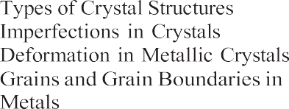

* 1. **Atomic Structure and the Elements**
  2. **Bonding between Atoms and Molecules**
  3. **Crystalline Structures**

2.3.1

2.3.2

2.3.3

2.3.4

* 1. **Noncrystalline (Amorphous) Structures**
  2. **Engineering Materials**

**36**

Part I of this book consists of four chapters that address this question. The current chapter considers the atomic structure of matter and the bonding bet- ween atoms and molecules. It also shows how atoms and molecules in engineering materials organize themselves into two structural forms: crystalline and noncrystalline. It turns out that the basic engineering materials—metals, ceramics, and polymers—can exist in either form, although a preference for a particular form is usually exhibited by a given material. For exam- ple, metals almost always exist as crystals in their solid state. Glass (e.g., window glass), a ceramic, assumes a noncrystalline form. Some polymers are mixtures of crystalline and amorphous structures.

Chapters 3 and 4 discuss the mechanical and physical properties that are relevant in manufacturing. Of course, these properties are also important in product design. Chapter 5 is concerned with several part and product

attributes that are specified during product design and must be achieved in manufac- turing: dimensions, tolerances, and surface finish. Chapter 5 also describes how these attributes are measured.

### Atomic Structure and the Elements

**2.**

The basic structural unit of matter is the atom. Each atom is composed of a positively charged nucleus, surrounded by a sufficient number of negatively charged electrons so that the charges are balanced. The number of electrons identifies the atomic number and the element of the atom. There are slightly more than 100 elements (not counting a few extras that have been artificially synthesized), and these elements are the chemi- cal building blocks of all matter.

Just as there are differences among the elements, there are also similarities. The elements can be grouped into families and relationships established between and within the families by means of the Periodic Table, shown in Figure 2.1. In the horizontal direction there is a certain repetition, or periodicity, in the arrange- ment of elements. Metallic elements occupy the left and center portions of the chart, and nonmetals are located to the right. Between them, along a diagonal, is a transition zone containing elements called ***metalloids*** or ***semimetals***. In principle, each of the elements can exist as a solid, liquid, or gas, depending on temperature and pressure. At room temperature and atmospheric pressure, they each have a natural phase; e.g., iron (Fe) is a solid, mercury (Hg) is a liquid, and nitrogen (N) is a gas.

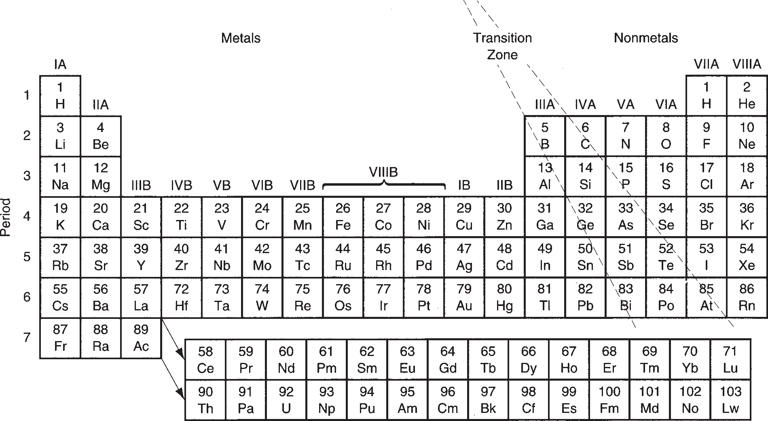

**FIGURE 2.1** Periodic Table of Elements. The atomic number and symbol are listed for the 103 elements.

In the table, the elements are arranged into vertical columns and horizontal rows in such a way that similarities exist among elements in the same columns. For exam- ple, in the extreme right column are the ***noble gases*** (helium, neon, argon, krypton, xenon, and radon), all of which exhibit great chemical stability and low reaction rates. The ***halogens*** (fluorine, chlorine, bromine, iodine, and astatine) in column VIIA share similar properties (hydrogen is not included among the halogens). The ***noble metals*** (copper, silver, and gold) in column IB have similar properties. Gen- erally, there are correlations in properties among elements within a given column, whereas differences exist among elements in different columns.

Many of the similarities and differences among the elements can be explained by their respective atomic structures. The simplest model of atomic structure, called the planetary model, shows the electrons of the atom orbiting around the nucleus at certain fixed distances, called shells, as shown in Figure 2.2. The hydrogen atom (atomic number 1) has one electron in the orbit closest to the nucleus. Helium (atomic number 2) has two. Also shown in the figure are the atomic structures for fluorine (atomic number 9), neon (atomic number 10), and sodium (atomic number 11). One might infer from these models that there is a maximum number of electrons that can be contained in a given orbit. This turns out to be correct, and the maximum is defined by

Maximum number of electrons in an orbit = 2*n*2

where *n* identifies the orbit, with *n* = 1 closest to the nucleus.

The number of electrons in the outermost shell, relative to the maximum number allowed, determines to a large extent the atom’s chemical affinity for other atoms. These outer-shell electrons are called ***valence electrons***. For exam- ple, because a hydrogen atom has only one electron in its single orbit, it readily combines with another hydrogen atom to form a hydrogen molecule H2. For the same reason, hydrogen also reacts readily with various other elements (e.g., to form H2O). In the helium atom, the two electrons in its only orbit are the maxi- mum allowed (2*n*2 = 2(1)2 = 2), and so helium is very stable. Neon is stable for the same reason: Its outermost orbit (*n* = 2) has eight electrons (the maximum allowed), so neon is an inert gas.

In contrast to neon, fluorine has one fewer electron in its outer shell (*n* = 2) than the maximum allowed and is readily attracted to other elements that might share an

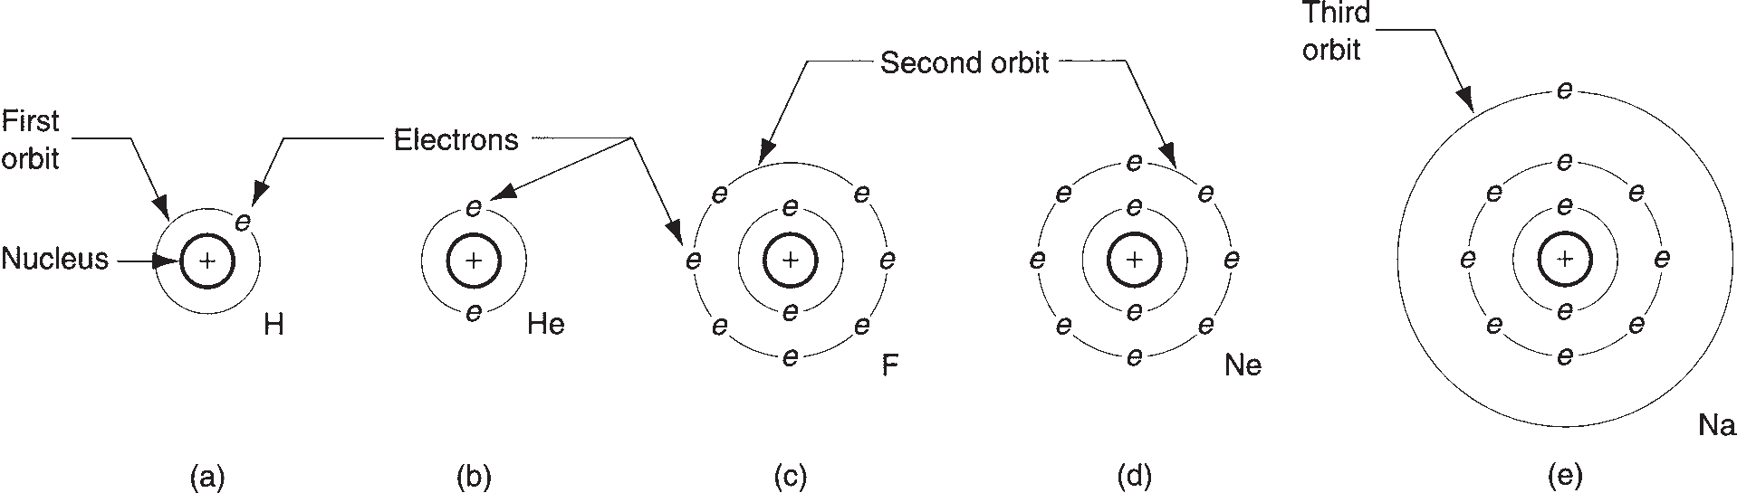

**FIGURE 2.2** Simple model of atomic structure for several elements: (a) hydrogen, (b) helium, (c) fluorine, (d) neon, and (e) sodium.

**FIGURE 2.3** The sodium fluoride molecule formed by the transfer of the “extra” electron of the sodium atom to complete the outer orbit of the fluorine atom.

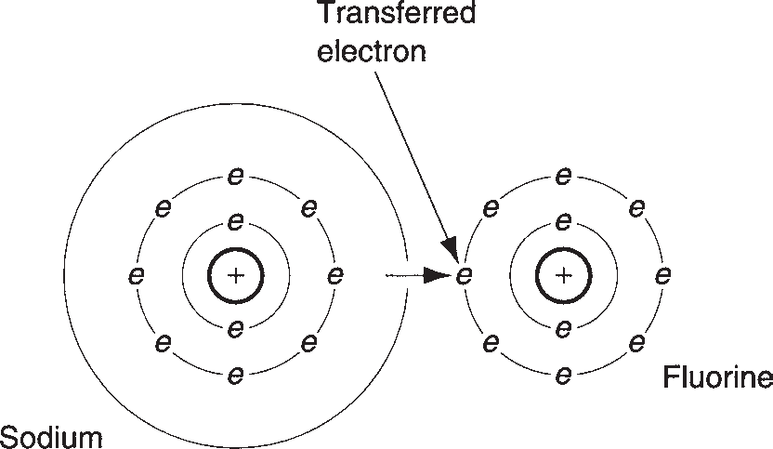

electron to make a more stable set. The sodium atom seems divinely made for the situation, with one electron in its outermost orbit. It reacts strongly with fluorine to form the compound sodium fluoride, as pictured in Figure 2.3.

At the low atomic numbers considered here, the prediction of the number of electrons in the outer orbit is straightforward. As the atomic number increases to higher levels, the allocation of electrons to the different orbits becomes somewhat more complicated. There are rules and guidelines, based on quantum mechanics, that can be used to predict the positions of the electrons among the various orbits and explain their characteristics. A discussion of these rules is somewhat beyond the scope of this coverage of manufacturing materials.

### Bonding between Atoms and Molecules

**2.2**

Atoms are held together in molecules by various types of bonds that depend on the valence electrons. By comparison, molecules are attracted to each other by weaker bonds, which generally result from the electron configuration in the indi- vidual molecules. Thus, we have two types of bonding: (1) primary bonds, gener- ally associated with the formation of molecules; and (2) secondary bonds, generally associated with attraction between molecules. Primary bonds are much stronger than secondary bonds.

**Primary Bonds** Primary bonds are characterized by strong atom-to-atom attrac- tions that involve the exchange of valence electrons. Primary bonds include the fol- lowing forms: (a) ionic, (b) covalent, and (c) metallic, as illustrated in Figure 2.4. Ionic and covalent bonds are called ***intra***molecular bonds because they involve at- tractive forces between atoms within the molecule.

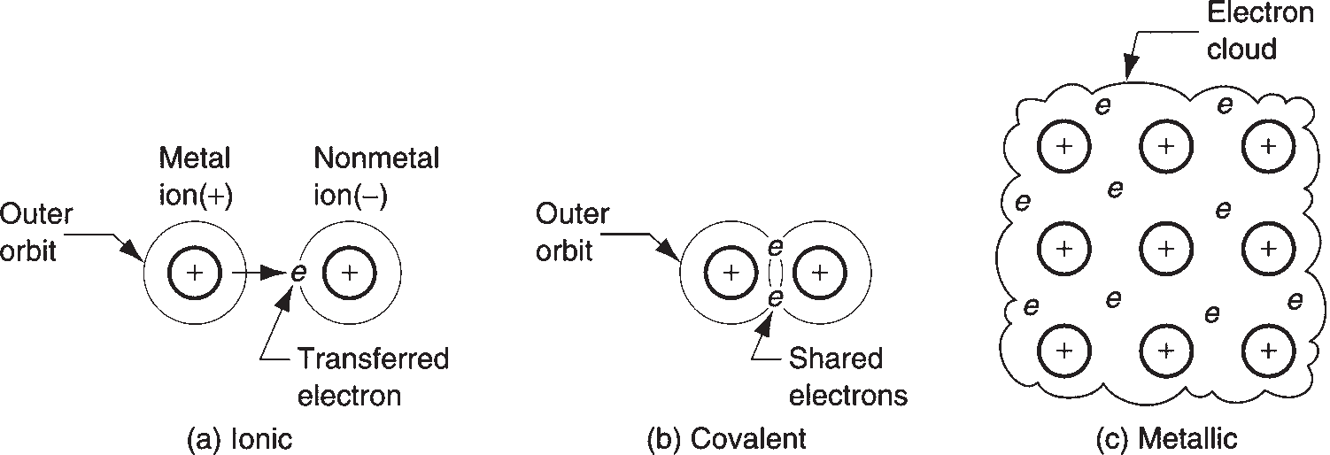

**FIGURE 2.4** Three

forms of primary bonding:

(a) ionic, (b) covalent, and (c) metallic.

In the ***ionic bond***, the atoms of one element give up their outer electron(s), which are in turn attracted to the atoms of some other element to increase their electron count in the outermost shell to eight. In general, eight electrons in the outer shell is the most stable atomic configuration (except for the very light atoms), and nature pro- vides a very strong bond between atoms that achieves this configuration. The previous example of the reaction of sodium and fluorine to form sodium fluoride (Figure 2.3) illustrates this form of atomic bond. Sodium chloride (table salt) is a more common example. Because of the transfer of electrons between the atoms, sodium and fluorine (or sodium and chlorine) ***ions*** are formed, from which this bonding derives its name. Properties of solid materials with ionic bonding include low electrical conductivity and poor ductility.

The ***covalent bond*** is one in which electrons are shared (as opposed to trans- ferred) between atoms in their outermost shells to achieve a stable set of eight. Fluorine and diamond are two examples of covalent bonds. In fluorine, one electron from each of two atoms is shared to form F2 gas, as shown in Figure 2.5(a). In the case of diamond, which is carbon (atomic number 6), each atom has four neighbors with which it shares electrons. This produces a very rigid three-dimensional struc- ture, not adequately represented in Figure 2.5(b), and accounts for the extreme high hardness of this material. Other forms of carbon (e.g., graphite) do not exhibit this rigid atomic structure. Solids with covalent bonding generally possess high hardness and low electrical conductivity.

The metallic bond is, of course, the atomic bonding mechanism in pure metals and metal alloys. Atoms of the metallic elements generally possess too few elec- trons in their outermost orbits to complete the outer shells for all of the atoms in, say, a given block of metal. Accordingly, instead of sharing on an atom-to-atom basis, ***metallic bonding*** involves the sharing of outer-shell electrons by all atoms to form a general electron cloud that permeates the entire block. This cloud pro- vides the attractive forces to hold the atoms together and form a strong, rigid structure in most cases. Because of the general sharing of electrons, and their freedom to move within the metal, metallic bonding provides for good electri- cal conductivity. Other typical properties of materials characterized by metallic bonding include good conduction of heat and good ductility. (Although some of these terms are yet to be defined, the reader’s general understanding of material properties is assumed.)

**Secondary Bonds** Whereas primary bonds involve atom-to-atom attractive forces, secondary bonds involve attraction forces between molecules, or ***inter***molecular forces. There is no transfer or sharing of electrons in secondary bonding, and these bonds are

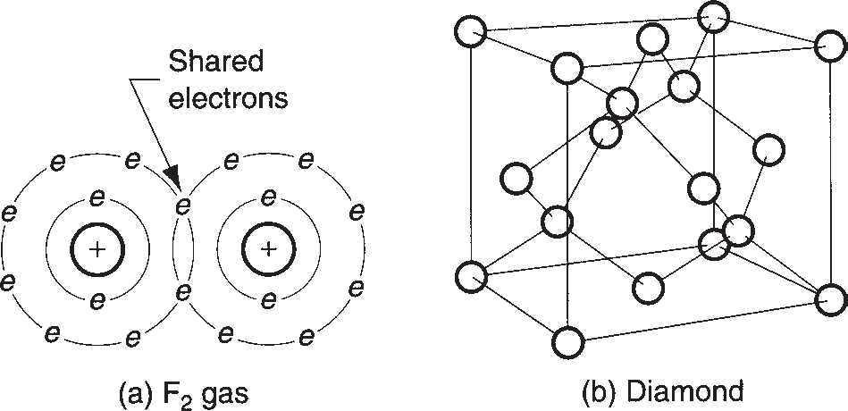

**FIGURE 2.5** Two examples of covalent bonding:

1. fluorine gas F2, and
2. diamond.

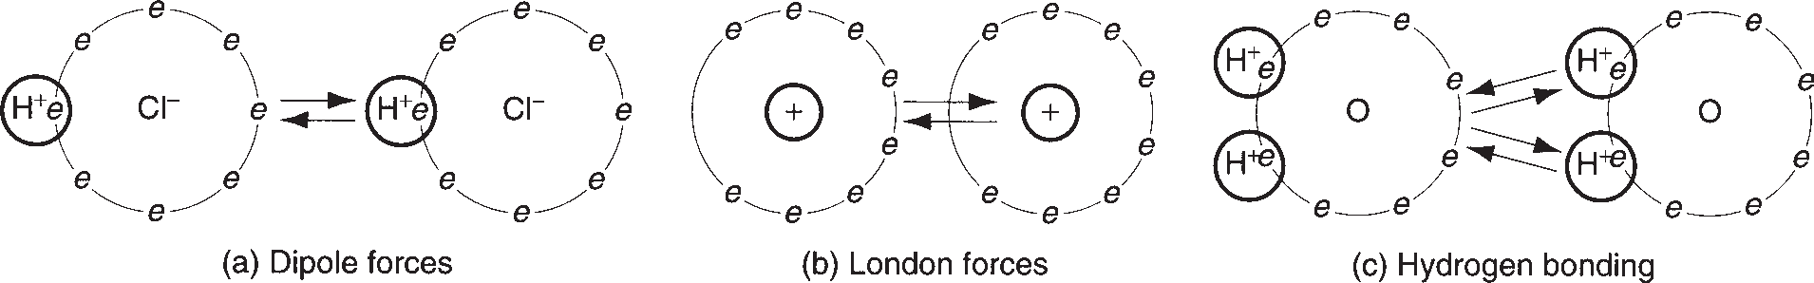

**FIGURE 2.6** Three types of secondary bonding: (a) dipole forces, (b) London forces, and (c) hydrogen bonding.

therefore weaker than primary bonds. There are three forms of secondary bonding:

(a) dipole forces, (b) London forces, and (c) hydrogen bonding, illustrated in Figure 2.6. Types (a) and (b) are often referred to as ***van der Waals*** forces, after the scientist who first studied and quantified them.

***Dipole forces*** arise in a molecule comprised of two atoms that have equal and opposite electrical charges. Each molecule therefore forms a dipole, as shown in Figure 2.6(a) for hydrogen chloride. Although the material is electrically neu- tral in its aggregate form, on a molecular scale the individual dipoles attract each other, given the proper orientation of positive and negative ends of the molecules. These dipole forces provide a net intermolecular bonding within the material.

***London forces*** involve attractive forces between nonpolar molecules; that is, the atoms in the molecule do not form dipoles in the sense of the preceding paragraph. However, owing to the rapid motion of the electrons in orbit around the molecule, temporary dipoles form when more electrons happen to be on one side of the mole- cule than the other, as suggested by Figure 2.6(b). These instantaneous dipoles pro- vide a force of attraction between molecules in the material.

Finally, ***hydrogen bonding*** occurs in molecules containing hydrogen atoms that are covalently bonded to another atom (e.g., oxygen in H2O). Because the elec- trons needed to complete the shell of the hydrogen atom are aligned on one side of its nucleus, the opposite side has a net positive charge that attracts the electrons of atoms in neighboring molecules. Hydrogen bonding is illustrated in Figure 2.6(c) for water, and is generally a stronger intermolecular bonding mechanism than the other two forms of secondary bonding. It is important in the formation of many polymers.

### Crystalline Structures

**2.3**

Atoms and molecules are used as building blocks for the more macroscopic struc- ture of matter that is considered here and in the following section. When materials solidify from the molten state, they tend to close ranks and pack tightly, in many cases arranging themselves into a very orderly structure, and in other cases, not quite so orderly. Two fundamentally different material structures can be distin- guished: (1) crystalline and (2) noncrystalline. Crystalline structures are examined in this section, and noncrystalline in the next.

Many materials form into crystals on solidification from the molten or liquid state. It is characteristic of virtually all metals, as well as many ceramics and polymers. A ***crystalline structure*** is one in which the atoms are located at regular and recurring positions in three dimensions. The pattern may be replicated millions of times within

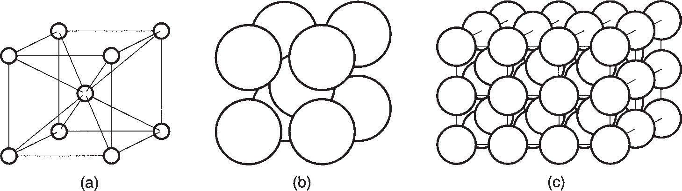

**FIGURE 2.7** Body-centered cubic (BCC) crystal structure: (a) unit cell with atoms indicated as point locations in a three-dimensional axis system; (b) unit cell model showing closely packed atoms (sometimes called the hard-ball model); and

1. repeated pattern of the BCC structure.

a given crystal. The structure can be viewed in the form of a ***unit cell***, which is the basic geometric grouping of atoms that is repeated. To illustrate, consider the unit cell for the body-centered cubic (BCC) crystal structure shown in Figure 2.7, one of the common structures found in metals. The simplest model of the BCC unit cell is illustrated in Figure 2.7(a). Although this model clearly depicts the locations of the atoms within the cell, it does not indicate the close packing of the atoms that occurs in the real crystal, as in Figure 2.7(b). Figure 2.7(c) shows the repeating nature of the unit cell within the crystal.

###### TYPES OF CRYSTAL STRUCTURES

In metals, three lattice structures are common: (1) body-centered cubic (BCC),

(2) face-centered cubic (FCC), and (3) hexagonal close-packed (HCP), illustrated in Figure 2.8. Crystal structures for the common metals are presented in Table 2.1. It should be noted that some metals undergo a change of structure at different temperatures. Iron, for example, is BCC at room temperature; it changes to FCC above 912°C (1674°F) and back to BCC at temperatures above 1400°C (2550°F). When a metal (or other material) changes structure like this, it is referred to as being ***allotropic***.

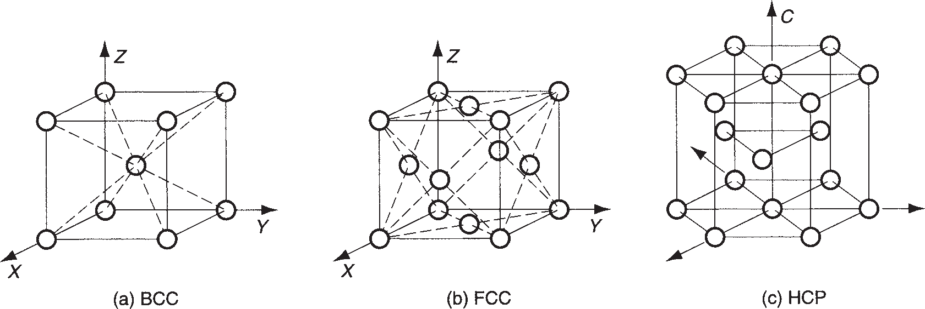

**FIGURE 2.8** Three types of crystal structures in metals: (a) body-centered cubic, (b) face-centered cubic, and (c) hexagonal close-packed.

|  |  |
| --- | --- |
|  | **Body-Centered Cubic Face-Centered Cubic Hexagonal Close-Packed (BCC) (FCC) (HCP)** |
| Chromium (Cr) Aluminum (Al) Magnesium (Mg) Iron (Fe) Copper (Cu) Titanium (Ti)  Molybdenum (Mo) Gold (Au) Zinc (Zn) Tantalum (Ta) Lead (Pb)  Tungsten (W) Silver (Ag) Nickel (Ni) |

###### IMPERFECTIONS IN CRYSTALS



**TABLE** • **2.1** Crystal structures for the common metals (at room temperature).

Thus far, crystal structures have been discussed as if they were perfect—the unit cell repeated in the material over and over in all directions. A perfect crystal is sometimes desirable to satisfy aesthetic or engineering purposes. For instance, a perfect dia- mond (contains no flaws) is more valuable than one containing imperfections. In the production of integrated circuit chips, large single crystals of silicon possess desirable processing characteristics for forming the microscopic details of the circuit pattern.

However, there are various reasons why a crystal’s lattice structure may not be perfect. The imperfections often arise naturally because of the inability of the solidifying material to continue the replication of the unit cell indefinitely without interruption. Grain boundaries in metals are an example. In other cases, the imper- fections are introduced purposely during the manufacturing process, for example, the addition of an alloying ingredient in a metal to increase its strength.

The various imperfections in crystalline solids are also called defects. Either term, ***imperfection*** or ***defect***, refers to deviations in the regular pattern of the crystalline lattice structure. They can be catalogued as (1) point defects, (2) line defects, and

(3) surface defects.

***Point defects*** are imperfections in the crystal structure involving either a single atom or a few atoms. The defects can take various forms including, as shown in Figure 2.9: (a) ***vacancy***, the simplest defect, involving a missing atom within the lattice structure; (b) ***ion-pair vacancy***, also called a ***Schottky defect***, which involves

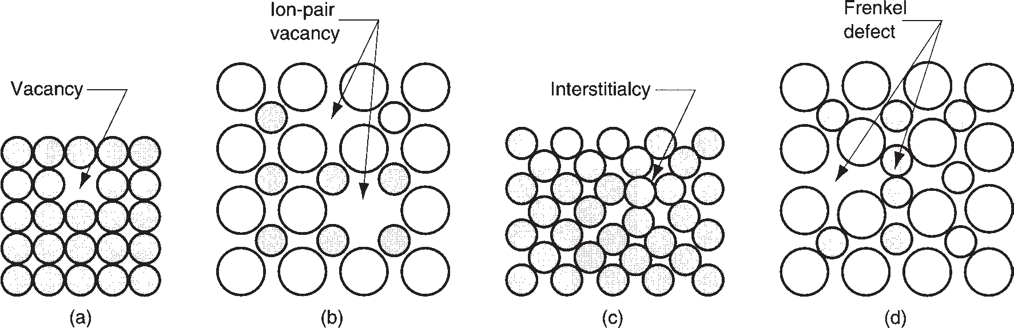

**FIGURE 2.9** Point defects: (a) vacancy, (b) ion-pair vacancy, (c) interstitialcy, and (d) displaced ion.

**FIGURE 2.10** Line

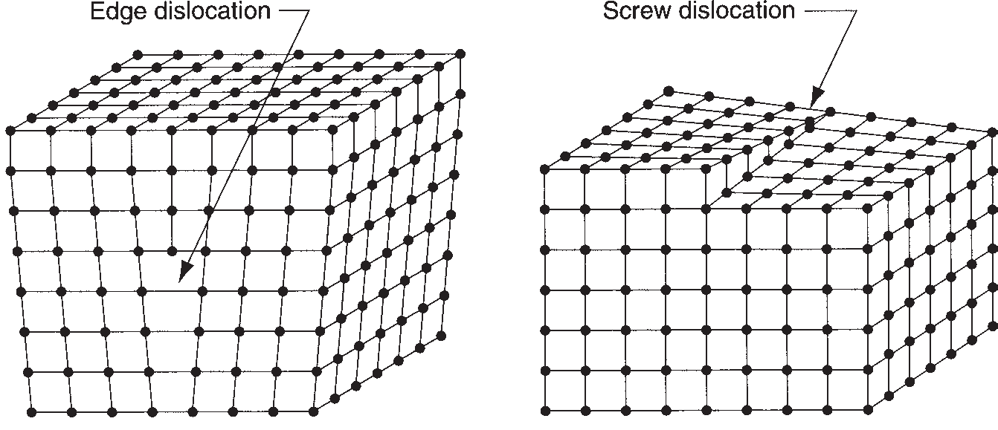

defects: (a) edge dislocation and

(b) screw dislocation. (a) (b)

a missing pair of ions of opposite charge in a compound that has an overall charge balance; (c) ***interstitialcy***, a lattice distortion produced by the presence of an extra atom in the structure; and (d) ***displaced ion***, known as a ***Frenkel defect***, which oc- curs when an ion becomes removed from a regular position in the lattice structure and inserted into an interstitial position not normally occupied by such an ion.

A ***line defect*** is a connected group of point defects that forms a line in the lat- tice structure. The most important line defect is the ***dislocation***, which can take two forms: (a) edge dislocation and (b) screw dislocation. An ***edge dislocation*** is the edge of an extra plane of atoms that exists in the lattice, as illustrated in Figure 2.10(a). A ***screw dislocation***, Figure 2.10(b), is a spiral within the lattice structure wrapped around an imperfection line, like a screw is wrapped around its axis. Both types of dislocations can arise in the crystal structure during solidification (e.g., casting), or they can be initiated during a deformation process (e.g., metal forming) performed on the solid material. Dislocations are useful in explaining certain aspects of me- chanical behavior in metals.

***Surface defects*** are imperfections that extend in two directions to form a boundary. The most obvious example is the external surface of a crystalline object that defines its shape. The surface is an interruption in the lattice structure. Surface boundaries can also lie inside the material. Grain boundaries are the best example of these in- ternal surface interruptions. Metallic grains are discussed in a moment, but first let consider how deformation occurs in a crystal lattice, and how the process is aided by the presence of dislocations.

###### DEFORMATION IN METALLIC CRYSTALS

When a crystal is subjected to a gradually increasing mechanical stress, its initial response is to deform ***elastically***. This can be likened to a tilting of the lattice struc- ture without any changes of position among the atoms in the lattice, in the manner depicted in Figure 2.11(a) and (b). If the force is removed, the lattice structure (and therefore the crystal) returns to its original shape. If the stress reaches a high value relative to the electrostatic forces holding the atoms in their lattice positions, a per- manent shape change occurs, called ***plastic deformation***. What has happened is that the atoms in the lattice have permanently moved from their previous locations, and a new equilibrium lattice has been formed, as suggested by Figure 2.11(c).

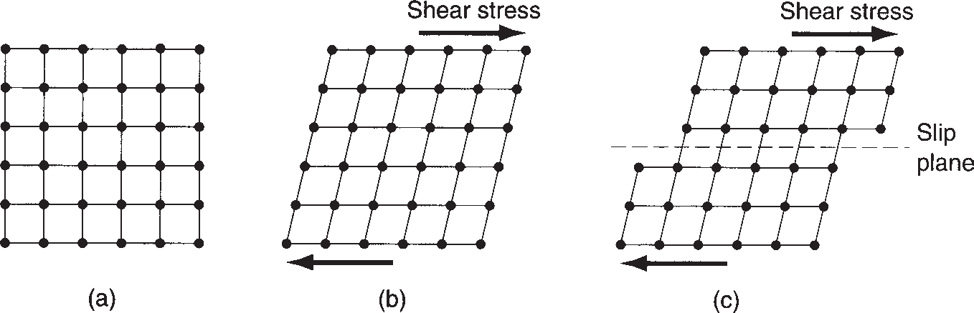

**FIGURE 2.11** Deformation of a crystal structure: (a) original lattice; (b) elastic deformation, with no permanent change in positions of atoms; and (c) plastic deformation, in which atoms in the lattice are forced to move to new “homes.”

The lattice deformation shown in (c) of the figure is one possible mechanism, called slip, by which plastic deformation can occur in a crystalline structure. The other is called twinning, discussed later.

***Slip*** involves the relative movement of atoms on opposite sides of a plane in the lattice, called the ***slip plane***. The slip plane must be somehow aligned with the lattice structure (as indicated in the sketch), and so there are certain preferred directions along which slip is more likely to occur. The number of these ***slip directions*** de- pends on the lattice type. The three common metal crystal structures are somewhat more complicated, especially in three dimensions, than the square lattice depicted in Figure

2.11. It turns out that HCP has the fewest slip directions, BCC the most, and FCC falls in between. HCP metals show poor ductility and are generally difficult to deform at room temperature. Metals with BCC structure would figure to have the highest ductility, if the number of slip directions were the only criterion. However, nature is not so simple. These metals are generally stronger than the others, which complicates the issue, and the BCC metals usually require higher stresses to cause slip. In fact, some of the BCC metals exhibit poor ductility. Low carbon steel is a notable exception; although relatively strong, it is widely used with great commer- cial success in sheet-metal-forming operations, where it exhibits good ductility. The FCC metals are generally the most ductile of the three crystal structures, combining a good number of slip directions with (usually) relatively low to moderate strength. All three of these metal structures become more ductile at elevated temperatures, and this fact is often exploited in shaping them.

Dislocations play an important role in facilitating slip in metals. When a lattice structure containing an edge dislocation is subjected to a shear stress, the material deforms much more readily than in a perfect structure. This is explained by the fact that the dislocation is put into motion within the crystal lattice in the presence of the stress, as shown in the series of sketches in Figure 2.12. Why is it easier to move a dis- location through the lattice than it is to deform the lattice itself? The answer is that the atoms at the edge dislocation require a smaller displacement within the distorted lattice structure to reach a new equilibrium position. Thus, a lower energy level is needed to realign the atoms into the new positions than if the lattice were missing the dislocation. A lower stress level is therefore required to effect the deformation. Because the new position manifests a similar distorted lattice, movement of atoms at the dislocation continues at the lower stress level.

The slip phenomenon and the influence of dislocations have been explained here on a very microscopic basis. On a larger scale, slip occurs many times over

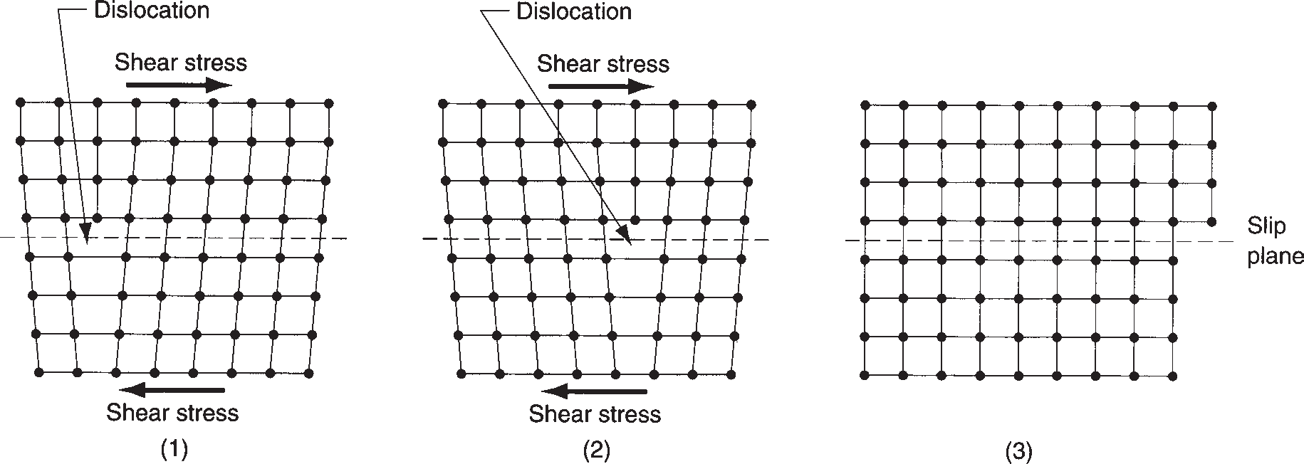

**FIGURE 2.12** Effect of dislocations in the lattice structure under stress. In the series of diagrams, the movement of the dislocation allows deformation to occur under a lower stress than in a perfect lattice.

throughout the metal when subjected to a deforming load, thus causing it to ex- hibit the familiar macroscopic behavior of stretching, compressing, or bending. Dislocations represent a good-news–bad-news situation. Because of dislocations, the metal is more ductile and yields more readily to plastic deformation (forming) during manufacturing. However, from a product design viewpoint, the metal is not nearly as strong as it would be in the absence of dislocations.

Twinning is a second way in which metal crystals plastically deform. ***Twinning*** can be defined as a mechanism of plastic deformation in which atoms on one side of a plane (called the twinning plane) are shifted to form a mirror image of the other side of the plane. It is illustrated in Figure 2.13. The mechanism is important in HCP metals (e.g., magnesium, zinc) because they do not slip readily. Besides structure, another factor in twinning is the rate of deformation. The slip mechanism requires more time than twinning, which can occur almost instantaneously. Thus, when the deformation rate is very high, metals twin that would otherwise slip. Low carbon steel is an example that illustrates this rate sensitivity; when subjected to high strain rates it twins, whereas at moderate rates it deforms by slip.

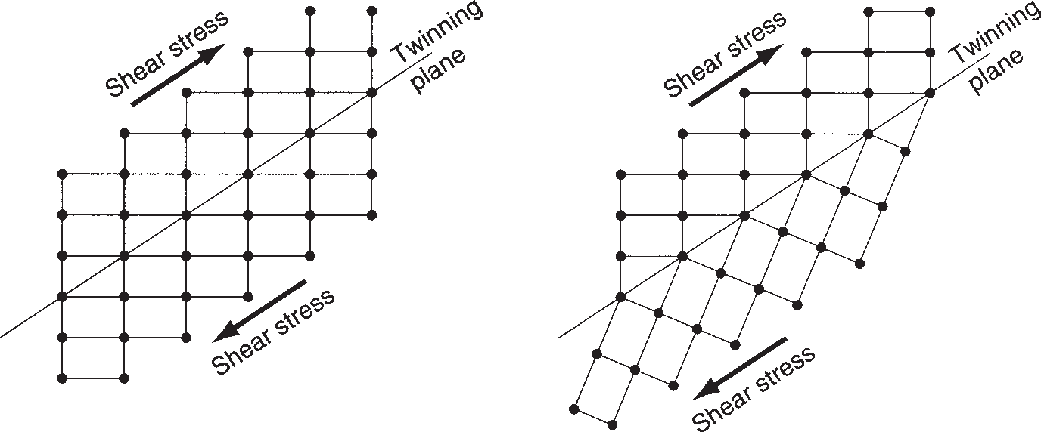

**FIGURE 2.13** Twinning involves the formation of an atomic mirror image (i.e., a “twin”) on the opposite side of the twinning plane:

(a) before and (b) after

twinning. (a) (b)

###### GRAINS AND GRAIN BOUNDARIES IN METALS

A given block of metal may contain millions of individual crystals, called ***grains***. Each grain has its own unique lattice orientation; but collectively, the grains are ran- domly oriented within the block. Such a structure is referred to as ***polycrystalline***. It is easy to understand how such a structure is the natural state of the material. When the block is cooled from the molten state and begins to solidify, nucleation of indi- vidual crystals occurs at random positions and orientations throughout the liquid. As these crystals grow they finally interfere with each other, forming at their interface a surface defect—a ***grain boundary***. The grain boundary consists of a transition zone, perhaps only a few atoms thick, in which the atoms are not aligned with either grain. The size of the grains in the metal block is determined by the number of nucleation sites in the molten material and the cooling rate of the mass, among other factors. In a casting process, the nucleation sites are often created by the relatively cold walls of the mold, which motivates a somewhat preferred grain orientation at these walls.

Grain size is inversely related to cooling rate: Faster cooling promotes smaller grain size, whereas slower cooling has the opposite effect. Grain size is important in metals because it affects mechanical properties. Smaller grain size is generally preferable from a design viewpoint because it means higher strength and hard- ness. It is also desirable in certain manufacturing operations (e.g., metal forming), because it means higher ductility during deformation and a better surface on the finished product.

Another factor influencing mechanical properties is the presence of grain boundaries in the metal. They represent imperfections in the crystalline structure that interrupt the continued movement of dislocations. This helps to explain why smaller grain size—therefore more grains and more grain boundaries—increases the strength of the metal. By interfering with dislocation movement, grain boundaries also contribute to the characteristic property of a metal to become stronger as it is deformed. The property is called ***strain hardening***, and it is examined more closely in Chapter 3 on mechanical properties.

### Noncrystalline (Amorphous) Structures

**2.4**

Many important materials are noncrystalline—liquids and gases, for example. Water and air have noncrystalline structures. A metal loses its crystalline structure when it is melted. Mercury is a liquid metal at room temperature, with its melting point of -38°C (-37°F). Important classes of engineering materials have a noncrystalline form in their solid state; the term ***amorphous*** is often used to describe these materi- als. Glass, many plastics, and rubber fall into this category. Many important plastics are mixtures of crystalline and noncrystalline forms. Even metals can be amorphous rather than crystalline, given that the cooling rate during transformation from liquid to solid is fast enough to inhibit the atoms from arranging themselves into their pre- ferred regular patterns. This can happen, for instance, if the molten metal is poured between cold, closely spaced, rotating rolls.

Two closely related features distinguish noncrystalline from crystalline materials:

(1) absence of a long-range order in the molecular structure, and (2) differences in melting and thermal expansion characteristics.

The difference in molecular structure can be visualized with reference to Fig- ure 2.14. The closely packed and repeating pattern of the crystal structure is shown on the left; and the less dense and random arrangement of atoms in the noncrystalline

**FIGURE 2.14** Illustration of difference in structure between: (a) crystalline and (b) noncrystalline materials. The crystal structure is regular, repeating, and denser, while the noncrystalline structure is more loosely packed and random.

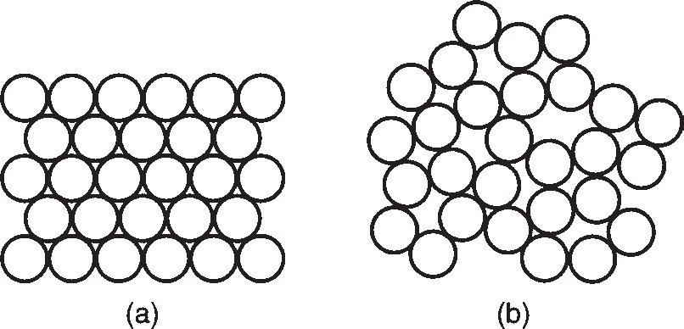

material on the right. The difference is demonstrated by a metal when it melts. The more loosely packed atoms in the molten metal show an increase in volume (reduction in density) compared with the material’s solid crystalline state. This effect is character- istic of most materials when melted (ice is a notable exception; liquid water is denser than solid ice). It is a general characteristic of liquids and solid amorphous materials that they are absent of long-range order as on the right in our figure.

The melting phenomenon will now be examined in more detail, and in doing so, the second important difference between crystalline and noncrystalline structures is illustrated. As indicated above, a metal experiences an increase in volume when it melts from the solid to the liquid state. For a pure metal, this volumetric change occurs rather abruptly, at a constant temperature (i.e., the melting temperature *Tm*), as indi- cated in Figure 2.15. The change represents a discontinuity from the slopes on either side in the plot. The gradual slopes characterize the metal’s ***thermal expansion***—the change in volume as a function of temperature, which is usually different in the solid and liquid states. Associated with the sudden volume increase as the metal transforms from solid to liquid at the melting point is the addition of a certain quantity of heat, called the ***heat of fusion***, which causes the atoms to lose the dense, regular arrange- ment of the crystalline structure. The process is reversible; it operates in both direc- tions. If the molten metal is cooled through its melting temperature, the same abrupt change in volume occurs (except that it is a decrease), and the same quantity of heat is given off by the metal.

An amorphous material exhibits quite different behavior than that of a pure metal when it changes from solid to liquid, as shown in Figure 2.15. The process is again reversible, but observe the behavior of the amorphous material during

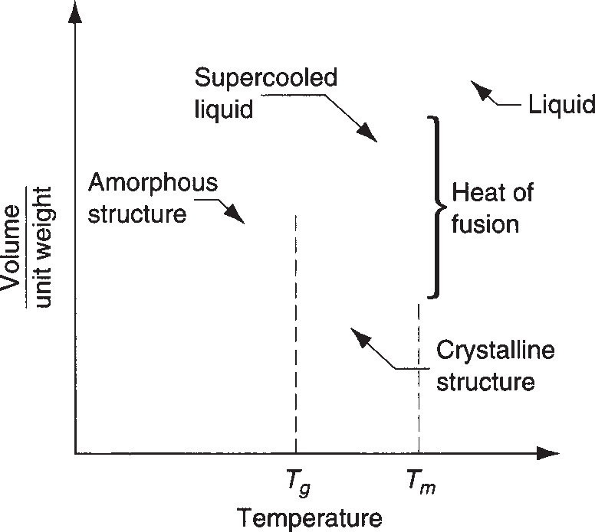

**FIGURE 2.15** Characteristic change in volume for a pure metal (a crystalline structure), compared to the same volumetric changes in glass

(a noncrystalline structure).

cooling from the liquid state, rather than during melting from the solid, as before. Glass (silica, SiO2) is used to illustrate. At high temperatures, glass is a true liquid, and the molecules are free to move about as in the usual definition of a liquid. As the glass cools, it gradually transforms into the solid state, going through a transi- tion phase, called a ***supercooled liquid***, before finally becoming rigid. It does not show the sudden volumetric change that is characteristic of crystalline materials; instead it passes through its melting temperature *Tm* without a change in its thermal expansion slope. In this supercooled liquid region, the material becomes increas- ingly viscous as the temperature continues to decrease. As it cools further, a point is finally reached at which the supercooled liquid converts to a solid. This is called the ***glass-transition temperature*** *Tg*. At this point, there is a change in the thermal expansion slope. (It might be more precise to refer to it as the thermal contraction slope; however, the slope is the same for expansion and contraction). The rate of thermal expansion is lower for the solid material than for the supercooled liquid.

The difference in behavior between crystalline and noncrystalline materials can be traced to the response of their respective atomic structures to changes in temper- ature. When a pure metal solidifies from the molten state, the atoms arrange them- selves into a regular and recurring structure. This crystal structure is much more compact than the random and loosely packed liquid from which it formed. Thus, the process of solidification produces the abrupt volumetric contraction observed in Figure 2.15 for the crystalline material. By contrast, amorphous materials do not achieve this repeating and closely packed structure at low temperatures. The atomic structure is the same random arrangement as in the liquid state; thus, there is no abrupt volumetric change as these materials transition from liquid to solid.

### Engineering Materials

**2.5**

This section summarizes how atomic structure, bonding, and crystal structure (or absence thereof) are related to the type of engineering material: metals, ceramics, and polymers.

**Metals** Metals have crystalline structures in the solid state, almost without excep- tion. The unit cells of these crystal structures are almost always BCC, FCC, or HCP. The atoms of the metals are held together by metallic bonding, which means that their valence electrons can move about with relative freedom (compared with the other types of atomic and molecular bonding). These structures and bonding gener- ally make the metals strong and hard. Many of the metals are quite ductile (capable of being deformed, which is useful in manufacturing), especially the FCC metals. Other general properties of metals related to structure and bonding include high electri- cal and thermal conductivity, opaqueness (impervious to light rays), and reflectivity (capacity to reflect light rays).

**Ceramics** Ceramic molecules are characterized by ionic or covalent bonding, or both. The metallic atoms release or share their outermost electrons to the nonme- tallic atoms, and a strong attractive force exists within the molecules. The general properties that result from these bonding mechanisms include high hardness and stiffness (even at elevated temperatures) and brittleness (no ductility). The bond- ing also means that ceramics are electrically insulating (nonconducting), refractory (thermally resistant), and chemically inert.

Section 1.6/Recent Developments in Manufacturing

**50**

Ceramics possess either a crystalline or noncrystalline structure. Most ceramics have a crystal structure, whereas glasses based on silica (SiO2) are amorphous. In certain cases, either structure can exist in the same ceramic material. For example, silica occurs in nature as crystalline quartz. When this mineral is melted and then cooled, it solidifies to form fused silica, which has a noncrystalline structure.

**Polymers** A polymer molecule consists of many repeating ***mers*** to form very large molecules held together by covalent bonding. Elements in polymers are usu- ally carbon plus one or more other elements such as hydrogen, nitrogen, oxygen, and chlorine. Secondary bonding (van der Waals) holds the molecules together within the aggregate material (intermolecular bonding). Polymers have either a glassy structure or mixture of glassy and crystalline. There are differences among the three polymer types. In ***thermoplastic polymers***, the molecules consist of long chains of mers in a linear structure. These materials can be heated and cooled without substantially altering their linear structure. In ***thermosetting polymers***, the molecules transform into a rigid, three-dimensional structure on cooling from a heated plastic condition. If thermosetting polymers are reheated, they degrade chemically rather than soften. ***Elastomers*** have large molecules with coiled struc- tures. The uncoiling and recoiling of the molecules when subjected to stress cycles motivate the aggregate material to exhibit its characteristic elastic behavior. The molecular structure and bonding of polymers provide them with the fol- lowing typical properties: low density, high electrical resistivity (some polymers are used as insulating materials), and low thermal conductivity. Strength and stiff- ness of polymers vary widely. Some are strong and rigid (although not matching the strength and stiffness of metals or ceramics),

whereas others exhibit highly elastic behavior.

# Physical Properties of Materials

**4**

**83**

##### Chapter Contents

* 1. Volumetric and Melting Properties
     1. Density
     2. Thermal Expansion
     3. Melting Characteristics
  2. Thermal Properties
     1. Specific Heat and Thermal Conductivity
     2. Thermal Properties in Manufacturing
  3. Mass Diffusion
  4. **Electrical Properties**
     1. Resistivity and Conductivity
     2. Classes of Materials by Electrical Properties
  5. Electrochemical Processes

Physical properties, as the term is used here, defines the behavior of materials in response to physical forces other than mechanical. They include volumetric, ther- mal, electrical, and electrochemical properties. Compo- nents in a product must do more than simply withstand mechanical stresses. They must conduct electricity (or prevent its conduction), allow heat to be transferred (or allow it to escape), transmit light (or block its transmis- sion), and satisfy myriad other functions.

Physical properties are important in manufacturing because they often influence the performance of the process. For example, thermal properties of the work material in machining determine the cutting tempera- ture, which affects how long the tool can be used be- fore it fails. In microelectronics, electrical properties of silicon and the way in which these properties can be altered by various chemical and physical processes com- prise the basis of semiconductor manufacturing.

This chapter covers the physical properties that are most important in manufacturing—properties that are encountered in subsequent chapters of the book. They are divided into major categories such as volumetric, thermal, electrical, and so on. Also, as in the previous chapter on mechanical properties, the importance of these properties in manufacturing is discussed.

### Volumetric and Melting Properties

These properties are related to the volume of solids and how they are affected by temperature. The prop- erties include density, thermal expansion, and melting point. They are explained in the following, and typical values for selected engineering materials are presented in Table 4.1.

|  |  |  |  |  |  |  |
| --- | --- | --- | --- | --- | --- | --- |
|  | **TABLE** • **4.1** Volumetric properties in U.S. customary units for selected engineering materials. | | | | | |
|  | **Material** | **Density**, *r*  **g/cm3 lb/in3** | | **Coefficient of Thermal Expansion**, *a*  8**C**2**1** 3 **10**2**6** 8**F**2**1** 3 **10**2**6** | | **Melting Point**, ***Tm***  8**C** 8**F** |
| ***Metals*** |  | |  | |  |
| Aluminum | 2.70 | 0.098 | 24 | 13.3 | 660 1220 |
| Copper | 8.97 | 0.324 | 17 | 9.4 | 1083 1981 |
| Iron | 7.87 | 0.284 | 12.1 | 6.7 | 1539 2802 |
| Lead | 11.35 | 0.410 | 29 | 16.1 | 327 621 |
| Magnesium | 1.74 | 0.063 | 26 | 14.4 | 650 1202 |
| Nickel | 8.92 | 0.322 | 13.3 | 7.4 | 1455 2651 |
| Steel | 7.87 | 0.284 | 12 | 6.7 | a a |
| Tin | 7.31 | 0.264 | 23 | 12.7 | 232 449 |
| Titanium | 4.51 | 0.163 | 8.6 | 4.7 | 1668 3034 |
| Tungsten | 19.30 | 0.697 | 4.0 | 2.2 | 3410 6170 |
| Zinc | 7.15 | 0.258 | 40 | 22.2 | 420 787 |
| ***Ceramics and Silicon*** |  | |  | |  |
| Glass | 2.5 | 0.090 | 1.8–9.0 | 1.0–5.0 | b b |
| Alumina | 3.8 | 0.137 | 9.0 | 5.0 | NA NA |
| Silica | 2.66 | 0.096 | NA | NA | b b |
| Silicon | 2.33 | 0.085 | 2.6 | 1.4 | 1414 2577 |
| ***Polymers*** |  | |  | |  |
| Phenol resins | 1.3 | 0.047 | 60 | 33 | c c |
| Nylon | 1.16 | 0.042 | 100 | 55 | b b |
| Teflon | 2.2 | 0.079 | 100 | 55 | b b |
| Natural rubber | 1.2 | 0.043 | 80 | 45 | b b |
| Polyethylene (low density) | 0.92 | 0.033 | 180 | 100 | b b |
| Polystyrene | 1.05 | 0.038 | 60 | 33 | b b |

Compiled from, [2], [3], [4], and other sources.



aMelting characteristics of steel depend on composition.

bSoftens at elevated temperatures and does not have a well-defined melting point.

cChemically degrades at high temperatures. NA = not available; value of property for this material could not be obtained.

###### DENSITY

In engineering, the density of a material is its weight per unit volume. Its symbol is *r*, and typical units are g/cm3 (lb/in3). The density of an element is determined by its atomic number and other factors such as atomic radius and atomic packing. The term ***specific gravity*** expresses the density of a material relative to the density of water and is therefore a ratio with no units.

Density is an important consideration in the selection of a material for a given application, but it is generally not the only property of interest. Strength is also important, and the two properties are often related in a ***strength-to-weight ratio***, which is the tensile strength of the material divided by its density. The ratio is useful in comparing materials for structural applications in aircraft, automobiles, and other products in which weight and energy are of concern.

###### THERMAL EXPANSION

The density of a material is a function of temperature. The general relationship is that density decreases with increasing temperature. Put another way, the volume per

unit weight increases with temperature. Thermal expansion is the name given to this effect that temperature has on density. It is usually expressed as the ***coefficient of thermal expansion***, which measures the change in length per degree of temperature, as mm/mm/°C (in/in/°F). It is a length ratio rather than a volume ratio because this is easier to measure and apply. It is consistent with the usual design situation in which dimensional changes are of greater interest than volumetric changes. The change in length corresponding to a given temperature change is given by:

*L*2 - *L*1 = *aL*1 (*T*2 - *T*1) (4.1)

where *a* = coefficient of thermal expansion, °C-1(°F-1); and *L*1 and *L*2 are lengths, mm (in), corresponding, respectively, to temperatures *T*1 and *T*2, °C (°F).

Values of coefficient of thermal expansion given in Table 4.1 suggest that it has a linear relationship with temperature. This is only an approximation. Not only is length affected by temperature, but the thermal expansion coefficient itself is also affected. For some materials it increases with temperature; for other materials it decreases. These changes are usually not significant enough to be of much concern, and values like those in the table are quite useful in design calculations for the range of temperatures contemplated in service. Changes in the coefficient are more sub- stantial when the metal undergoes a phase transformation, such as from solid to liquid, or from one crystal structure to another.

In manufacturing operations, thermal expansion is put to good use in shrink fit and expansion fit assemblies (Section 31.3), in which a part is heated to increase its size or cooled to decrease its size to permit insertion into some other part. When the part returns to ambient temperature, a tightly fitted assembly is obtained. Thermal expansion can be a problem in heat treatment (Chapter 26) and welding (Section 29.6) because of thermal stresses that develop in the material during these processes.

###### MELTING CHARACTERISTICS

For a pure element, the ***melting point*** *Tm* is the temperature at which the mate- rial transforms from solid to liquid state. The reverse transformation, from liquid to solid, occurs at the same temperature and is called the ***freezing point***. For crystalline elements, such as metals, the melting and freezing temperatures are the same. A cer- tain amount of heat energy, called the ***heat of fusion***, is required at this temperature to accomplish the transformation from solid to liquid.

Melting of a metal element at a specific temperature assumes equilibrium condi- tions. Exceptions occur in nature; for example, when a molten metal is cooled, it may remain in the liquid state below its freezing point if nucleation of crystals does not initiate immediately. When this happens, the liquid is said to be ***supercooled***.

There are other variations in the melting process—differences in the way melt- ing occurs in different materials. For example, unlike pure metals, most metal alloys do not have a single melting point. Instead, melting begins at a certain temperature, called the ***solidus***, and continues as the temperature increases until finally convert- ing completely to the liquid state at a temperature called the ***liquidus***. Between the two temperatures, the alloy is a mixture of solid and molten metals, the amounts of each being inversely proportional to their relative distances from the liquidus and

in this way, exceptions are eutectic alloys that

solidus. Although most alloys behave

**FIGURE 4.1** Changes in volume per unit weight (1/density) as a function of temperature for a hypothetical pure metal, alloy, and glass; all exhibiting similar thermal expansion and melting characteristics.

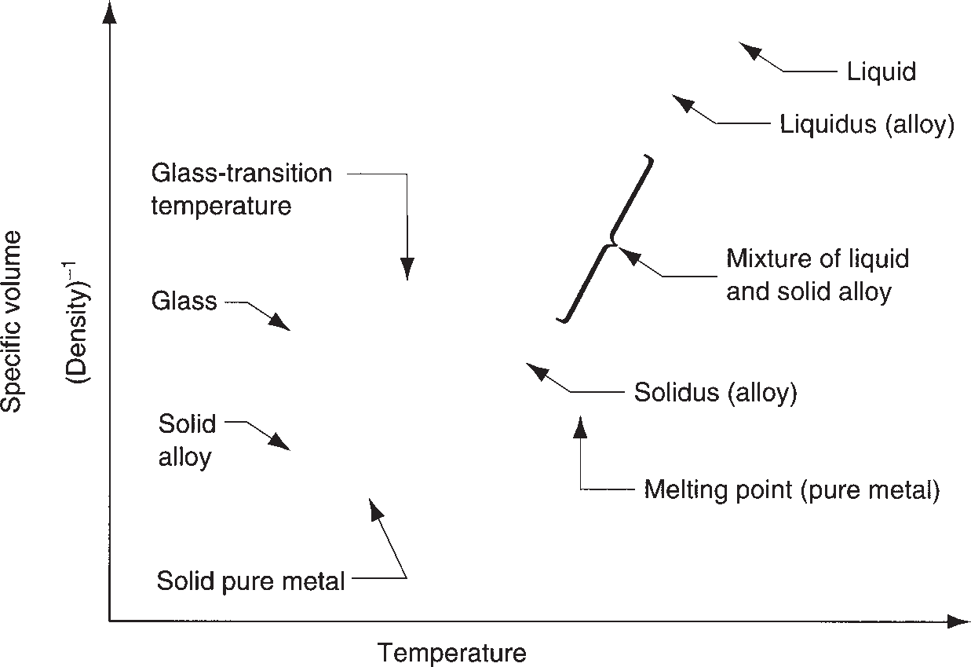

melt (and freeze) at a single temperature. These issues are examined in the discus- sion of phase diagrams in Chapter 6.

Another difference in melting occurs with noncrystalline materials (glasses). In these materials, there is a gradual transition from solid to liquid states. The solid material gradually softens as temperature increases, finally becoming liquid at the melting point. During softening, the material has a consistency of increasing plasticity (increasingly like a fluid) as it gets closer to the melting point.

These differences in melting characteristics among pure metals, alloys, and glass are portrayed in Figure 4.1. The plots show changes in density as a function of tem- perature for three hypothetical materials: a pure metal, an alloy, and glass. Plotted in the figure is the volumetric change, which is the reciprocal of density.

The importance of melting in manufacturing is obvious. In metal casting (Chapters 10 and 11), the metal is melted and then poured into a mold cavity. Metals with lower melting points are generally easier to cast, but if the melting temperature is too low, the metal loses its applicability as an engineering material. Melting char- acteristics of polymers are important in plastic molding and other polymer shaping processes (Chapter 13). Sintering of powdered metals and ceramics requires knowl- edge of melting points. Sintering does not melt the materials, but the temperatures used in the process must approach the melting point to achieve the required bond- ing of the powders (Chapters 15 and 16).

### Thermal Properties

**4.2**

Much of the previous section is concerned with the effects of temperature on volu- metric properties of materials. Certainly, thermal expansion, melting, and heat of fusion are thermal properties because temperature determines the thermal energy level of the atoms, leading to the changes in the materials. The current section ex- amines several additional thermal properties—ones that relate to the storage and flow of heat within a substance. The usual properties of interest are specific heat

|  |  |  |  |  |  |  |  |  |
| --- | --- | --- | --- | --- | --- | --- | --- | --- |
| **Material** | **Cal/g** °**Ca or Btu/lbm** °**F** |  | **J/s mm**  °**C** | **Btu/hr in** °**F** | **Material** | **Cal/g** °**Ca or Btu/lbm** °**F** | **J/s mm**  °**C** | **Btu/hr in** °**F** |
| ***Metals*** |  |  |  |  | ***Ceramics*** |  |  |  |
| Aluminum | 0.21 |  | 0.22 | 9.75 | Alumina | 0.18 | 0.029 | 1.4 |
| Cast iron | 0.11 |  | 0.06 | 2.7 | Concrete | 0.2 | 0.012 | 0.6 |
| Copper | 0.092 |  | 0.40 | 18.7 | ***Polymers*** |  |  |  |
| Iron | 0.11 |  | 0.072 | 2.98 | Phenolics | 0.4 | 0.00016 | 0.0077 |
| Lead | 0.031 |  | 0.033 | 1.68 | Polyethylene | 0.5 | 0.00034 | 0.016 |
| Magnesium | 0.25 |  | 0.16 | 7.58 | Teflon | 0.25 | 0.00020 | 0.0096 |
| Nickel | 0.105 |  | 0.070 | 2.88 | Natural rubber | 0.48 | 0.00012 | 0.006 |
| Steel | 0.11 |  | 0.046 | 2.20 | ***Other*** |  |  |  |
| Stainless steelb | 0.11 |  | 0.014 | 0.67 | Silicon | 0.17 | 0.149 | 6.6 |
| Tin | 0.054 |  | 0.062 | 3.0 | Water (liquid) | 1.00 | 0.0006 | 0.029 |
| Zinc | 0.091 |  | 0.112 | 5.41 | Ice | 0.46 | 0.0023 | 0.11 |

Compiled from [2], [3], [6], and other sources.



and these values change for different temperatures.

**Specific Heat Thermal Conductivity**

**Specific Heat Thermal Conductivity**

aSpecific heat has the same numerical value in Btu/lbm-F or Cal/g-C. 1.0 Calorie = 4.186 Joule.

bAustenitic (18-8) stainless steel.

and thermal conductivity, values of which are compiled for selected materials in Table 4.2.

###### SPECIFIC HEAT AND THERMAL CONDUCTIVITY

The specific heat *C* of a material is defined as the quantity of heat energy required to increase the temperature of a unit mass of the material by one degree. Some typical values are listed in Table 4.2. To determine the amount of energy needed to heat a certain weight of a metal in a furnace to a given elevated temperature, the following equation can be used:

*H* = *C W* (*T*2 - *T*1) (4.2)

where *H* = amount of heat energy, J (Btu); *C* = specific heat of the material, J/kg °C (Btu/lb °F); *W* = its weight, kg (lb); and (*T*2 - *T*1) = change in temperature, °C (°F). The volumetric heat storage capacity of a material is often of interest. This is sim- ply density multiplied by specific heat *rC*. Thus, ***volumetric specific heat*** is the heat energy required to raise the temperature of a unit volume of material by one degree, J/mm3 °C (Btu/in3 °F).

Conduction is a fundamental heat-transfer process. It involves transfer of thermal energy within a material from molecule to molecule by purely thermal motions; no transfer of mass occurs. The thermal conductivity of a substance is therefore its capa- bility to transfer heat through itself by this physical mechanism. It is measured by the ***coefficient of thermal conductivity*** *k*, which has typical units of J/s mm °C (Btu/ in hr

°F). The coefficient of thermal conductivity is generally high in metals, low in

ceramics and plastics.

The ratio of thermal conductivity to volumetric specific heat is frequently encoun- tered in heat transfer analysis. It is called the ***thermal diffusivity*** *K* and is determined as

*K* =  *k*

*rC*

(4.3)

Thermal diffusivity is used to calculate cutting temperatures in machining (Section 20.5.1).

###### THERMAL PROPERTIES IN MANUFACTURING

Thermal properties play an important role in manufacturing because heat genera- tion is common in so many processes. In some operations heat is the energy that ac- complishes the process; in others heat is generated as a consequence of the process. Specific heat is of interest for several reasons. In processes that require heating of the material (e.g., casting, heat treating, and hot metal forming), specific heat deter- mines the amount of heat energy needed to raise the temperature to a desired level, according to Equation (4.2).

In many processes carried out at ambient temperature, the mechanical energy to perform the operation is converted to heat, which raises the temperature of the work part. This is common in machining and cold forming of metals. The temperature rise is a function of the metal’s specific heat. Coolants are often used in machining to reduce these temperatures, and here the fluid’s heat capacity is critical. Water is almost always employed as the base for these fluids because of its high heat-carrying capacity.

Thermal conductivity functions to dissipate heat in manufacturing processes, sometimes beneficially, sometimes not. In mechanical processes such as metal form- ing and machining, much of the power required to operate the process is converted to heat. The ability of the work material and tooling to conduct heat away from its source is highly desirable in these processes.

On the other hand, high thermal conductivity of the work metal is undesirable in fusion welding processes such as arc welding. In these operations, the heat input must be concentrated at the joint location so that the metal can be melted. For exam- ple, copper is generally difficult to weld because its high thermal conductivity allows heat to be conducted from the energy source into the work too rapidly, inhibiting heat buildup for melting at the joint.

### Mass Diffusion

**4.3**

In addition to heat transfer in a material, there is also mass transfer. ***Mass diffusion*** involves movement of atoms or molecules within a material or across a boundary between two materials in contact. It is perhaps more appealing to one’s intuition that such a phenomenon occurs in liquids and gases, but it also occurs in solids. It occurs in pure metals, in alloys, and between materials that share a common interface. Be- cause of thermal agitation of the atoms in a material (solid, liquid, or gas), atoms are continuously moving about. In liquids and gases, where the level of thermal agitation is high, it is a free-roaming movement. In solids (metals in particular), the atomic motion is facilitated by vacancies and other imperfections in the crystal structure.

Diffusion can be illustrated by the series of sketches in Figure 4.2 for the case of two metals suddenly brought into intimate contact with each other. At the start, both

Interface





Pure A Pure B A A and B B Uniform mixture of A and B

(1) (2)

(a)

(3)

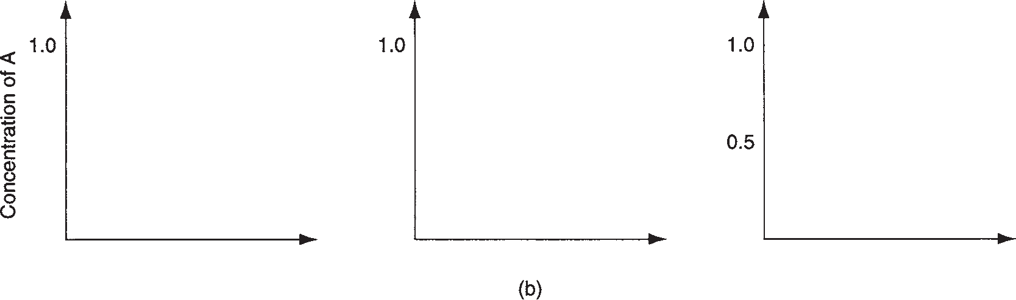

**FIGURE 4.2** Mass diffusion: (a) model of atoms in two solid blocks in contact: (1) at the start when two pieces are brought together, they each have their individual compositions; (2) after some time, an exchange of atoms has occurred; and (3) eventually, a condition of uniform concentration occurs. The concentration gradient *dc/dx* for metal A is plotted in (b) of the figure.

metals have their own atomic structure; but with time there is an exchange of atoms, not only across the boundary, but within the separate pieces. Given enough time, the assembly of two pieces will finally reach a uniform composition throughout.

Temperature is an important factor in diffusion. At higher temperatures, thermal agitation is greater and the atoms can move about more freely. Another factor is the concentration gradient *dc*/*dx*, which indicates the concentration of the two types of atoms in a direction of interest defined by *x*. The concentration gradient is plotted in Figure 4.2(b) to correspond to the instantaneous distribution of atoms in the assembly. The relationship often used to describe mass diffusion is ***Fick’s first law***:

*dm* = -*D dc A dt* (4.4)

( )

*dt*

where *dm* = small amount of material transferred, *D* = diffusion coefficient of the metal, which increases rapidly with temperature, *dc*/*dx* = concentration gradient, *A*

= area of the boundary, and *dt* represents a small time increment. An alternative expression of Equation (4.4) gives the mass diffusion rate:

*dm* = -*D* ( *dc* ) *A* (4.5)

*dt dt*

Although these equations are difficult to use in calculations because of the prob- lem of assessing *D*, they are helpful in understanding diffusion and the variables on which *D* depends.

Mass diffusion is used in several processes. A number of surface-hardening treat- ments are based on diffusion (Section 26.4), including carburizing and nitriding. Among the welding processes, diffusion welding (Section 29.5.2) is used to join two components by pressing them together and allowing diffusion to occur across the boundary to create a permanent bond. Diffusion is also used in electronics manufac- turing to alter the surface chemistry of a semiconductor chip in microscopic local- ized regions to create circuit details (Section 33.4.3).

### Electrical Properties

**4.4**

Engineering materials exhibit a great variation in their capacity to conduct electric- ity. This section defines the physical properties by which this capacity is measured.

###### RESISTIVITY AND CONDUCTIVITY

The flow of electrical current involves movement of ***charge carriers***—infinitesimally small particles possessing an electrical charge. In solids, these charge carriers are elec- trons. In a liquid solution, charge carriers are positive and negative ions. The move- ment of charge carriers is driven by the presence of an electric voltage and resisted by the inherent characteristics of the material, such as atomic structure and bonding between atoms and molecules. This is the familiar relationship defined by Ohm’s law:

*I* = *E*

*R*

(4.6)

where *I* = current, A; *E* = voltage, V; and *R* = electrical resistance, !1. The resistance in a uniform section of material (e.g., a wire) depends on its length *L*, cross-sectional area *A*, and the resistivity of the material *r*; thus,

*R* = *r L*

*A*

or *r* = *R A* (4.7)

*L*

where resistivity has units of !1-m2/m or !1-m (!1-in). ***Resistivity*** is the basic property that defines a material’s capability to resist current flow. Table 4.3 lists values of re- sistivity for selected materials. Resistivity is not a constant; instead it varies, as do so many other properties, with temperature. For metals, it increases with temperature. It is often more convenient to consider a material as conducting electrical current rather than resisting its flow. The ***conductivity*** of a material is simply the reciprocal of resistivity:

Electrical conductivity = 1 (4.8) where conductivity has units of (!1-m)-1 ((!1-in)-1).

*r*

###### CLASSES OF MATERIALS BY ELECTRICAL PROPERTIES

Metals are the best ***conductors*** of electricity, because of their metallic bonding. They have the lowest resistivity (Table 4.3). Most ceramics and polymers, whose electrons are tightly bound by covalent and/or ionic bonding, are poor conductors. Many of these materials are used as ***insulators*** because they possess high resistivities.

|  |  |  |  |  |  |
| --- | --- | --- | --- | --- | --- |
| **Material** | V**-m** | V**-in** | **Material** | V**-m** | V**-in** |
| ***Conductors*** | 10-6-10-8 | 10-4-10-7 | ***Conductors***, ***continued*** |  |  |
| Aluminum | 2.8 X 10-8 | 1.1 X 10-6 | Steel, low C | 17.0 X 10-8 | 6.7 X 10-6 |
| Aluminum alloys | 4.0 X 10-8a | 1.6 X 10-6a | Steel, stainless | 70.0 X 10-8a | 27.6 X 10-6 |
| Cast iron | 65.0 X 10-8a | 25.6 X 10-6a | Tin | 11.5 X 10-8 | 4.5 X 10-6 |
| Copper | 1.7 X 10-8 | 0.67 X 10-6 | Zinc | 6.0 X 10-8 | 2.4 X 10-6 |
| Gold | 2.4 X 10-8 | 0.95 X 10-6 | Carbon 5000 X 10-8b | | 2000 X 10-6b |
| Iron | 9.5 X 10-8 | 3.7 X 10-6 | ***Semiconductors*** | 101-105 | 102-107 |
| Lead | 20.6 X 10-8 | 8.1 X 10-6 | Silicon | 1.0 X 103 | 0.4 X 105 |
| Magnesium | 4.5 X 10-8 | 1.8 X 10-6 | ***Insulators*** | 1012-1015 | 1013–1017 |
| Nickel | 6.8 X 10-8 | 2.7 X 10-6 | Natural rubber | 1.0 X 1012b | 0.4 X 1014b |
| Silver | 1.6 X 10-8 | 0.63 X 10-6 | Polyethylene | 100 X 1012b | 40 X 1014b |

Compiled from various standard sources. aValue varies with alloy composition. bValue is approximate.



**TABLE** • **4.3** Resistivity of selected materials.

**Resistivity**

**Resistivity**

An insulator is sometimes referred to as a dielectric, because the term ***dielectric*** means nonconductor of direct current. It is a material that can be placed between two electrodes without conducting current between them. However, if the voltage is high enough, the current will suddenly pass through the material, for example, in the form of an arc. The ***dielectric strength*** of an insulating material, then, is the electrical potential required to break down the insulator per unit thickness. Appropriate units are volts/m (volts/in).

In addition to conductors and insulators (or dielectrics), there are also supercon- ductors and semiconductors. A ***superconductor*** is a material that exhibits zero resis- tivity. It is a phenomenon that has been observed in certain materials at low tempera- tures approaching absolute zero. We might expect the existence of this phenomenon, due to the significant effect that temperature has on resistivity. That these supercon- ducting materials exist is of great scientific interest. If materials could be developed that exhibit this property at more normal temperatures, there would be significant practical implications in power transmission, electronic switching speeds, and mag- netic field applications.

Semiconductors have already proven their practical worth. Their applications range from mainframe computers to household appliances and automotive engine controllers. As one would guess, a ***semiconductor*** is a material whose resistivity lies between insulators and conductors. The typical range is shown in Table 4.3. The most commonly used semiconductor material today is silicon (Section 7.5.2), largely because of its abundance in nature, relative low cost, and ease of processing. What makes semiconductors unique is the capacity to significantly alter conductivi- ties in their surface chemistries in microscopic areas to fabricate integrated circuits (Chapter 33).

Electrical properties play an important role in various manufacturing processes. Some of the nontraditional processes use electrical energy to remove material. Electric discharge machining (Section 25.3.1) uses the heat generated by electrical energy in the form of sparks to remove material from metals. Most of the important

welding processes use electrical energy to melt the joint metal. Finally, the capacity to alter electrical properties of semiconductor materials is the basis for microelec- tronics manufacturing.

### Electrochemical Processes

**4.5**

***Electrochemistry*** is a field of science concerned with the relationship between electric- ity and chemical changes, and with the conversion of electrical and chemical energy.

In a water solution, the molecules of an acid, base, or salt are dissociated into positively and negatively charged ions. These ions are the charge carriers in the solution—they allow electric current to be conducted, playing the same role that electrons play in metallic conduction. The ionized solution is called an ***electrolyte***; and electrolytic conduction requires that current enter and leave the solution at ***electrodes***. The positive electrode is called the ***anode***, and the negative electrode is the ***cathode***. The whole arrangement is called an ***electrolytic cell***. At each electrode, some chemical reaction occurs, such as the deposition or dissolution of material, or the decomposition of gas from the solution. ***Electrolysis*** is the name given to these chemical changes occurring in the solution.

Consider a specific case of electrolysis: decomposition of water, illustrated in Figure 4.3. To accelerate the process, dilute sulfuric acid (H2SO4) is used as the elec- trolyte, and platinum and carbon (both chemically inert) are used as electrodes. The electrolyte dissociates in the ions H+ and SO =. The H+ ions are attracted to the negatively charged cathode; upon reaching it they acquire an electron and combine into molecules of hydrogen gas:

4

2H+ + 2e → H2 (gas) (4.9a)

The SO4 = ions are attracted to the anode, transferring electrons to it to form addi- tional sulfuric acid and liberate oxygen:

2SO4= - 4e + 2H 2O → 2H2SO4 + O 2 (gas) (4.9b)

The product H2SO4 is dissociated into ions of H+ and SO4 = again and so the process continues.

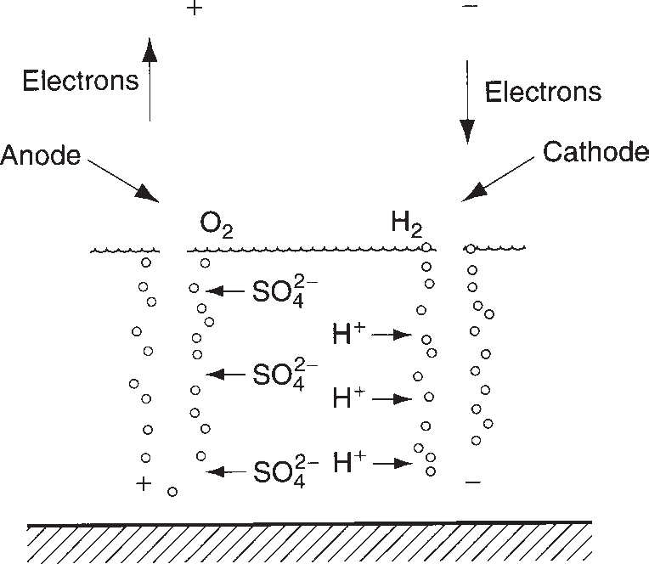

**FIGURE 4.3** Example of electrolysis: decomposition of water.

Section 4.4/Electrical Properties

**91**

In addition to the production of hydrogen and oxygen gases, as illustrated by the example, electrolysis is also used in several other industrial processes. Two examples are (1) ***electroplating*** (Section 27.3.1), an operation that adds a thin coating of one metal (e.g., chromium) to the surface of a second metal (e.g., steel) for decorative or other purposes; and (2) ***electrochemical machining*** (Section 25.2), a process in which material is removed from the surface of a metal part. Both these operations rely on electrolysis to either add or remove material from the surface of a metal part. In elec- troplating, the work part is set up in the electrolytic circuit as the cathode, so that the positive ions of the coating metal are attracted to the negatively charged part. In elec- trochemical machining, the work part is the anode, and a tool with the desired shape is the cathode. The action of electrolysis in this setup is to remove metal from the part surface in regions determined by the shape of the tool as it slowly feeds

into the work.

The two physical laws that determine the amount of material deposited or removed from a metallic surface were first stated by the British scientist Michael Faraday:

* + - 1. The mass of a substance liberated in an electrolytic cell is proportional to the quantity of electricity passing through the cell.
      2. When the same quantity of electricity is passed through different electrolytic cells, the masses of the substances liberated are proportional to their chemical equivalents.

# **5** Measurement

**95**

Dimensions, Surfaces, and their

In addition to mechanical and physical properties of materials, other factors that determine the perform- ance of a manufactured product include the dimen- sions and surfaces of its components. ***Dimensions*** are the linear or angular sizes of a component specified on the part drawing. Dimensions are important because they determine how well the components of a product fit together during assembly. When fabricating a given component, it is nearly impossible and very costly to make the part to the exact dimension given on the

Chapter Contents

* 1. Dimensions, Tolerances, and Related Attributes
     1. Dimensions and Tolerances
     2. Other Geometric Attributes
  2. Conventional Measuring Instruments and Gages
     1. Precision Gage Blocks
     2. Measuring Instruments for Linear Dimensions
     3. Comparative Instruments
     4. Fixed Gages
     5. Angular Measurements
  3. Surfaces
     1. Characteristics of Surfaces
     2. Surface Texture
     3. Surface Integrity
  4. Measurement of Surfaces
     1. Measurement of Surface Roughness
     2. Evaluation of Surface Integrity
  5. Effect of Manufacturing Processes

drawing. Instead a limited variation is allowed from the dimension, and that allowable variation is called a ***tolerance***.

The surfaces of a component are also important. They affect product performance, assembly fit, and aesthetic appeal that a potential customer might have for the product. A ***surface*** is the exterior boundary of an object with its surroundings, which may be another object, a fluid, or space, or combinations of these. The surface encloses the object’s bulk mechanical and physical properties.

This chapter covers dimensions, tolerances, and surfaces—three attributes specified by the product designer and determined by the manufacturing proc- esses that make the parts and products. It also consid- ers how these attributes are assessed using measuring and gaging devices. Closely related topics are quality control and inspection, covered in Chapter 40.

#### Dimensions, Tolerances, and Related Attributes

**5.**

The basic parameters used by design engineers to specify sizes of geometric features on a part drawing are defined in this section. The parameters include dimensions and tolerances, flatness, roundness, and angularity.

* + 1. DIMENSIONS AND TOLERANCES

ANSI [3] defines a ***dimension*** as “a numerical value expressed in appropriate units of measure and indicated on a drawing and in other documents along with lines, symbols, and notes to define the size or geometric characteristic, or both, of a part or part feature.” Dimensions on part drawings represent nominal or basic sizes of the part and its features. These are the values that the designer would like the part size to be, if the part could be made to an exact size with no errors or variations in the fabrication process. However, there are variations in the manu- facturing process, which are manifested as variations in the part size. Tolerances are used to define the limits of the allowed variation. Quoting again from the ANSI standard [3], a ***tolerance*** is “the total amount by which a specific dimension is permitted to vary. The tolerance is the difference between the maximum and minimum limits.” Tolerances can be specified in several ways, illustrated in Figure 5.1. Probably most common is the ***bilateral tolerance***, in which the variation is permitted in both positive and negative directions from the nominal dimension. For example, in Figure 5.1(a), the nominal dimension = 2.500 linear units (e.g., mm, in), with an allowable variation of

0.005 units in either direction. Parts outside these limits are unacceptable. It is pos- sible for a bilateral tolerance to be unbalanced; for example, 2.500 + 0.010, -0.005 dimensional units. A ***unilateral tolerance*** is one in which the variation from the speci- fied dimension is permitted in only one direction, either positive or negative, as in Figure 5.1(b). ***Limit dimensions*** are an alternative method to specify the permissible variation in a part feature size; they consist of the maximum and minimum dimensions allowed, as in Figure 5.1(c).

* + 1. OTHER GEOMETRIC ATTRIBUTES

Dimensions and tolerances are normally expressed as linear (length) values. There are other geometric attributes of parts that are also important, such as flatness of a surface, roundness of a shaft or hole, parallelism between two surfaces, and so on. Definitions of these terms are listed in Table 5.1.

**FIGURE 5.1** Three

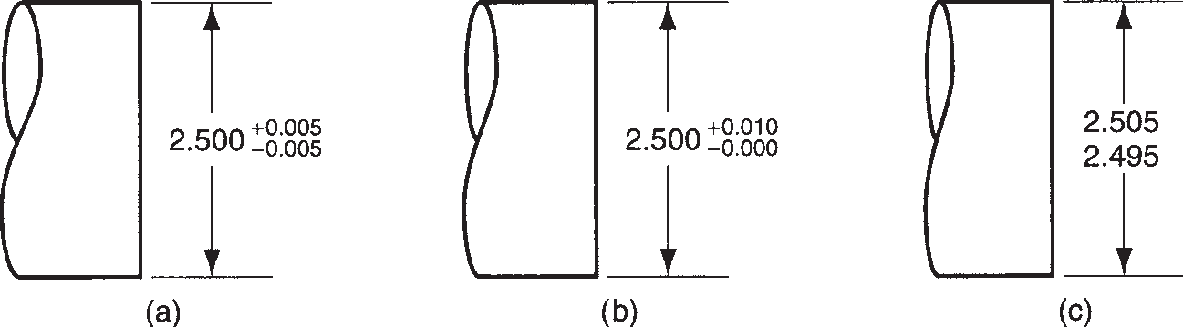

ways to specify tolerance limits for a nominal dimension of 2.500: (a) bilateral, (b) unilateral, and (c) limit dimensions.

**TABLE** • **5.1** Definitions of geometric attributes of parts.



***Angularity***—The extent to which a part feature such as a surface or axis is at a specified angle relative to a reference surface. If the angle = 90°, then the attribute is called perpendicularity or squareness.

***Circularity***—For a surface of revolution such as a cylinder, circular hole, or cone, circularity is the degree to which all points on the intersection of the surface and a plane perpendicular to the axis of revolution are equidistant from the axis. For a sphere, circularity is the degree to which all points on the intersection of the surface and a plane passing through the center are equidistant from the center.

***Concentricity***—The degree to which any two (or more) part features such as a cylindrical surface and a circular hole have a common axis.

***Cylindricity***—The degree to which all points on a surface of revolution such as a cylinder are equidistant from the axis of revolution.

***Flatness***—The extent to which all points on a surface lie in a single plane.

***Parallelism***—The degree to which all points on a part feature such as a surface, line, or axis are equidistant from a reference plane or line or axis.

***Perpendicularity***—The degree to which all points on a part feature such as a surface, line, or axis are 90° from a reference plane or line or axis.

***Roundness***—Same as circularity.

***Squareness***—Same as perpendicularity.

***Straightness***—The degree to which a part feature such as a line or axis is a straight line.

#### Measuring Instruments and Gages

**5.2**

***Measurement*** is a procedure in which an unknown quantity is compared with a known standard, using an accepted and consistent system of units. Two systems of units have evolved in the world: (1) the U.S. customary system (U.S.C.S.), and (2) the International System of Units (or SI, for Systeme Internationale d’Unites), more popularly known as the metric system (Historical Note 5.1). Both systems are used in parallel throughout this book. The metric system is widely accepted in nearly every part of the industrialized world except the United States, which has stubbornly clung to its U.S.C.S. Gradually, the United States is adopting SI.



Measurement systems in ancient civilizations were basic linear measure of the Greeks was the ***finger*** (about based on dimensions of the human body. Egyptians 19 mm or 3/4 in), and 16 fingers equaled one ***foot.*** The developed the cubit as a linear measurement standard Romans adopted and adapted the Greek system, speci- around 3000 BCE. The ***cubit*** was defined as the length fically the foot, dividing it into 12 parts (called ***unciae***). of a human arm and hand from elbow to fingertip. The Romans defined five feet as a ***pace*** and 5000 feet Although there were difficulties due to variations in arm as a ***mile*** (such a nice round number, how did we end up lengths, the cubit was standardized in the form of a with 5280 feet in a mile?).

master cubit made of granite.This standard cubit, which During medieval Europe, various national and re- measured 524 mm (26.6 in), was used to produce other gional measurement systems developed, many of cubit sticks throughout Egypt. The standard cubit was them based on the Roman standards. Two primary divided into ***digits*** (a human finger width), with 28 dig- systems emerged in the Western world, the English

***hand***. Thus, a system of measures and standards was defined the ***yard*** “as the distance from the thumb

world passed to the Greeks and then the Romans. The 12 ***inches***. The American colonies were tied to England,

and it was therefore natural for the United States to of course). Multiples and subdivisions of the meter adopt the same system of measurements at the time were based on Greek prefixes.

of its independence. This became the U.S. customary Dissemination of the metric system throughout system (U.S.C.S.). Europe during the early 1800s was encouraged by the The initial proposal for the metric system is cred- military successes of French armies under Napoleon. In ited to vicar G. Mouton of Lyon, France around 1670. other parts of the world, adoption of the metric system His proposal included three important features that occurred over many years and was often motivated by were subsequently incorporated into the metric significant political changes. This was the case in Japan,

standards: (1) the basic unit was defined in terms of China, the Soviet Union (Russia), and Latin America.

a measurement of the Earth, which was presumed An act of British Parliament in 1963 redefined the constant;

1. the units were subdivided decimally; and English system of weights and measures in terms of
2. units had rational prefixes. Mouton’s proposal was metric units and mandated a changeover to metric discussed and debated among scientists in France for two years later, thus aligning Britain with the rest of the next 125 years. A result of the French Revolution Europe and leaving the United States as the only major was the adoption of the metric system of weights industrial nation that was nonmetric. In 1960, an inter- and measures (in 1795). The basic unit of length was national conference on weights and measures in Paris the ***meter***, which was then defined as 1/10,000,000 reached agreement on new standards based on the of the length of the meridian between the North metric system. Thus the metric system became the Pole and the Equator, and passing through Paris (but Systeme Internationale (SI).

Measurement provides a numerical value of the quantity of interest, within cer- tain limits of accuracy and precision. ***Accuracy*** is the degree to which the measured value agrees with the true value of the quantity of interest. A measurement proce- dure is accurate when it is absent of systematic errors, which are positive or negative deviations from the true value that are consistent from one measurement to the next. ***Precision*** is the degree of repeatability in the measurement process. Good precision means that random errors in the measurement procedure are minimized. Random errors are usually associated with human participation in the measurement process. Examples include variations in the setup, imprecise reading of the scale, round-off approximations, and so on. Nonhuman contributors to random error include tem- perature changes, gradual wear and/or misalignment in the working elements of the device, and other variations.

Closely related to measurement is gaging. ***Gaging*** (also spelled ***gauging***) deter- mines simply whether the part characteristic meets or does not meet the design spec- ification. It is usually faster than measuring, but scant information is provided about the actual value of the characteristic of interest.

This section considers the variety of manually operated measuring instruments and gages used to evaluate dimensions such as length and diameter, as well as fea- tures such as angles, straightness, and roundness. This type of equipment is found in metrology labs, inspection departments, and tool rooms. The logical starting topic is precision gage blocks.

* + 1. PRECISION GAGE BLOCKS

Precision gage blocks are the standards against which other dimensional measuring instruments and gages are compared. Gage blocks are usually square or rectangu- lar. The measuring surfaces are finished to be dimensionally accurate and parallel to

within several millionths of an inch and are polished to a mirror finish. Several grades of precision gage blocks are available, with closer tolerances for higher precision grades. The highest grade—the ***master laboratory standard***—is made to a tolerance of

±0.000,03 mm (±0.000,001 in). Depending on degree of hardness desired and price the user is willing to pay, gage blocks can be made out of any of several hard materi- als, including tool steel, chrome-plated steel, chromium carbide, or tungsten carbide.

Precision gage blocks are available in certain standard sizes or in sets, the latter containing a variety of different-sized blocks. The sizes in a set are systematically determined so they can be stacked to achieve virtually any dimension desired to within 0.0025 mm (0.0001 in).

For best results, gage blocks must be used on a flat reference surface, such as a surface plate. A ***surface plate*** is a large solid block whose top surface is finished to a flat plane. Most surface plates today are made of granite. Granite has the advantage of being hard, non-rusting, nonmagnetic, long wearing, thermally stable, and easy to maintain.

Gage blocks and other high-precision measuring instruments must be used under standard conditions of temperature and other factors that might adversely affect the measurement. By international agreement, 20°C (68°F) has been established as the standard temperature. Metrology labs operate at this standard. If gage blocks or other measuring instruments are used in a factory environment in which the temperature differs from this standard, corrections for thermal expansion or contraction may be required. Also, working gage blocks used for inspection in the shop are subject to wear and must be calibrated periodically against more precise laboratory gage blocks.

* + 1. MEASURING INSTRUMENTS FOR LINEAR DIMENSIONS

Measuring instruments can be divided into two types: graduated and nongraduated. ***Graduated measuring devices*** include a set of markings (called ***graduations***) on a linear or angular scale to which the object’s feature of interest can be compared for measurement. ***Nongraduated measuring devices*** possess no such scale and are used to make comparisons between dimensions or to transfer a dimension for measure- ment by a graduated device.

The most basic of the graduated measuring devices is the ***rule*** (made of steel, and often called a ***steel rule***), used to measure linear dimensions. Rules are available in various lengths. Metric rule lengths include 150, 300, 600, and 1000 mm, with gradu- ations of 1 or 0.5 mm. Common U.S. sizes are 6, 12, and 24 in, with graduations of 1/32, 1/64, or 1/100 in.

***Calipers*** are available in either nongraduated or graduated styles. A nongradu- ated caliper (referred to simply as a ***caliper***) consists of two legs joined by a hinge mechanism, as in Figure 5.2. The ends of the legs are made to contact the surfaces of the object being measured, and the hinge is designed to hold the legs in position during use. The contacts point either inward or outward. When they point inward, as in Figure 5.2, the instrument is an ***outside caliper*** and is used for measuring out- side dimensions such as a diameter. When the contacts point outward, it is an ***inside caliper***, which is used to measure the distance between two internal surfaces. An instrument similar in configuration to the caliper is a ***divider***, except that both legs are straight and terminate in hard, sharply pointed contacts. Dividers are used for scaling distances between two points or lines on a surface, and for scribing circles or arcs onto a surface.

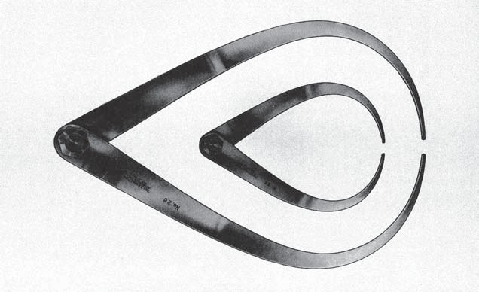**FIGURE 5.2** Two sizes of outside calipers. (Courtesy of L. S. Starrett Co.)

**FIGURE 5.3** Slide

caliper, opposite sides of instrument shown. (Courtesy of L. S. Starrett Co.)

A variety of graduated calipers are available for various measurement purposes. The simplest is the ***slide caliper***, which consists of a steel rule to which two jaws are added, one fixed at the end of the rule and the other movable, shown in Figure 5.3. Slide calipers can be used for inside or outside measurements, depending on whether the inside or outside jaw faces are used. In use, the jaws are forced into contact with the part surfaces to be measured, and the location of the movable jaw indicates the

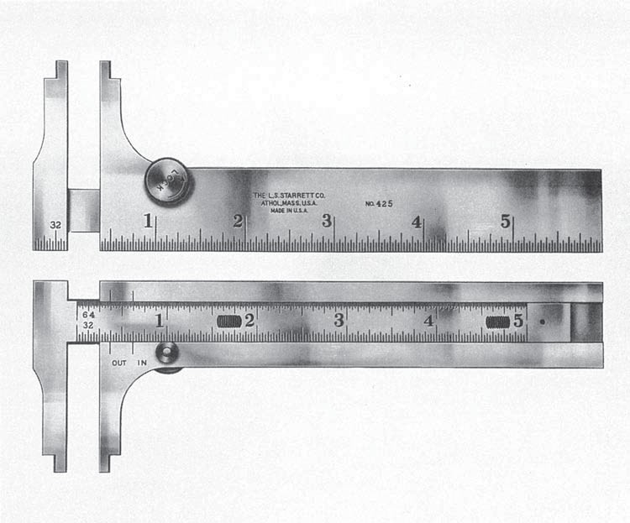

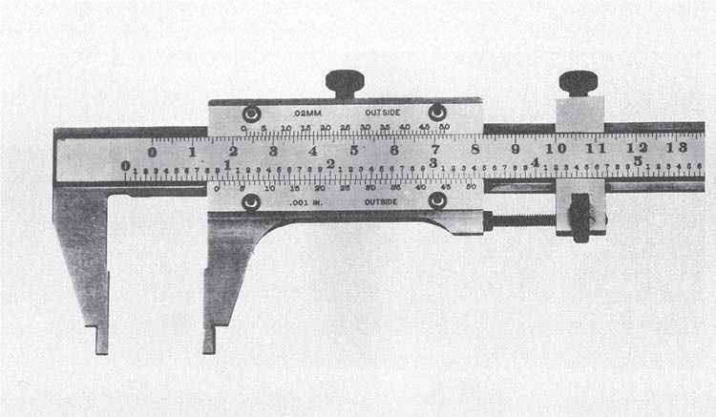**FIGURE 5.4** Vernier caliper. (Courtesy of L. S. Starrett Co.)

**FIGURE 5.5** External micrometer, standard 1-in size with digital readout. (Courtesy of L. S. Starrett Co.)

dimension of interest. Slide calipers permit more accurate and precise measurements than simple rules. A refinement of the slide caliper is the ***vernier caliper***, shown in Figure

* 1. In this device, the movable jaw includes a vernier scale, named after P. Vernier (1580–1637), a French mathematician who invented it. The vernier provides graduations of 0.01 mm in the SI (and 0.001 inch in the U.S. customary scale), much more precise than the slide caliper.

The ***micrometer*** is a widely used and very accurate measuring device, the most com- mon form of which consists of a spindle and a C-shaped anvil, as in Figure 5.5. The spindle is moved relative to the fixed anvil by means of an accurate screw thread. On a typical U.S. micrometer, each rotation of the spindle provides 0.025 in of linear travel. Attached to the spindle is a thimble graduated with 25 marks around its circumference,

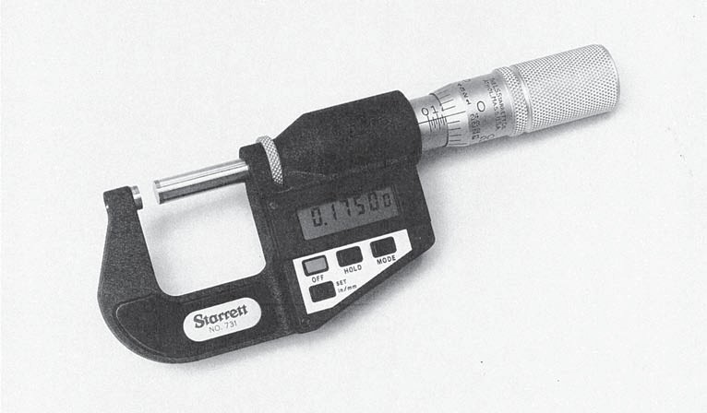

each mark corresponding to 0.001 in. The micrometer sleeve is usually equipped with a vernier, allowing resolutions as close as 0.0001 in. On a micrometer with metric scale, graduations are 0.01 mm. Modern micrometers (and graduated calipers) are available with electronic devices that display a digital readout of the measurement (as in the figure). These instruments are easier to read and eliminate much of the human error associated with reading conventional graduated devices.

The most common micrometer types are (1) ***external micrometer***, Figure 5.5, also called an ***outside micrometer***, which comes in a variety of standard anvil sizes; (2) ***internal micrometer***, or ***inside micrometer***, which consists of a head assembly and a set of rods of different lengths to measure various inside dimensions that might be encountered; and (3) ***depth micrometer***, similar to an inside micrometer but adapted to measure hole depths.

* + 1. COMPARATIVE INSTRUMENTS

Comparative instruments are used to make dimensional comparisons between two objects, such as a work part and a reference surface. They are usually not capable of providing an absolute measurement of the quantity of interest; instead, they measure the magnitude and direction of the deviation between two objects. Instruments in this category include mechanical and electronic gages.

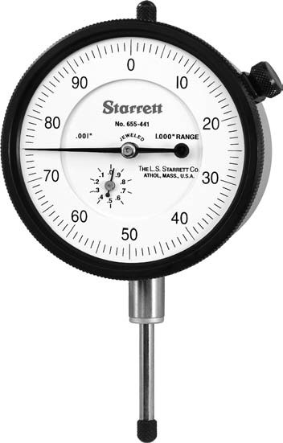**Mechanical Gages: Dial Indicators *Mechanical gages*** are designed to mechani- cally magnify the deviation to permit observation. The most common instrument in this category is the ***dial indicator***, Figure 5.6, which converts and amplifies the linear movement of a contact pointer into rotation of a dial needle. The dial is graduated in

**FIGURE 5.6** Dial indicator showing dial and graduated face. (Courtesy of L. S. Starrett Co.)

**FIGURE 5.7** Dial

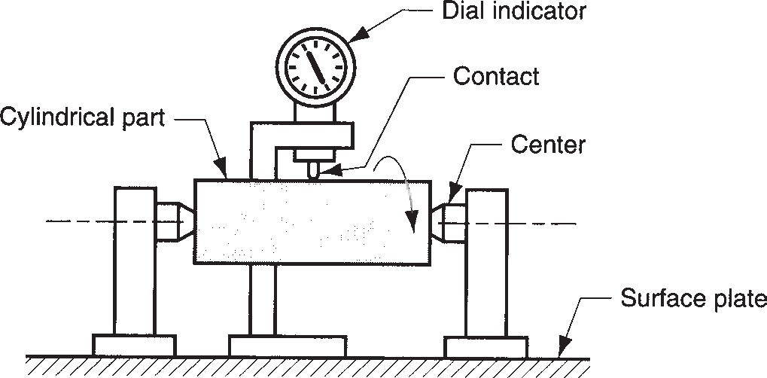

indicator setup to measure runout; as part is rotated about its center, variations in outside surface relative to center are indicated on the dial.

small units such as 0.01 mm (or 0.001 in). Dial indicators are used in many applications to measure straightness, flatness, parallelism, squareness, roundness, and run-out. A typical setup for measuring run-out is illustrated in Figure 5.7.

**Electronic Gages** Electronic gages are a family of measuring and gaging instru- ments based on transducers capable of converting a linear displacement into an electrical signal. The electrical signal is then amplified and transformed into a suita- ble data format such as a digital readout, as in Figure 5.5. Applications of electronic gages have grown rapidly in recent years, driven by advances in microprocessor technology. They are gradually replacing many of the conventional measuring and gaging devices. Advantages of electronic gages include (1) good sensitivity, accu- racy, precision, repeatability, and speed of response; (2) ability to sense very small dimensions—down to 0.025 *m*m (1 *m*-in.); (3) ease of operation; (4) reduced human error;

(5) electrical signal that can be displayed in various formats; and (6) capabil- ity to be interfaced with computer systems for data processing.

* + 1. FIXED GAGES

A fixed gage is a physical replica of the part dimension to be assessed. There are two basic categories: master gage and limit gage. A ***master gage*** is fabricated to be a direct replica of the nominal size of the part dimension. It is generally used for set- ting up a comparative measuring instrument, such as a dial indicator; or for calibrat- ing a measuring device.

A ***limit gage*** is fabricated to be a reverse replica of the part dimension and is designed to check the dimension at one or more of its tolerance limits. A limit gage often consists of two gages in one piece, the first for checking the lower limit of the tolerance on the part dimension, and the other for checking the upper limit. These gages are popularly known as ***GO/NO-GO gages***, because one gage limit allows the part to be inserted, whereas the other limit does not. The ***GO limit*** is used to check the dimension at its maximum material condition; this is the minimum size for an internal feature such as a hole, and it is the maximum size for an external fea- ture such as an outside diameter. The ***NO-GO limit*** is used to inspect the minimum material condition of the dimension in question.

Common limit gages are snap gages and ring gages for checking outside part dimensions, and plug gages for checking inside dimensions. A ***snap gage*** consists of a C-shaped frame with gaging surfaces located in the jaws of the frame, as in

**FIGURE 5.8** Snap gage for measuring diameter of a part; difference in height of GO and NO-GO gage buttons is exaggerated.

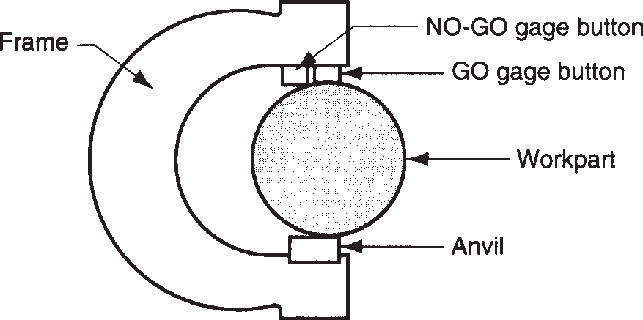

Figure 5.8. It has two gage buttons, the first being the GO gage, and the second being the NO-GO gage. Snap gages are used for checking outside dimensions such as diameter, width, thickness, and similar surfaces.

***Ring gages*** are used for checking cylindrical diameters. For a given application, a pair of gages is usually required, one GO and the other NO-GO. Each gage is a ring whose opening is machined to one of the tolerance limits of the part diameter. For ease of handling, the outside of the ring is knurled. The two gages are distinguished by the presence of a groove around the outside of the NO-GO ring.

The most common limit gage for checking hole diameter is the ***plug gage***. The typical gage consists of a handle to which are attached two accurately ground cylin- drical pieces (plugs) of hardened steel, as in Figure 5.9. The cylindrical plugs serve as the GO and NO-GO gages. Other gages similar to the plug gage include ***taper gages***, consisting of a tapered plug for checking tapered holes; and ***thread gages***, in which the plug is threaded for checking internal threads on parts.

A wear allowance is usually added to the GO limit (maximum material condition) of fixed gages, especially ones that are used frequently. This allowance is expected to account for gradual wearing of the gage GO surface against the part surfaces that are being checked. The wear allowance is typically specified as a percent that is applied to the total tolerance band of the part dimension of interest.

|  |  |
| --- | --- |
| Example 5.1 Wear allowance on a fixed gage | A GO/NO GO plug gage is designed to check a hole diameter that is dimensioned 20.00 mm ± 0.10 mm. A wear allowance of 2.5% of the total tolerance band is applied to the GO side of the gage. Determine the nominal sizes of the GO and NO GO sides of the gage.  **Solution:** The total tolerance band = 0.10 + 0.10 = 0.20 mm. The wear allowance = 0.025(0.20) = 0.005 mm. The GO gage is used to check the minimum acceptable hole diameter, which is 20.00 - 0.10 = 19.90 mm. Because this is the surface that will wear, the wear allowance is applied to it. Accordingly, the nominal size of the GO gage = 19.90 + 0.005 = 19.905 mm.  The NO GO gage is used to check the maximum hole diameter. Because insertion of the gage will occur only in an out-of-tolerance situation, its wear should be negligible. Therefore, the nominal size of the NO GO gage =  20.00 + 0.10 = 20.10 mm. |
|  |

**FIGURE 5.9** Plug gage; difference in diameters of GO and NO-GO plugs is exaggerated.

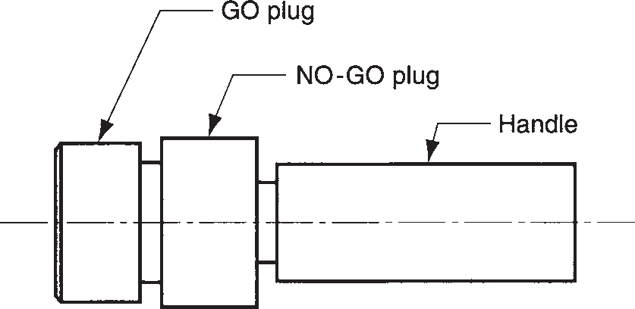

Fixed gages are easy to use, and the time required to complete an inspection is almost always less than when a measuring instrument is employed. Fixed gages were a fundamental element in the development of interchangeable parts manufacturing (Historical Note 1.1). They provided the means by which parts could be made to tolerances that were sufficiently close for assembly without filing and fitting. Their disadvantage is that they provide little if any information on the actual part size; they only indicate whether the size is within tolerance. Today, with the availability of high- speed electronic measuring instruments, and with the need for statistical proc- ess control of part sizes, use of gages is gradually giving way to instruments that provide actual measurements of the dimension of interest.

* + 1. ANGULAR MEASUREMENTS

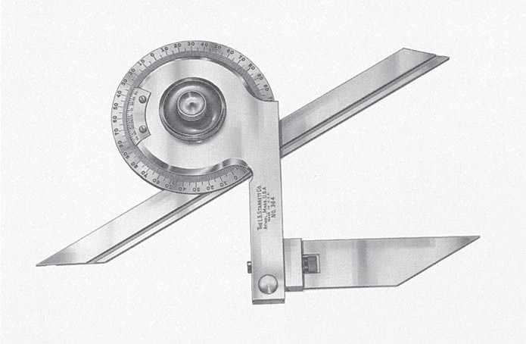Angles can be measured using any of several styles of ***protractor***. A ***simple protrac- tor*** consists of a blade that pivots relative to a semicircular head that is graduated in angular units (e.g., degrees, radians). To use, the blade is rotated to a position corresponding to some part angle to be measured, and the angle is read off the angular scale. A ***bevel protractor***, Figure 5.10, consists of two straight blades that

**FIGURE 5.10** Bevel

protractor with vernier scale. (Courtesy of L. S. Starrett Co.)

**FIGURE 5.11** Setup for using a sine bar.

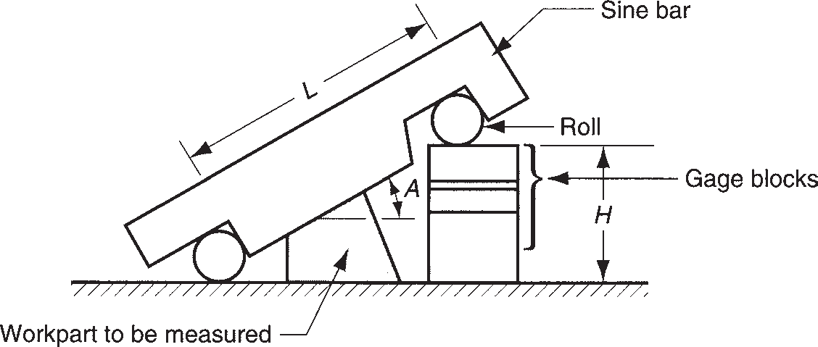

pivot relative to each other. The pivot assembly has a protractor scale that permits the angle formed by the blades to be read. When equipped with a vernier, the bevel protractor can be read to about 5 min; without a vernier the resolution is only about 1 degree.

High precision in angular measurements can be made using a ***sine bar***, illustrated in Figure 5.11. One possible setup consists of a flat steel straight edge (the sine bar), and two precision rolls set a known distance apart on the bar. The straight edge is aligned with the part angle to be measured, and gage blocks are used or other accurate linear measurements are made to determine height. The proce- dure is carried out on a surface plate to achieve the most accurate results. This height *H* and the length *L* of the sine bar between rolls are used to calculate the angle *A* using

sin *A* = *H* (5.2)

*L*

|  |  |
| --- | --- |
| Example 5.2 Sine bar measurement | A sine bar that is 200.00 mm long is used to measure the angle on a part in a setup similar to that in Figure 5.11. Gage blocks are stacked to a height of  40.380 mm. Determine the angle of interest.  **Solution:** sin *A* = 40.38 = 0.2019, *A* = sin-1(0.2019) = 11.64°.  200.00 |
|  |

#### Surfaces

**5.3**

A surface is what one touches when holding an object such as a manufactured part. The designer specifies the part dimensions, relating the various surfaces to each other. These ***nominal surfaces***, representing the intended surface contour of the part, are defined by lines in the engineering drawing. The nominal surfaces appear as absolutely straight lines, ideal circles, round holes, and other edges and surfaces that are geometrically perfect. The actual surfaces of a manufactured part are deter- mined by the processes used to make it. The variety of processes available in manu- facturing result in wide variations in surface characteristics, and it is important for engineers to understand the technology of surfaces.

Surfaces are commercially and technologically important for a number of reasons, different reasons for different applications: (1) Aesthetic reasons—surfaces that are smooth and free of scratches and blemishes are more likely to give a favorable impression to the customer. (2) Surfaces affect safety. (3) Friction and wear depend on surface characteristics. (4) Surfaces affect mechanical and physical properties; for example, surface flaws can be points of stress concentration. (5) Assembly of parts is affected by their surfaces; for example, the strength of adhesively bonded joints (Section 30.3) is increased when the surfaces are slightly rough. (6) Smooth surfaces make better electrical contacts.

***Surface technology*** is concerned with (1) defining the characteristics of a surface,

(2) surface texture, (3) surface integrity, and (4) the relationship between manufac- turing processes and the characteristics of the resulting surface. The first three topics are covered in this section, and the final topic is presented in Section 5.5.

* + 1. CHARACTERISTICS OF SURFACES

A microscopic view of a part’s surface reveals its irregularities and imperfections. The features of a typical surface are illustrated in the highly magnified cross sec- tion of the surface of a metal part in Figure 5.12. Although the discussion here is focused on metallic surfaces, these comments apply to ceramics and polymers, with modifications owing to differences in structure of these materials. The bulk of the part, referred to as the ***substrate***, has a grain structure that depends on previous processing of the metal; for example, the metal’s substrate structure is affected by its chemical composition, the casting process originally used on the metal, and any deformation operations and heat treatments performed on the casting. The exterior of the part is a surface whose topography is anything but straight and smooth. In this highly magnified cross section, the surface has roughness, wavi- ness, and flaws. Although not shown here, it also possesses a pattern and/or direction resulting from the mechanical process that produced it. All of these geometric fea-

tures are included in the term ***surface texture***.

Just below the surface is a layer of metal whose structure differs from that of the substrate. This is called the ***altered layer***, and it is a manifestation of the actions that have been visited upon the surface during its creation and after- ward. Manufacturing processes involve energy, usually in large amounts, which operates on the part against its surface. The altered layer may result from work hardening (mechanical energy), heating (thermal energy), chemical treatment, or even electrical energy. The metal in this layer is affected by the application

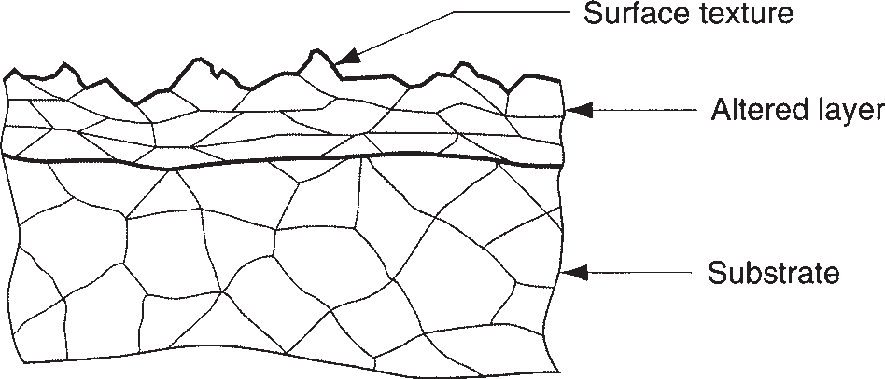

**FIGURE 5.12** A magnified cross section of a typical metallic part surface.

of energy, and its microstructure is altered accordingly. This altered layer falls within the scope of ***surface integrity***, which is concerned with the definition, specification, and control of the surface layers of a material (most commonly metals) in manufacturing and subsequent performance in service. The scope of surface integrity is usually interpreted to include surface texture as well as the altered layer beneath.

In addition, most metal surfaces are coated with an ***oxide film***, given sufficient time after processing for the film to form. Aluminum forms a hard, dense, thin film of Al2O3 on its surface (which serves to protect the substrate from corrosion), and iron forms oxides of several chemistries on its surface (rust, which provides virtually no protection at all). There is also likely to be moisture, dirt, oil, adsorbed gases, and other contaminants on the part’s surface.

* + 1. SURFACE TEXTURE

Surface texture consists of the repetitive and/or random deviations from the nomi- nal surface of an object; it is defined by four features: roughness, waviness, lay, and flaws, shown in Figure 5.13. ***Roughness*** refers to the small, finely spaced deviations from the nominal surface that are determined by the material characteristics and the process that formed the surface. ***Waviness*** is defined as the deviations of much larger spacing; they occur because of work deflection, vibration, heat treatment, and similar factors. Roughness is superimposed on waviness. ***Lay*** is the predominant direction or pattern of the surface texture. It is determined by the manufacturing method used to create the surface, usually from the action of a cutting tool. Figure 5.14 presents most of the possible lays a surface can take, together with the symbol used by a designer to specify them. Finally, ***flaws*** are irregularities that occur occasionally on the sur- face; these include cracks, scratches, inclusions, and similar defects in the surface. Although some of the flaws relate to surface texture, they also affect surface integrity (Section 5.3.3).

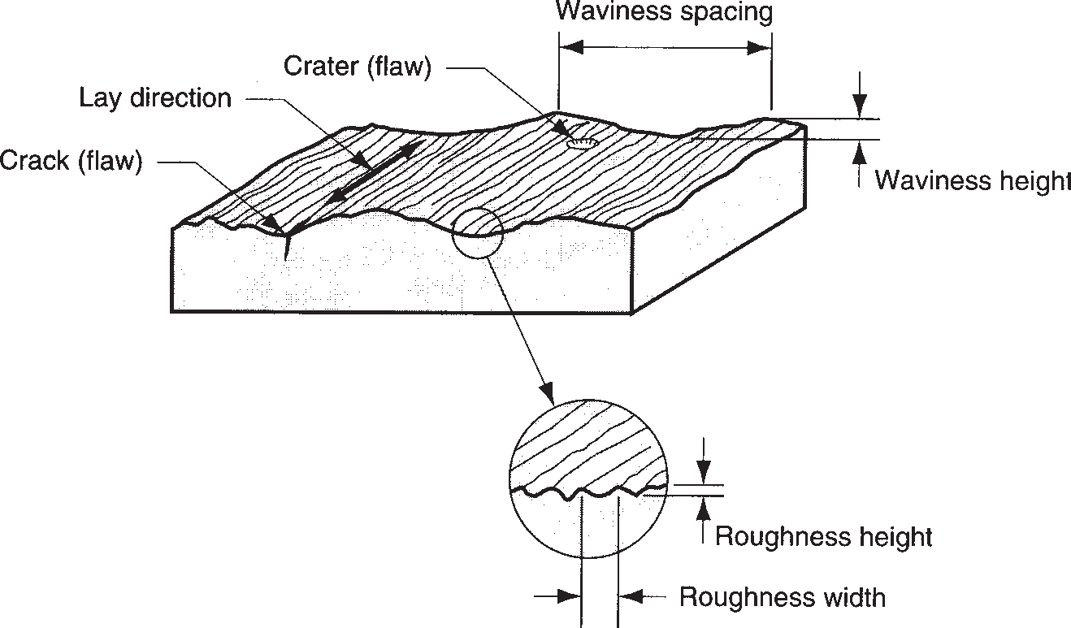

**FIGURE 5.13** Surface texture features.

**FIGURE 5.14** Possible lays of a surface. ([1]).

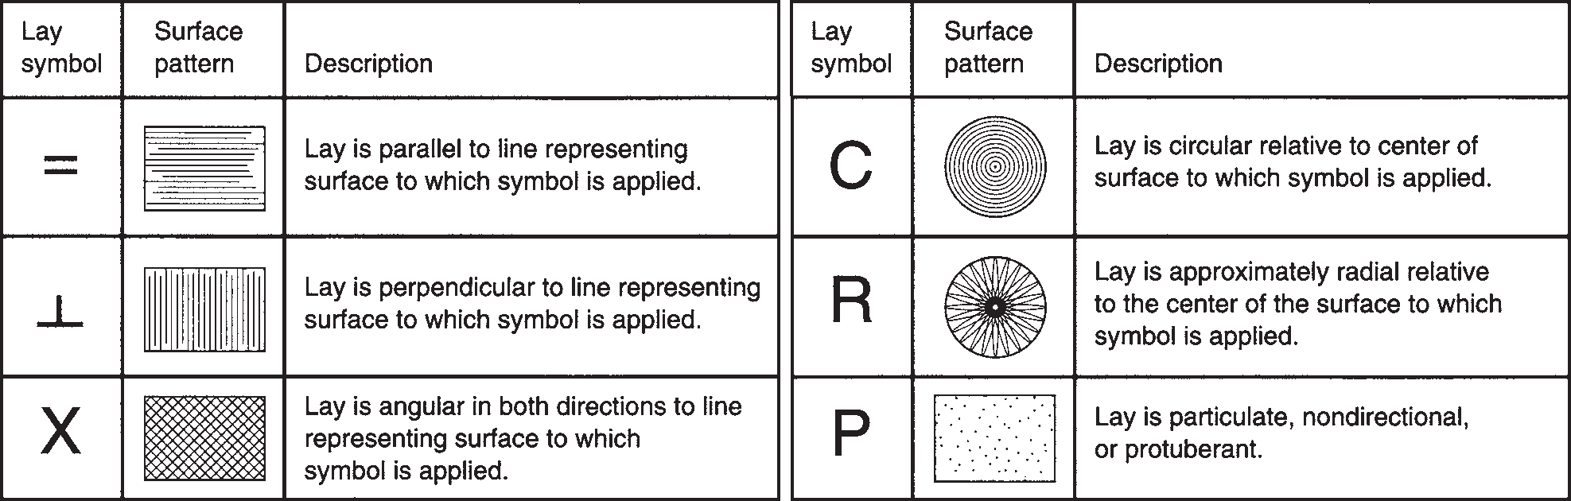

**Surface Roughness and Surface Finish** Surface roughness is a measurable characteristic based on the roughness deviations as defined above. ***Surface finish*** is a more subjective term denoting smoothness and general quality of a surface. In popular usage, surface finish is often used as a synonym for surface roughness.

The most commonly used measure of surface texture is surface roughness. With respect to Figure 5.15, ***surface roughness*** can be defined as the average of the vertical deviations from the nominal surface over a specified surface length. An arithmetic average (AA) is generally used, based on the absolute values of the deviations, and this roughness value is referred to by the name ***average roughness***. In equation form,

*Lm*

*Ra* = J

0

|*y*| *dx* (5.1)

*Lm*

where *Ra* = arithmetic mean value of roughness, m (in); *y* = the vertical deviation from nominal surface (converted to absolute value), m (in); and *Lm* = the speci- fied distance over which the surface deviations are measured. An approximation of Equation (5.1), perhaps easier to comprehend, is given by

*n* |*yi|*

z *n*

*Ra* =

*i*=1

(5.2)

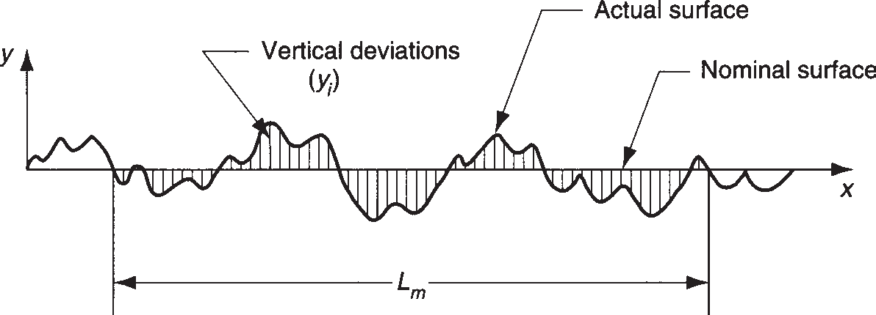**FIGURE 5.15**

Deviations from nominal surface used in the two definitions of surface roughness.

where *Ra* has the same meaning as above; *yi* = vertical deviations converted to abso- lute value and identified by the subscript *i*, m (in); and *n* = the number of deviations included in *Lm*. The units in these equations are meters and inches. In fact, the scale of the deviations is very small, so more appropriate units are *m*m (*m*m = m X 10-6 = mm X 10-3) or *m*-in (*m*-in = inch X 10-6). These are the units commonly used to express surface roughness.

The AA method is the most widely used averaging method for surface roughness today. An alternative, sometimes used in the United States, is the ***root-mean-square*** (RMS) average, which is the square root of the mean of the squared deviations over the measuring length. RMS surface roughness values will almost always be greater than the AA values because the larger deviations will figure more prominently in the calculation of the RMS value.

Surface roughness suffers the same kinds of deficiencies of any single measure used to assess a complex physical attribute. For example, it fails to account for the lay of the surface pattern; thus, surface roughness may vary significantly, depending on the direction in which it is measured.

Another deficiency is that waviness can be included in the *Ra* computation. To deal with this problem, a parameter called the ***cutoff length*** is used as a filter that separates the waviness in a measured surface from the roughness deviations. In effect, the cutoff length is a sampling distance along the surface. A sampling distance shorter than the waviness width will eliminate the vertical deviations associated with waviness and only include those associated with roughness. The most common cutoff length used in practice is 0.8 mm (0.030 in). The measuring length *Lm* is normally set at about five times the cutoff length.

The limitations of surface roughness have motivated the development of addi- tional measures that more completely describe the topography of a given surface. These measures include three-dimensional graphical renderings of the surface, as described in [17].

**Symbols for Surface Texture** Designers specify surface texture on an engineer- ing drawing by means of symbols as in Figure 5.16. The symbol designating surface texture parameters is a check mark (looks like a square root sign), with entries as indicated for average roughness, waviness, cutoff, lay, and maximum roughness spac- ing. The symbols for lay are from Figure 5.14.

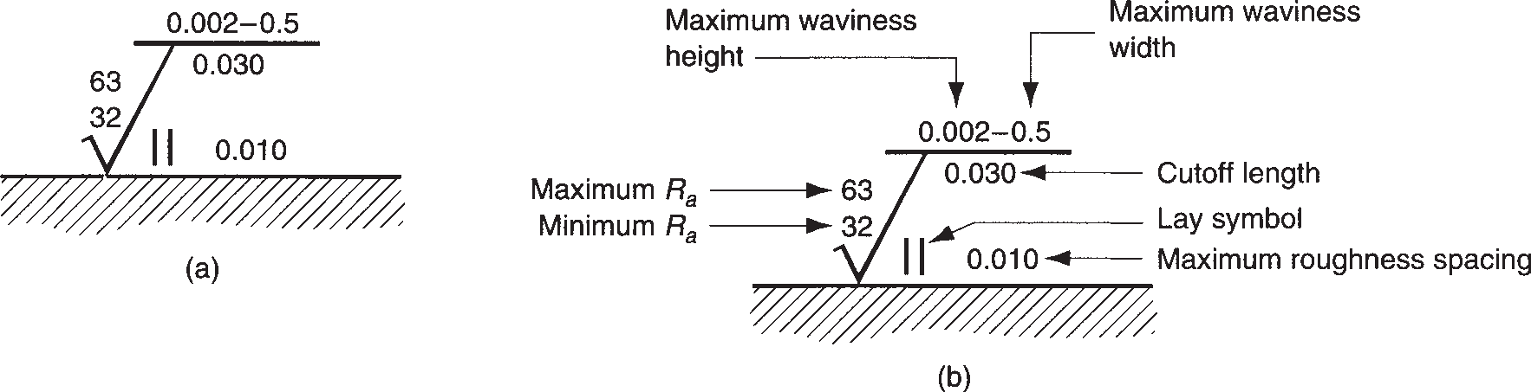

**FIGURE 5.16** Surface texture symbols in engineering drawings: (a) the symbol, and (b) symbol with identification labels. Values of *Ra* are given in microinches; units for other measures are given in inches. Designers do not always specify all of the parameters on engineering drawings.

* + 1. SURFACE INTEGRITY

Surface texture alone does not completely describe a surface. There may be metal- lurgical or other changes in the material immediately beneath the surface that can have a significant effect on its mechanical properties. ***Surface integrity*** is the study and control of this subsurface layer and any changes in it as a result of processing that may influence the performance of the finished part or product. This subsurface layer was previously referred to as the altered layer when its structure differs from the substrate, as in Figure 5.12.

The possible alterations and injuries to the subsurface layer that can occur in man- ufacturing are listed in Table 5.2. The surface changes are caused by the application of various forms of energy during processing—mechanical, thermal, chemical, and electrical. Mechanical energy is the most common form used in manufacturing; it is applied against the work material in operations such as metal forming (e.g., forging, extrusion), pressworking, and machining. Although its primary function in these proc- esses is to change the geometry of the work part, mechanical energy can also cause residual stresses, work hardening, and cracks in the surface layers. Table 5.3 indicates

**TABLE** • **5.2** Surface and subsurface alterations that define surface integrity.a



***Absorption*** are impurities that are absorbed and retained in surface layers of the base material, possibly leading to embrittlement or other property changes.

***Alloy depletion*** occurs when critical alloying elements are lost from the surface layers, with possible loss of properties in the metal.

***Cracks*** are narrow ruptures or separations either at or below the surface that alter the continuity of the material. Cracks are characterized by sharp edges and length-to-width ratios of 4:1 or more.

They are classified as macroscopic (can be observed with magnification of 10X or less) and microscopic (requires magnification of more than 10X).

***Craters*** are rough surface depressions left in the surface by short circuit discharges; associated with electrical processing methods such as electric dis- charge machining and electrochemical machining (Chapter 25).

***Hardness changes*** refer to hardness differences at or near the surface.

***Heat affected zone*** are regions of the metal that are affected by the application of thermal energy; the regions are not melted but are sufficiently heated that they undergo metallurgical changes that affect properties. Abbreviated HAZ, the effect is most prominent in fusion welding operations (Chapter 29).

***Inclusions*** are small particles of material incorporated into the surface layers during processing; they are a discontinuity in the base material. Their composition usually differs from the base material.

***Intergranular attack*** refers to various forms of chemical reaction at the surface, including intergranular corrosion and oxidation.

***Laps***, ***folds***, ***seams*** are irregularities and defects in the surface caused by plastic working of overlapping surfaces.

***Pits*** are shallow depressions with rounded edges formed by any of several mechanisms, including selective etching or corrosion; removal of surface inclusions; mechanically formed dents; or electrochemical action.

***Plastic deformation*** refers to microstructural changes from deforming the metal at the surface; it results in strain hardening.

***Recrystallization*** involves the formation of new grains in strain hardened metals; associated with heating of metal parts that have been deformed.

***Redeposited metal*** is metal that is removed from the surface in the molten state and then reattached prior to solidification.

***Resolidified metal*** is a portion of the surface that is melted during processing and then solidified without detaching from the surface. The name ***remelted metal*** is also used for resolidified metal. ***Recast metal*** is a term that includes both redeposited and resolidified metal.

***Residual stresses*** are stresses remaining in the material after processing.

***Selective etch*** is a form of chemical attack that concentrates on certain components in the base material.

a Compiled from [2].

|  |  |  |  |  |
| --- | --- | --- | --- | --- |
|  | **TABLE • 5.3** Forms of energy applied in manufacturing and the resulting possible surface and subsurface alterations that can occur.a | | | |
|  | **Mechanical** | **Thermal** | **Chemical** | **Electrical** |
| Residual stresses in subsurface layer | Metallurgical changes (recrystallization, grain size changes, phase changes at surface)  Redeposited or resolidified material  Heat-affected zone Hardness changes | Intergranular attack Chemical contamination | Changes in conductivity and/or magnetism |
| Cracks—microscopic and macroscopic  Plastic deformation Laps, folds, or seams | Absorption of elements such as H and Cl  Corrosion, pitting, and etching | Craters resulting from short circuits during certain electrical processing techniques |
| Voids or inclusions  Hardness variations (e.g., work hardening) | Dissolving of microconstituents  Alloy depletion |  |

a Based on [2].

the various types of surface and subsurface alterations that are attributable to the dif- ferent forms of energy applied in manufacturing. Most of the alterations in the table refer to metals, for which surface integrity has been most intensively studied.

#### Measurement of Surfaces

**5.4**

Surfaces are described as consisting of two parameters: (1) surface texture and

(2) surface integrity. This section is concerned with the measurement of these two parameters.

* + 1. MEASUREMENT OF SURFACE ROUGHNESS

Various methods are used to assess surface roughness. They can be divided into three categories: (1) subjective comparison with standard test surfaces, (2) stylus electronic instruments, and (3) optical techniques.

**Standard Test Surfaces** Sets of standard surface finish blocks are available, pro- duced to specified roughness values. To estimate the roughness of a given test speci- men, the surface is compared with the standard both visually and by the “fingernail test.” In this test, the user gently scratches the surfaces of the specimen and the stand- ards, judging which standard is closest to the specimen. Standard test surfaces are a convenient way for a machine operator to obtain an estimate of surface roughness. They are also useful for design engineers in judging what value of surface roughness to specify on a part drawing.

**Stylus Instruments** The disadvantage of the fingernail test is its subjectivity. Several stylus-type instruments are commercially available to measure surface roughness—similar to the fingernail test, but more scientific. An example is the instrument shown in Figure 5.17 tracing a standard test surface. In these elec- tronic devices, a cone-shaped diamond stylus with point radius of about 0.005 mm (0.0002 in) and 90° tip angle is traversed across the test surface at a constant slow speed. The operation is depicted in Figure 5.18. As the stylus head is traversed horizontally, it also moves vertically to follow the surface deviations. The vertical movement is converted into an electronic signal that represents the topography

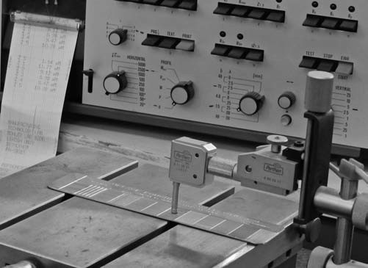**FIGURE 5.17** Stylus-type instrument for measuring surface roughness travers- ing a standard test surface. (Courtesy of George E. Kane Manufacturing Technology Laboratory, Lehigh University.)

of the surface. This can be displayed as either a profile of the actual surface or an average roughness value. ***Profiling devices*** use a separate flat plane as the nominal reference against which deviations are measured. The output is a plot of the sur- face contour along the line traversed by the stylus. This type of system can identify both roughness and waviness in the test surface. ***Averaging devices*** reduce the roughness deviations to a single value *Ra*. They use skids riding on the actual sur- face to establish the nominal reference plane. The skids act as a mechanical filter to reduce the effect of waviness in the surface; in effect, these averaging devices electronically perform the computations in Equation (5.1).

**Optical Techniques** Most other surface-measuring instruments employ optical techniques to assess roughness. These techniques are based on light reflectance from the surface, light scatter or diffusion, and laser technology. They are useful in appli- cations where stylus contact with the surface is undesirable. Some of the techniques permit very-high-speed operation, thus making 100% inspection feasible. However, the optical techniques yield values that do not always correlate well with roughness measurements made by stylus-type instruments.

* + 1. EVALUATION OF SURFACE INTEGRITY

Surface integrity is more difficult to assess than surface roughness. Some of the tech- niques to inspect for subsurface changes are destructive to the material specimen. Evaluation techniques for surface integrity include the following:

**FIGURE 5.18** Sketch illustrating the operation of stylus-type instrument. Stylus head traverses horizontally across surface, while stylus moves vertically to follow surface profile. Vertical movement is converted into either (1) a profile of the surface or (2) the average roughness value.

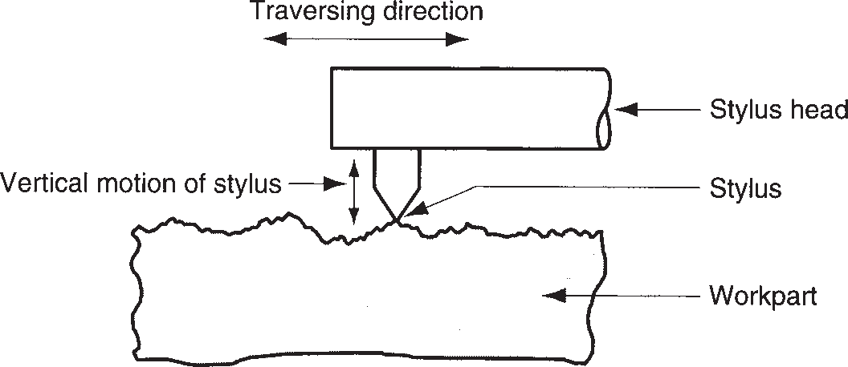

* + - * ***Surface texture***. Surface roughness, designation of lay, and other measures pro- vide superficial data on surface integrity. This type of testing is relatively simple to perform and is always included in the evaluation of surface integrity.
      * ***Visual examination***. Visual examination can reveal various surface flaws such as cracks, craters, laps, and seams. This type of assessment is often augmented by fluorescent and photographic techniques.
      * ***Microstructural examination***. This involves standard metallographic tech- niques for preparing cross sections and obtaining photomicrographs for exami- nation of microstructure in the surface layers compared with the substrate.
      * ***Microhardness profile***. Hardness differences near the surface can be detected using microhardness measurement techniques such as Knoop and Vickers (Section 3.2.1). The part is sectioned, and hardness is plotted against distance

below the surface to obtain a hardness profile of the cross section.

* + - * ***Residual stress profile***. X-ray diffraction techniques can be employed to meas- ure residual stresses in the surface layers of a part.

#### Effect of Manufacturing Processes

**5.5**

The ability to achieve a certain tolerance or surface is a function of the manufactur- ing process. This section describes the general capabilities of various processes in terms of tolerance and surface roughness and surface integrity.

Some manufacturing processes are inherently more accurate than others. Most machining processes are quite accurate, capable of tolerances of ±0.05 mm (±0.002 in) or better. By contrast, sand castings are generally inaccurate, and tolerances of 10 to 20 times those used for machined parts should be specified. In Table 5.4, we list a variety

processes.b



**Process Typical Tolerance**, **mm (in)**

Sand casting

Cast iron ±1.3 (±0.050)

Steel ±1.5 (±0.060)

Aluminum ±0.5 (±0.020)

Die casting ±0.12 (±0.005) Plastic molding:

Polyethylene ±0.3 (±0.010)

Polystyrene ±0.15 (±0.006) Machining:

Drilling, 6 mm (0.25 in) +0.08/-0.03 (+0.003/-0.001)

Milling ±0.08 (±0.003)

Turning ±0.05 (±0.002)

**Process**

Abrasive Grinding Lapping Honing

Nontraditional and thermal Chemical machining Electric discharge Electrochem. grind Electrochem. machine Electron beam cutting Laser beam cutting Plasma arc cutting

**Typical Tolerance**, **mm (in)**

±0.008 (±0.0003)

±0.005 (±0.0002)

±0.005 (±0.0002)

±0.08 (±0.003)

±0.025 (±0.001)

±0.025 (±0.001)

±0.05 (±0.002)

±0.08 (±0.003)

±0.08 (±0.003)

±1.3 (±0.050)

b Compiled from [4], [5], and other sources. For each process category, tolerances vary depending on process parameters. Also, tolerances increase with part size.

Section 5.4/Measurement of Surfaces

**115**

|  |  |  |  |  |  |  |
| --- | --- | --- | --- | --- | --- | --- |
|  | **TABLE** • **5.5** Surface roughness values produced by the various manufacturing processes.a | | | | | |
|  |  | **Typical** |  |  | **Typical** | **Roughness** |
| **Process** | **Finish** | **Roughness Range** b | **Process** | **Finish** | **Range b** |
| Casting:  Die casting | Good | 1–2 (30–65) | Abrasive: Grinding Honing Lapping Polishing Superfinish  Nontraditional: Chemical milling Electrochemical Electric discharge Electron beam Laser beam  Thermal:  Arc welding Flame cutting Plasma arc cutting | Very good Very good Excellent Excellent Excellent  Medium Good Medium Medium Medium  Poor Poor Poor | 0.1–2 (5–75)  0.1–1 (4–30)  0.05–0.5 (2–15)  0.1–0.5 (5–15)  0.02–0.3 (1–10)  1.5–5 (50–200)  0.2–2 (10–100)  1.5–15 (50–500)  1.5–15 (50–500)  1.5–15 (50–500)  5–25 (250–1000)  12–25 (500–1000)  12–25 (500–1000) |
| Investment | Good | 1.5–3 (50–100) |
| Sand casting | Poor | 12–25 (500–1000) |
| Metal forming: |  |  |
| Cold rolling | Good | 1–3 (25–125) |
| Sheet metal draw | Good | 1–3 (25–125) |
| Cold extrusion | Good | 1–4 (30–150) |
| Hot rolling | Poor | 12–25 (500–1000) |
| Machining: |  |  |
| Boring | Good | 0.5–6 (15–250) |
| Drilling | Medium | 1.5–6 (60–250) |
| Milling | Good | 1–6 (30–250) |
| Reaming | Good | 1–3 (30–125) |
| Shaping and planing | Medium | 1.5–12 (60–500) |
| Sawing | Poor | 3–25 (100–1000) |
| Turning | Good | 0.5–6 (15–250) |

a Compiled from [1], [2], and other sources.

b Roughness range values are given, *m*m (*m*-in). Roughness can vary significantly for a given process, depending on process parameters.

of manufacturing processes and indicate the typical tolerances for each process. Toler- ances are based on the process capability for the particular manufacturing operation, as defined in Section 40.2. The tolerance that should be specified is a function of part size; larger parts require more generous tolerances. The table lists tolerances for moderately sized parts in each processing category.

The manufacturing process determines surface finish and surface integrity. Some processes are capable of producing better surfaces than others. In general, process- ing cost increases with improvement in surface finish. This is because additional operations and more time are usually required to obtain increasingly better surfaces. Processes noted for providing superior finishes include honing, lapping, polishing, and superfinishing (Chapter 24). Table 5.5 indicates the usual surface roughness that can be expected from various manufacturing processes.

## Metals

**6**

Part II covers the four types of engineering materials:

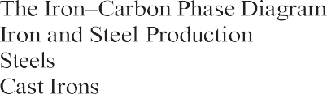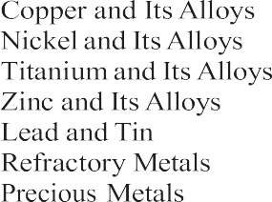

* 1. **Alloys and Phase Diagrams**

6.1.1

6.1.2

* 1. **Ferrous Metals**

6.2.1

6.2.2

6.2.3

6.2.4

* 1. **Nonferrous Metals**

6.3.1

6.3.2 Magnesium and Its Alloys 6.3.3

6.3.4

6.3.5

6.3.6

6.3.7

6.3.8

6.3.9

* 1. **Superalloys**

**118**

(1) metals, (2) ceramics, (3) polymers, and (4) composites. Metals are the most important engineering materials and the topic of this chapter. A ***metal*** is a category of materi- als generally characterized by properties of ductility, mal- leability, luster, and high electrical and thermal conduc- tivity. The category includes both metallic elements and their alloys. Metals have properties that satisfy a wide variety of design requirements. The manufacturing proc- esses by which they are shaped into products have been developed and refined over many years; indeed, some of the processes date from ancient times (Historical Note 1.2). In addition, the properties of metals can be en- hanced through heat treatment, covered in Chapter 26. The technological and commercial importance of metals derives from the following general properties

possessed by virtually all of the common metals:

* ***High stiffness and strength***. Metals can be alloyed for high rigidity, strength, and hardness; thus, they are

used to provide the structural framework for most engineered products.

* ***Toughness***. Metals have the capacity to absorb energy better than other classes of materials.
* ***Good electrical conductivity***. Metals are conduc- tors because of their metallic bonding that permits the free movement of electrons as charge carriers.
* ***Good thermal conductivity***. Metallic bonding also explains why metals generally conduct heat better than ceramics or polymers.

In addition, certain metals have specific properties that make them attractive for specialized applications. Many common metals are available at relatively low cost per unit weight and are often the material of choice simply because of their low cost.

Metals are converted into parts and products using a variety of manufacturing processes. The starting form of the metal differs, depending on the process. The major categories are (1) ***cast metal***, in which the initial form is a casting; (2) ***wrought metal***, in which the metal has been worked or can be worked (e.g., rolled or other- wise formed) after casting; better mechanical properties are generally associated with wrought metals compared with cast metals; and (3) ***powdered metal***, in which the metal is purchased in the form of very small powders for conversion into parts using powder metallurgy techniques. Most metals are available in all three forms. The discussion in this chapter focuses on categories (1) and (2), which are of greatest commercial and engineering interest. Powder metallurgy techniques are examined in Chapter 15.

Metals are classified into two major groups: (1) ***ferrous***—those based on iron; and (2) ***nonferrous***—all other metals. The ferrous group can be further subdivided into steels and cast irons. Most of the discussion in the present chapter is organized around this classification, but first the general topic of alloys and phase diagrams is introduced.

#### Alloys and Phase Diagrams

**6.**

Although some metals are important as pure elements (e.g., gold, silver, copper), most engineering applications require the improved properties obtained by alloying. Through alloying, it is possible to enhance strength, hardness, and other properties compared with pure metals. This section defines and classifies alloys; it then discusses phase diagrams which indicate the phases of an alloy system as a function of compo- sition and temperature.

* + 1. ALLOYS

An alloy is a metal composed of two or more elements, at least one of which is metal- lic. The two main categories of alloys are (1) solid solutions and (2) intermediate phases.

**Solid Solutions** A solid solution is an alloy in which one element is dissolved in another to form a single-phase structure. The term ***phase*** describes any homogeneous mass of material, such as a metal in which the grains all have the same crystal lattice structure. In a solid solution, the solvent or base element is metallic, and the dissolved element can be either metallic or nonmetallic. Solid solutions come in two forms, shown in Figure 6.1. The first is a ***substitutional solid solution***, in which atoms of the solvent element are replaced in its unit cell by the dissolved element. Brass is an example, in which zinc is dissolved in copper. To make the substitution, several rules must be satisfied ([3], [6], [7]): (1) the atomic radii of the two elements must be simi- lar, usually within 15%; (2) their lattice types must be the same; (3) if the elements have different valences, the lower valence metal is more likely to be the solvent; and

(4) if the elements have high chemical affinity for each other, they are less likely to form a solid solution and more likely to form a compound.

**FIGURE 6.1** Two forms of solid solutions:



* + - 1. substitutional solid solution, and
      2. interstitial solid solution. (a) (b)

The second type of solid solution is an ***interstitial solid solution***, in which atoms of the dissolving element fit into the vacant spaces between base metal atoms in the lattice structure. It follows that the atoms fitting into these interstices must be small compared with those of the solvent metal. The most important example of this second type is carbon dissolved in iron to form steel.

In both forms of solid solution, the alloy structure is generally stronger and harder than either of the component elements.

**Intermediate Phases** There are usually limits to the solubility of one element in another. When the amount of the dissolving element in the alloy exceeds the solid solubility limit of the base metal, a second phase forms in the alloy. The term ***inter- mediate phase*** is used to describe it because its chemical composition is intermediate between the two pure elements. Its crystalline structure is also different from those of the pure metals. Depending on composition, and recognizing that many alloys consist of more than two elements, these intermediate phases can be of several types, includ- ing (1) metallic compounds consisting of a metal and nonmetal such as Fe3C; and (2) intermetallic compounds—two metals that form a compound, such as Mg2Pb. The composition of the alloy is often such that the intermediate phase is mixed with the primary solid solution to form a two-phase structure, one phase dispersed throughout the second. These two-phase alloys are important because they can be formulated and heat-treated for significantly higher strength than solid solutions.

* + 1. PHASE DIAGRAMS

As the term is used in this text, a phase diagram is a graphical means of represent- ing the phases of a metal alloy system as a function of composition and temperature. Discussion of the diagram will be limited to alloy systems consisting of two elements at atmospheric pressures. This type of diagram is called a ***binary phase diagram***. Other forms of phase diagrams are discussed in texts on materials science, such as [6].

**The Copper–Nickel Alloy System** The best way to introduce the phase dia- gram is by example. Figure 6.2 presents one of the simplest cases, the Cu–Ni alloy system. Composition is plotted on the horizontal axis and temperature on the verti- cal axis. Thus, any point in the diagram indicates the overall composition and the phase or phases present at the given temperature. Pure copper melts at 1083°C (1981°F), and pure nickel at 1455°C (2651°F). Alloy compositions between these extremes exhibit gradual melting that commences at the solidus and concludes at the liquidus as temperature is increased.

The copper–nickel system is a solid solution alloy throughout its entire range of compositions. Anywhere in the region below the solidus line, the alloy is a solid

**FIGURE 6.2** Phase

Temperature,°C

Temperature,°F

diagram for the

0 10 20 30 40 50 60 70 80 90 100



3000

1600

Liquid solution

Liquid + solid

2800

140 0

Liquidus

2600

1260°C

2400

*L*

*C S*

120 0

Solidus

2200

20 00

1083°C

Solid solution

100 0

1800

26% 36% 62%

copper–nickel alloy Cu

system.

% Nickel (Ni) Ni

solution; there are no intermediate solid phases in this system. However, there is a mixture of phases in the region bounded by the solidus and liquidus. Recall from Section 4.1.3 that the solidus is the temperature at which the solid metal begins to melt as temperature is increased, and the liquidus is the temperature at which melting is completed. It can now be seen in the phase diagram that these tem- peratures vary with composition. Between the solidus and liquidus, the metal is a solid–liquid mix.

**Determining Chemical Compositions of Phases** Although the overall composition of the alloy is given by its position along the horizontal axis, the com- positions of the liquid and solid phases are not the same. It is possible to determine these compositions from the phase diagram by drawing a horizontal line at the tem- perature of interest. The points of intersection between the horizontal line and the solidus and liquidus indicate the compositions of the solid and liquid phases present, respectively. Simply construct the vertical projections from the intersection points to the *x*-axis and read the corresponding compositions.

|  |  |
| --- | --- |
| Example 6.1 Determining compositions from the phase diagram | Analyze the compositions of the liquid and solid phases present in the copper- nickel system at an aggregate composition of 50% nickel and a temperature of 1260°C (2300°F).  **Solution:** A horizontal line is drawn at the given temperature level as shown in Figure 6.2. The line intersects the solidus at a composition of 62% nickel, thus indicating the composition of the solid phase. The intersection with the liquidus occurs at a composition of 36% Ni, corresponding to the analysis of the liquid phase. |
|  |

As the temperature of the 50–50 Cu–Ni alloy is reduced, the solidus line is reached at about 1221°C (2230°F). Applying the same procedure used in the example, the composition of the solid metal is 50% nickel, and the composition of the last remain- ing liquid to freeze is about 26% nickel. How is it, the reader might ask, that the last ounce of molten metal has a composition so different from the solid metal into which it freezes? The answer is that the phase diagram assumes equilibrium condi- tions are allowed to prevail. In fact, the binary phase diagram is sometimes called an equilibrium diagram because of this assumption. What it means is that enough time is permitted for the solid metal to gradually change its composition by diffusion to achieve the composition indicated by the intersection point along the liquidus. In practice, when an alloy freezes (e.g., a casting), ***segregation*** occurs in the solid mass because of nonequilibrium conditions. The first liquid to solidify has a composition that is rich in the metal element with the higher melting point. Then as additional metal solidifies, its composition is different from that of the first metal to freeze. As the nucleation sites grow into a solid mass, compositions are distributed within the mass, depending on the temperature and time in the process at which freezing occurred. The overall composition is the average of the distribution.

**Determining Amounts of Each Phase** The amounts of each phase present at a given temperature can also be determined from the phase diagram. This is done by the ***inverse lever rule***: (1) using the same horizontal line as before that indicates the overall composition at a given temperature, measure the distances between the aggregate composition and the intersection points with the liquidus and solidus, identifying the distances as *CL* and *CS*, respectively (refer back to Figure 6.2);

1. the proportion of liquid phase present is given by

*L* phase proportion =  *CS*

(*CS* + *CL*)

1. the proportion of solid phase present is given by

*S* phase proportion =  *CL*

(*CS* + *CL*)

(6.1)

(6.2)

|  |  |
| --- | --- |
| Example 6.2 Determining proportions of each phase | Determine the proportions of liquid and solid phases for the 50% nickel composition of the copper–nickel system at the temperature of 1260°C (2300°F).  **Solution:** Using the same horizontal line in Figure 6.2 as in previous Example 6.1, the distances *CS* and *CL* are measured as 10 mm and 12 mm, respectively. Thus the proportion of the liquid phase is 10/22 = 0.45 (45%), and the proportion of solid phase is 12/22 = 0.55 (55%). |
|  |

The proportions given by Eqs. (6.1) and (6.2) are by weight, same as the phase diagram percentages. Note that the proportions are based on the distance on the opposite side of the phase of interest; hence the name inverse lever rule. One can see the logic in this by taking the extreme case when, say, *CS* = 0; at that point, the proportion of the liquid phase is zero because the solidus has been reached and the alloy is therefore completely solidified.

The methods for determining chemical compositions of phases and the amounts of each phase are applicable to the solid region of the phase diagram as well as the liquidus–solidus region. Wherever there are regions in the phase diagram in which two phases are present, these methods can be used. When only one phase is present (in Figure 6.2, this is the entire solid region), the composition of the phase is its aggregate composition under equilibrium conditions; and the inverse lever rule does not apply because there is only one phase.

**The Tin–Lead Alloy System** A more complicated phase diagram is the Sn–Pb system, shown in Figure 6.3. Tin–lead alloys have traditionally been used as solders for making electrical and mechanical connections (Section 30.2).1 The phase dia- gram exhibits several features not included in the previous Cu–Ni system. One fea- ture is the presence of two solid phases, alpha (*a*) and beta (*b*). The *a* phase is a solid solution of tin in lead at the left side of the diagram, and the *b* phase is a solid solu- tion of lead in tin that occurs only at elevated temperatures around 200°C (375°F) at the right side of the diagram. Between these solid solutions lies a mixture of the two solid phases, *a* + *b*.

Another feature of interest in the tin–lead system is how melting differs for dif- ferent compositions. Pure tin melts at 232°C (449°F), and pure lead melts at 327°C (621°F). Alloys of these elements melt at lower temperatures. The diagram shows two liquidus lines that begin at the melting points of the pure metals and meet at a composition of 61.9% Sn. This is the eutectic composition for the tin–lead system. In general, a ***eutectic alloy*** is a particular composition in an alloy system for which the solidus and liquidus are at the same temperature. The correspond- ing ***eutectic temperature***, the melting point of the eutectic composition, is 183°C (362°F) in the present case. The eutectic temperature is always the lowest melt- ing point for an alloy system (eutectic is derived from the Greek word ***eutektos***, meaning easily melted).

300

200

Temperature °C

100

600

500

Liquid

*α* + *L*

*β*

*β* + *L*

183°C 61.9% Sn

(362°F) (eutectic composition)

*α* + *β*

400

Temperature °F

300

200

100

**FIGURE 6.3** Phase

diagram for the tin–lead alloy system.

0 0

20 40 60 80

Pb % Tin (Sn) Sn

1Because lead is a poisonous substance, alternative alloying elements have been substituted for lead in many commercial solders. These are called lead-free solders.

|  |  |
| --- | --- |
|  | **TABLE** • **6.1** Basic data on the metallic elements: (a) iron. |
|  | Symbol: Fe Atomic number: 26  Specific gravity: 7.87 Crystal structure: BCC  Melting temperature: 1539°C (2802°F)  Elastic modulus: 209,000 MPa (30 X 106 lb/in2) Principal ore: ***Hematite*** (Fe2O3)  Alloying elements: Carbon; also chromium, manganese, nickel, molybdenum, vanadium, and silicon.  Typical applications: Construction, machinery, automotive, railway tracks and equipment. |

Compiled from [6], [11], [12], and other references.

Methods for determining the chemical analysis of the phases and the proportions of phases present can be readily applied to the Sn–Pb system just as it was used in the Cu–Ni system. In fact, these methods are applicable in any region containing two phases, including two solid phases. Most alloy systems are characterized by the existence of multiple solid phases and eutectic compositions, and so the phase dia- grams of these systems are often similar to the tin–lead diagram. Of course, many alloy systems are considerably more complex, for example, the iron-carbon system, considered next.

#### Ferrous Metals

**6.2**

The ferrous metals are based on iron, one of the oldest metals known to humans (Historical Note 6.1). The properties and other data relating to iron are listed in Table 6.1(a). The ferrous metals of engineering importance are alloys of iron and carbon. These alloys divide into two major groups: steel and cast iron. Together, they constitute approximately 85% of the metal tonnage in the United States [6]. The discussion of ferrous metals begins with the iron–carbon phase diagram.

**Historical Note 6.1** *Iron and steel*

Iron was discovered sometime during the Bronze was harder than bronze and that it took a sharper, Age. It was probably uncovered from ashes of fires stronger edge.

built near iron ore deposits. Use of the metal grew, During the Middle Ages in Europe, the invention finally surpassing bronze in importance. The Iron Age of the cannon created the first real demand for iron; is usually dated from about 1200 B.C.E, although ar- only then did it finally exceed copper and bronze in tifacts made of iron have been found in the Great usage. Also, the cast iron stove, the appliance of the Pyramid of Giza in Egypt, which dates to 2900 B.C.E. seventeenth and eighteenth centuries, significantly Iron-smelting furnaces have been discovered in Israel increased demand for iron (Historical Note 11.3). dating to 1300 B.C.E. Iron chariots, swords, and tools In the nineteenth century, industries such as rail- were made in ancient Assyria (northern Iraq) around roads, shipbuilding, construction, machinery, and the 1000 B.C.E. The Romans inherited ironworking from military created a dramatic growth in the demand their provinces, mainly Greece, and they developed for iron and steel in Europe and America. Although the technology to new heights, spreading it through- large quantities of (crude) ***pig iron*** could be pro- out Europe. The ancient civilizations learned that iron duced by ***blast furnaces***, the subsequent processes

for producing wrought iron and steel were slow. The When electricity became available in abundance necessity to improve productivity of these vital met- in the late 1800s, this energy source was used for als was the “mother of invention.” Henry Bessemer steelmaking. The first commercial ***electric furnace*** for in England developed the process of blowing air up production of steel was operated in France in 1899. through the molten iron that led to the ***Bessemer*** By 1920, this had become the principal process for ***converter*** (patented in 1856). Pierre and Emile Mar- making alloy steels.

tin in France built the first ***open hearth furnace*** in The use of pure oxygen in steelmaking was initiated 1864. These methods permitted up to 15 tons of just before World War II in several European countries steel to be produced in a single batch (heat), a sub- and the United States. Work in Austria after the war cul- stantial increase from previous methods. minated in the development of the ***basic oxygen fur-*** In the United States, expansion of the railroads ***nace*** (BOF). This has become the leading modern tech- after the Civil War created a huge demand for steel. nology for producing steel, surpassing the open hearth In the 1880s and 1890s, steel beams were first used method around 1970. The Bessemer converter had been in significant quantities in construction. Skyscrapers surpassed by the open hearth method around 1920 and came to rely on these steel frames. ceased to be a commercial steelmaking process in 1971.

* + 1. THE IRON–CARBON PHASE DIAGRAM

The iron–carbon phase diagram is shown in Figure 6.4. Pure iron melts at 1539°C (2802°F). During the rise in temperature from ambient, it undergoes several solid phase transformations as indicated in the diagram. Starting at room temperature the phase is alpha (*a*), also called ***ferrite***. At 912°C (1674°F), ferrite transforms to gamma (*g*), called ***austenite***. This, in turn, transforms at 1394°C (2541°F) to delta (*d*), which remains until melting occurs. The three phases are distinct; alpha and delta have BCC lattice structures (Section 2.3.1), and between them, gamma is FCC.

0



1800

Liquid (*L*)

320

*δ*

280

1400

240

*γ* + *L*

1000

*α* + *γ*

*L* + Fe3C

(2066°F)

200

*γ* + Fe3C Solid

160

*A*1

600

120

*α* + Fe3C Solid

800

200

400

0

0

0

Temperature, °C

Temperature, °F

0

0

**FIGURE 6.4** Phase

diagram for iron–carbon system, up to about 6% carbon.

0 1 2 3 4 5 6

Fe C

% Carbon (C)

Iron as a commercial product is available at various levels of purity. ***Electrolytic iron*** is the most pure, at about 99.99%, for research and other purposes where the pure metal is required. ***Ingot iron***, containing about 0.1% impurities (including about 0.01% carbon), is used in applications in which high ductility or corrosion resistance are needed. ***Wrought iron*** contains about 3% slag but very little carbon, and is easily shaped in hot forming operations such as forging.

Solubility limits of carbon in iron are low in the ferrite phase—only about 0.022% at 723°C (1333°F). Austenite can dissolve up to about 2.1% carbon at a temperature of 1130°C (2066°F). This difference in solubility between alpha and gamma leads to opportunities for strengthening by heat treatment, but leave that for Chapter 26. Even without heat treatment, the strength of iron increases dramatically as carbon content increases, and the metal is called steel. More precisely, ***steel*** is defined as an iron–carbon alloy containing from 0.02% to 2.11% carbon.2 Of course, steels can also contain other alloying elements as well.

The diagram indicates a eutectic composition at 4.3% carbon. There is a similar feature in the solid region of the diagram at 0.77% carbon and 723°C (1333°F). This is called the ***eutectoid composition***. Steels below this carbon level are known as ***hypoeutectoid steels***, and above this carbon level, from 0.77% to 2.1%, they are called ***hypereutectoid steels***.

In addition to the phases mentioned, one other phase is prominent in the iron– carbon alloy system. This is Fe3C, also known as ***cementite***, an intermediate phase. It is a metallic compound of iron and carbon that is hard and brittle. At room tem- perature under equilibrium conditions, iron–carbon alloys form a two-phase system at carbon levels even slightly above zero. The carbon content in steel ranges between these very low levels and about 2.1% C. Above 2.1% C, up to about 4% or 5%, the alloy is defined as ***cast iron***.

* + 1. IRON AND STEEL PRODUCTION

Coverage of iron and steel production begins with the iron ores and other raw mate- rials required. Iron-making is then discussed, in which iron is reduced from the ores, and steelmaking, in which the iron is refined to obtain the desired purity and com- position (alloying) of steel. The casting processes accomplished at the steel mill are then considered.

**Iron Ores and Other Raw Materials** The principal ore used in the production of iron and steel is ***hematite*** (Fe2O3). Other iron ores include ***magnetite*** (Fe3O4), ***siderite*** (FeCO3), and ***limonite*** (Fe2O3-*x*H2O, in which *x* is typically around 1.5). Iron ores contain from 50% to around 70% iron, depending on grade (hematite is almost 70% iron). In addition, scrap iron and steel are widely used today as raw materials in iron- and steelmaking.

Other raw materials needed to reduce iron from the ores are coke and limestone. ***Coke*** is a high carbon fuel produced by heating bituminous coal in a limited oxy- gen atmosphere for several hours, followed by water spraying in special quench- ing towers. Coke serves two functions in the reduction process: (1) it is a fuel that

2 This is the conventional definition of steel, but exceptions exist. A recently developed steel for sheet metal forming, called ***interstitial-free steel***, has a carbon content of only 0.005%. It is discussed in Section 6.2.3.

supplies heat for the chemical reactions; and (2) it produces carbon monoxide (CO) to reduce the iron ore. ***Limestone*** is a rock containing high proportions of calcium carbonate (CaCO3). The limestone is used in the process as a flux to react with and remove impurities in the molten iron as slag.

**Iron-making** To produce iron, a charge of ore, coke, and limestone are dropped into the top of a blast furnace. A ***blast furnace*** is a refractory-lined chamber with a diameter of about 9 to 11 m (30–35 ft) at its widest and a height of 40 m (125 ft), in which hot gases are forced into the lower part of the chamber at high rates to accom- plish combustion and reduction of the iron. A typical blast furnace and some of its technical details are illustrated in Figures 6.5 and 6.6. The charge slowly descends from the top of the furnace toward the base and is heated to temperatures around 1650°C (3000°F). Burning of the coke is accomplished by the hot gases (CO, H2, CO2, H2O, N2, O2, and fuels) as they pass upward through the layers of charge material. The carbon monoxide is supplied as hot gas, and it is also formed from combustion of coke. The CO gas has a reducing effect on the iron ore; the reaction (simplified) can be written as follows (using hematite as the starting ore):

Fe2O3 + CO → 2FeO + CO2 (6.3a)

**FIGURE 6.5** Cross

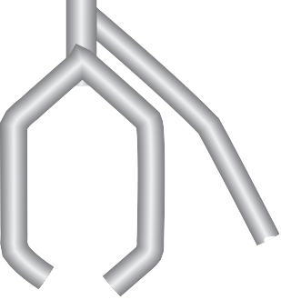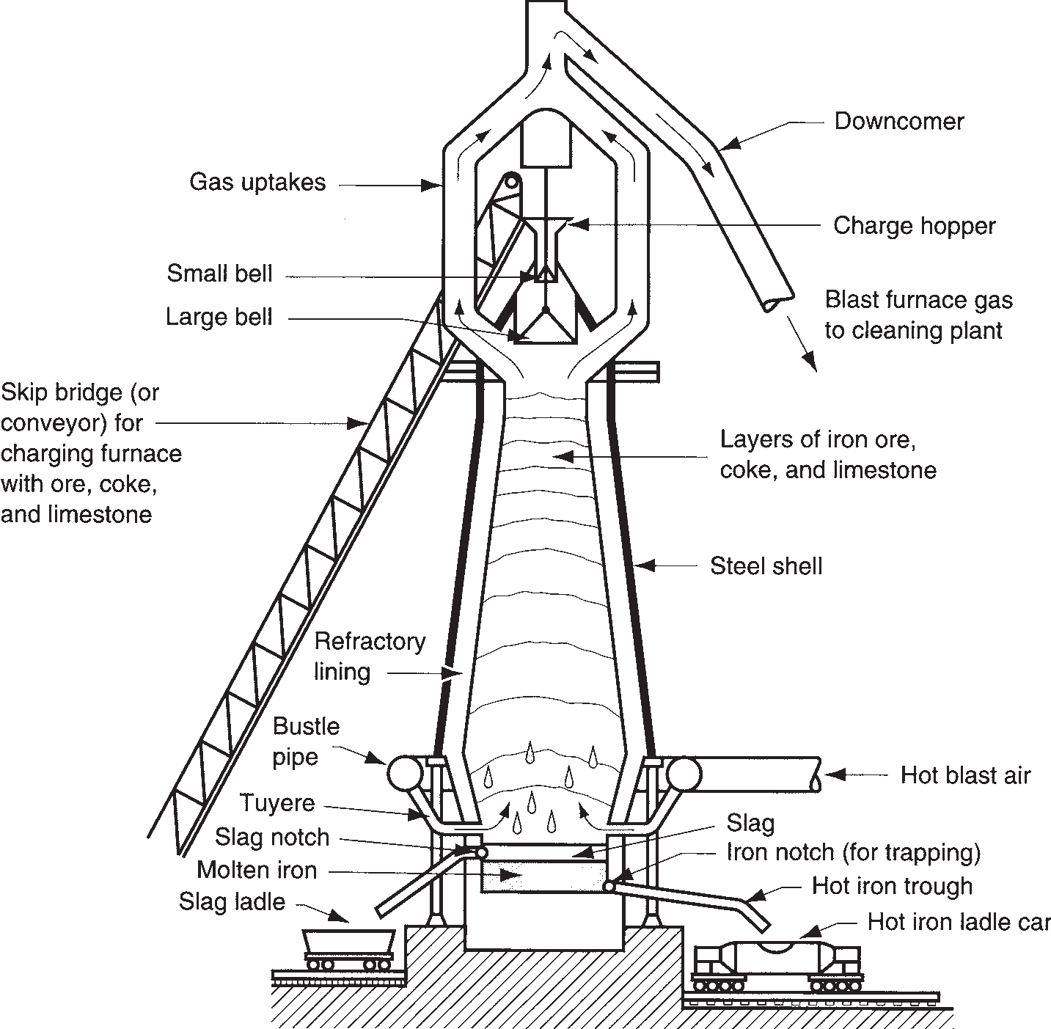

section of ironmaking blast furnace showing major components.

Iron ore, coke, and

limestone Gas to cleaning and reheating

Typical temperature profile 200°C (400°F)

800°C (1500°F)

Direction of motion of charge material

**FIGURE 6.6**

Schematic diagram indicating details of the blast furnace operation.

1100°C (2000°F)

1400°C (2500°F)

1650°C (3000°F)

Slag

Direction of motion of hot gases

Hot blast air Molten pig iron

Carbon dioxide reacts with coke to form more carbon monoxide:

CO2 + C (coke) → 2CO (6.3b)

which then accomplishes the final reduction of FeO to iron:

FeO + CO → Fe + CO2 (6.3c)

The molten iron drips downward, collecting at the base of the blast furnace. This is periodically tapped into hot iron ladle cars for transfer to subsequent steelmaking operations.

The role played by limestone can be summarized as follows. First the limestone is reduced to lime (CaO) by heating, as follows:

CaCO3 → CaO + CO2 (6.4)

The lime combines with impurities such as silica (SiO2), sulfur (S), and alumina (Al2O3) in reactions that produce a molten slag that floats on top of the iron.

It is instructive to note that approximately 7 tons of raw materials are required to produce 1 ton of iron. The ingredients are proportioned about as follows: 2.0 tons of iron ore, 1.0 ton of coke, 0.5 ton of limestone, and (here’s the amazing statistic)

3.5 tons of gases. A significant proportion of the byproducts are recycled.

The iron tapped from the base of the blast furnace (called ***pig iron***) contains more than 4% C, plus other impurities: 0.3–1.3% Si, 0.5–2.0% Mn, 0.1–1.0% P, and 0.02–0.08% S [11]. Further refinement of the metal is required for both cast iron and steel. A furnace called a ***cupola*** (Section 11.4.1) is commonly used for converting pig iron into gray cast iron. For steel, compositions must be more closely controlled and impurities brought to much lower levels.

**Steelmaking** Since the mid–1800s, a number of processes have been developed for refining pig iron into steel. Today, the two most important processes are the basic oxygen furnace (BOF) and the electric furnace. Both are used to produce carbon and alloy steels.

**FIGURE 6.7** Basic

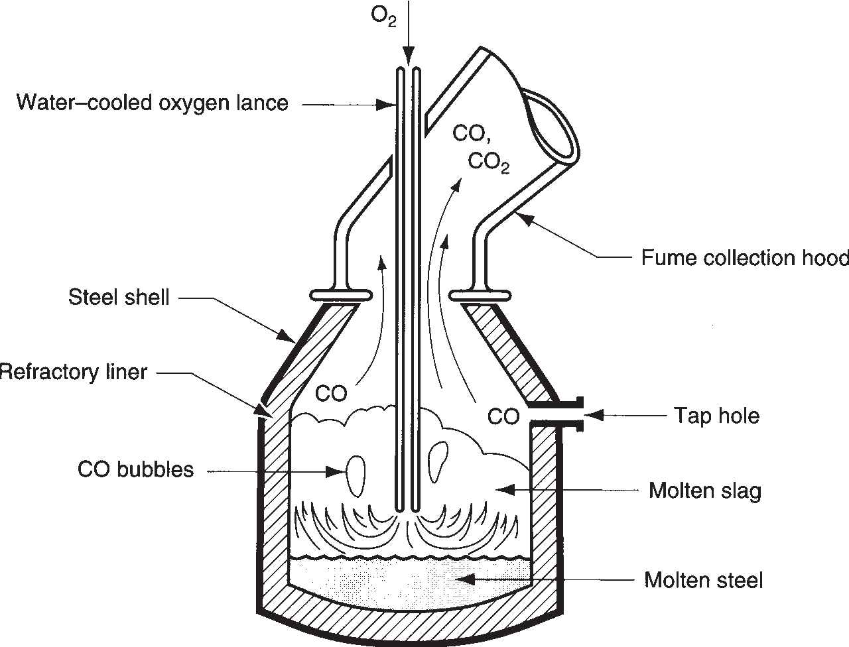

oxygen furnace showing BOF vessel during processing of a heat.

The ***basic oxygen furnace*** accounts for about 70% of U.S. steel production. The BOF is an adaptation of the Bessemer converter. Whereas the Bessemer process used air blown up through the molten pig iron to burn off impurities, the basic oxy- gen process uses pure oxygen. A diagram of the conventional BOF during the mid- dle of a heat is illustrated in Figure 6.7. The typical BOF vessel is about 5 m (16 ft) inside diameter and can process 150 to 200 tons in a heat.

The BOF steelmaking sequence is shown in Figure 6.8. Integrated steel mills transfer the molten pig iron from the blast furnace to the BOF in railway cars called hot-iron ladle cars. In modern practice, steel scrap is added to the pig iron, account- ing for about 30% of a typical BOF charge. Lime (CaO) is also added. After charg- ing, the lance is inserted into the vessel so that its tip is about 1.5 m (5 ft) above the surface of the molten iron. Pure O2 is blown at high velocity through the lance, causing combustion and heating at the surface of the molten pool. Carbon dissolved in the iron and other impurities such as silicon, manganese, and phosphorus are oxi- dized. The reactions are

2C + O2 → 2CO (CO2 is also produced) (6.5a) Si + O2 → SiO2 (6.5b)

2Mn + O2 → 2MnO (6.5c)

4P + 5O2 → 2P2O5 (6.5d)

The CO and CO2 gases produced in the first reaction escape through the mouth of the BOF vessel and are collected by the fume hood; the products of the other three reactions are removed as slag, using the lime as a fluxing agent. The C content in the iron decreases almost linearly with time during the process, thus permit- ting fairly predictable control over carbon levels in the steel. After refining to the

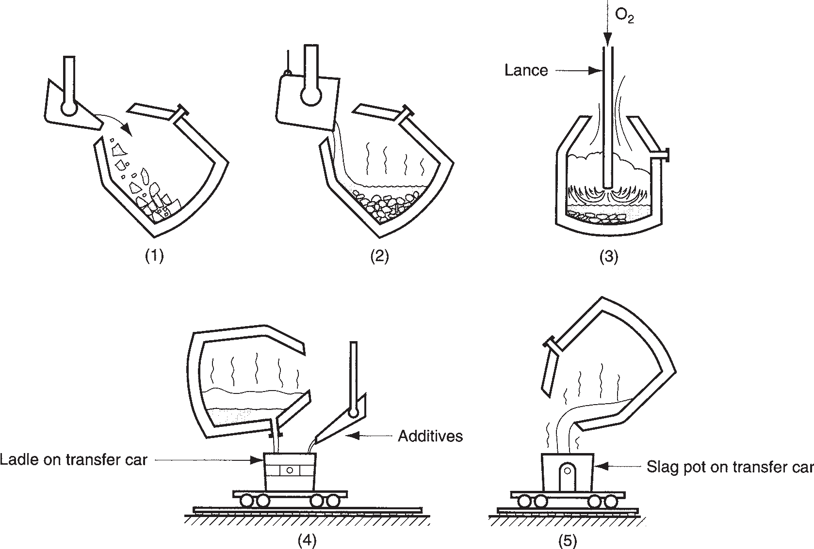

**FIGURE 6.8** BOF sequence during processing cycle: (1) charging of scrap and (2) pig iron; (3) blowing (Figure 6.7);

(4) tapping the molten steel; and (5) pouring off the slag.

desired level, the molten steel is tapped; alloying ingredients and other additives are poured into the heat; then the slag is poured. A 200-ton heat of steel can be processed in about 20 min, although the entire cycle time (tap-to-tap time) takes about 45 min.

Recent advances in the technology of the basic oxygen process include the use of nozzles in the bottom of the vessel through which oxygen is injected into the molten iron. This allows better mixing than the conventional BOF lance, resulting in shorter processing times (a reduction of about 3 min), lower carbon contents, and higher yields.

The ***electric arc furnace*** accounts for about 30% of U.S. steel production. Although pig iron was originally used as the charge in this type of furnace, scrap iron and scrap steel are the primary raw materials today. Electric arc furnaces are available in several designs; the direct arc type shown in Figure 6.9 is currently the most economical type. These furnaces have removable roofs for charging from above; tapping is accomplished by tilting the entire furnace. Scrap iron and steel selected for their compositions, together with alloying ingredients and limestone (flux), are charged into the furnace and heated by an electric arc that flows between large electrodes and the charge metal. Complete melting requires about 2 hours; tap-to-tap time is 4 hours. Capacities of electric furnaces commonly range between 25 and 100 tons per heat. Electric arc furnaces are noted for better quality steel but higher cost per ton, compared with the BOF. The electric arc furnace is generally associated with production of alloy steels, tool steels, and stainless steels.

**FIGURE 6.9** Electric arc furnace for steelmaking.

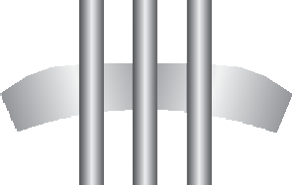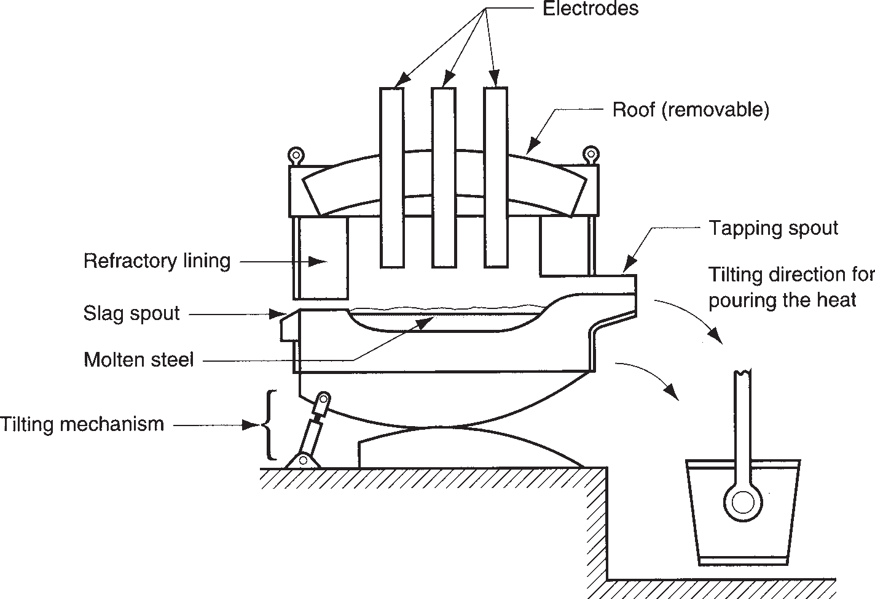

**Casting of Ingots** Steels produced by BOF or electric furnace are solidified for subsequent processing either as cast ingots or by continuous casting. Steel ***ingots*** are large discrete castings weighing from less than 1 ton up to around 300 tons (the weight of an entire heat). Ingot molds are made of high carbon iron and are tapered at the top or bottom for removal of the solid casting. A ***big-end-down mold*** is illus- trated in Figure 6.10. The cross section may be square, rectangular, or round, and the perimeter is usually corrugated to increase surface area for faster cooling. The mold is placed on a platform called a ***stool***; after solidification the mold is lifted, leaving the casting on the stool.

The solidification process for ingots as well as other castings is described in Chapter 10 on casting fundamentals. Because ingots are such large castings, the time required for solidification and the associated shrinkage are significant. Porosity caused by the reaction of carbon and oxygen to form CO during cooling and solidi- fication is a problem that must be addressed in ingot casting. These gases are lib- erated from the molten steel because of their reduced solubility with decreasing temperature. Cast steels are often treated to limit or prevent CO gas evolution

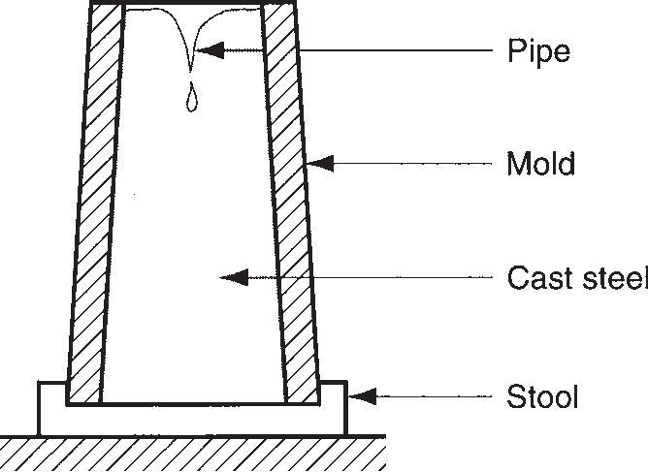

**FIGURE 6.10** A big-end-down ingot mold typical of type used in steelmaking.

during solidification. The treatment involves adding elements such as Si and Al that react with the oxygen dissolved in the molten steel, so it is not available for CO reaction. The structure of the solid steel is thus free of pores and other defects caused by gas formation.

**Continuous Casting** Continuous casting is widely applied in aluminum and cop- per production, but its most noteworthy application is in steelmaking. The process is replacing ingot casting because it dramatically increases productivity. Ingot casting is a discrete process. Because the molds are relatively large, solidification time is sig- nificant. For a large steel ingot, it may take 10 to 12 hours for the casting to solidify. The use of continuous casting reduces solidification time by an order of magnitude. The continuous casting process, also called ***strand casting***, is illustrated in Figure 6.11. Molten steel is poured from a ladle into a temporary container called a ***tundish***, which dispenses the metal to one or more continuous casting molds. The steel begins to solidify at the outer regions as it travels down through the water- cooled mold. Water sprays accelerate the cooling process. While still hot and plastic, the metal is bent from vertical to horizontal orientation. It is then cut into sections or fed continuously into a rolling mill (Section 18.1) in which it is formed into plate

or sheet stock or other cross sections.

**FIGURE 6.11**

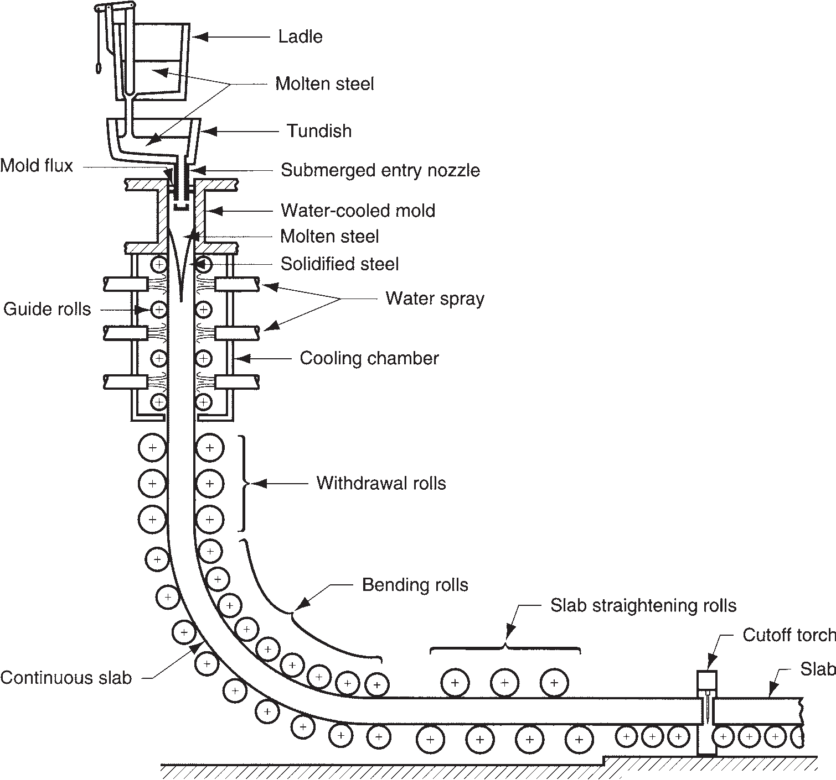

Continuous casting; steel is poured into tundish and distributed to a water-cooled continuous casting mold; it solidifies as it travels down through the mold. Thickness of slab is exaggerated for clarity.

* + 1. STEELS

As defined earlier, ***Steel*** is an alloy of iron that contains carbon ranging by weight between 0.02% and 2.11% (most steels range between 0.05% and 1.1% C). It often includes other alloying ingredients, such as manganese, chromium, nickel, and/or molybdenum; but it is the carbon content that turns iron into steel. Hundreds of compositions of steel are available commercially. For purposes of organization here, the vast majority of commercially important steels can be grouped into the follow- ing categories: (1) plain carbon steels, (2) low alloy steels, (3) stainless steels, (4) tool steels, and (5) specialty steels.

**Plain Carbon Steels** These steels contain carbon as the principal alloying element, with only small amounts of other elements (about 0.4% manganese plus lesser amounts of silicon, phosphorus, and sulfur). The strength of plain carbon steels increases with carbon content. A typical plot of the relationship is illustrated in Figure 6.12. As seen in the phase diagram for iron and carbon (Figure 6.4), steel at room temperature is a mixture of ferrite (*a*) and cementite (Fe3C). The cementite particles distributed throughout the ferrite act as obstacles to the movement of dis- locations during slip (Section 2.3.3); more carbon leads to more barriers, and more barriers mean stronger and harder steel.

According to a designation scheme developed by the American Iron and Steel Institute (AISI) and the Society of Automotive Engineers (SAE), plain carbon steels are specified by a four-digit number system: 10XX, where 10 indicates that the steel is plain carbon, and XX indicates the percent of carbon in hundredths of percentage points. For example, 1020 steel contains 0.20% C. The plain carbon steels are typically classified into three groups according to their carbon content:

* + - 1. ***Low carbon steels*** contain less than 0.20% C and are by far the most widely used steels. Typical applications are automobile sheet-metal parts, plate steel for fabrication, and railroad rails. These steels are relatively easy to form, which accounts for their popularity where high strength is not required. Steel castings usually fall into this carbon range, also.

240

220

200

Hardness, HB

160

800

600

Tensile strength, MPa

400

120

100

Tensile

strength

Hardness

Tensile strength, 1000 lb/in2.

80

60

**FIGURE 6.12** Tensile strength and hardness as a function of carbon content in plain carbon steel (hot-rolled,

120

80

200

~

0 0.2 0.4 0.6

40

20

0.8 1.0

unheat-treated). % Carbon (C)

* + - 1. ***Medium carbon steels*** range in carbon between 0.20% and 0.50% and are specified for applications requiring higher strength than the low-C steels. Applications include machinery components and engine parts such as crank- shafts and connecting rods.
      2. ***High carbon steels*** contain carbon in amounts greater than 0.50%. They are specified for still higher strength applications and where stiffness and hard- ness are needed. Springs, cutting tools and blades, and wear-resistant parts are examples.

Increasing carbon content strengthens and hardens the steel, but its ductility is reduced. Also, high carbon steels can be heat treated to form martensite, making the steel very hard and strong (Section 26.2).

**Low Alloy Steels** Low alloy steels are iron–carbon alloys that contain additional alloying elements in amounts totaling less than about 5% by weight. Owing to these additions, low alloy steels have mechanical properties that are superior to those of the plain carbon steels for given applications. Superior properties usually mean higher strength, hardness, hot hardness, wear resistance, toughness, and more desir- able combinations of these properties. Heat treatment is often required to achieve these improved properties.

Common alloying elements added to steel are chromium, manganese, molyb- denum, nickel, and vanadium, sometimes individually but usually in combi- nations. These elements typically form solid solutions with iron and metallic compounds with carbon (carbides), assuming sufficient carbon is present to sup- port a reaction. The effects of the principal alloying ingredients can be summa- rized as follows:

* + - * + ***Chromium*** (Cr) improves strength, hardness, wear resistance, and hot hardness. It is one of the most effective alloying ingredients for increasing hardenability (Section 26.2.3). In significant proportions, Cr improves corrosion resistance.
        + ***Manganese*** (Mn) improves the strength and hardness of steel. When the steel is heat treated, hardenability is improved with increased manganese. Because of these benefits, manganese is a widely used alloying ingredient in steel.
        + ***Molybdenum*** (Mo) increases toughness and hot hardness. It also improves hardenability and forms carbides for wear resistance.
        + ***Nickel*** (Ni) improves strength and toughness. It increases hardenability but not as much as some of the other alloying elements in steel. In significant amounts it improves corrosion resistance and is the other major ingredient (besides

chromium) in certain types of stainless steel.

* + - * + ***Vanadium*** (V) inhibits grain growth during elevated temperature processing and heat treatment, which enhances strength and toughness of steel. It also forms carbides that increase wear resistance.

The AISI-SAE designations of many of the low alloy steels are presented in Table 6.2, which indicates nominal chemical analysis. As before, carbon content is specified by XX in 1/100% of carbon. For completeness, plain carbon steels (10XX) are included. To obtain an idea of the properties possessed by some of these steels, Table 6.3 lists the treatment to which the steel is subjected for strengthening and its strength and ductility.

|  |  |  |  |  |  |  |  |  |  |  |
| --- | --- | --- | --- | --- | --- | --- | --- | --- | --- | --- |
|  | **Nominal Chemical Analysis**, **%** | | | | | | | | | |
| **Code** | **Name of Steel** | **Cr** | **Mn** | **Mo** | **Ni** | **V** | **P** | **S** | **Si** |
| 10XX | Plain carbon |  | 0.4 |  |  |  | 0.04 | 0.05 |  |
| 11XX | Resulfurized |  | 0.9 |  |  |  | 0.01 | 0.12 | 0.01 |
| 12XX | Resulfurized, rephosphorized |  | 0.9 |  |  |  | 0.10 | 0.22 | 0.01 |
| 13XX | Manganese |  | 1.7 |  |  |  | 0.04 | 0.04 | 0.3 |
| 20XX | Nickel steels |  | 0.5 |  | 0.6 |  | 0.04 | 0.04 | 0.2 |
| 31XX | Nickel–chrome | 0.6 |  |  | 1.2 |  | 0.04 | 0.04 | 0.3 |
| 40XX | Molybdenum |  | 0.8 | 0.25 |  |  | 0.04 | 0.04 | 0.2 |
| 41XX | Chrome–molybdenum | 1.0 | 0.8 | 0.2 |  |  | 0.04 | 0.04 | 0.3 |
| 43XX | Ni–Cr–Mo | 0.8 | 0.7 | 0.25 | 1.8 |  | 0.04 | 0.04 | 0.2 |
| 46XX | Nickel–molybdenum |  | 0.6 | 0.25 | 1.8 |  | 0.04 | 0.04 | 0.3 |
| 47XX | Ni–Cr–Mo | 0.4 | 0.6 | 0.2 | 1.0 |  | 0.04 | 0.04 | 0.3 |
| 48XX | Nickel–molybdenum |  | 0.6 | 0.25 | 3.5 |  | 0.04 | 0.04 | 0.3 |
| 50XX | Chromium | 0.5 | 0.4 |  |  |  | 0.04 | 0.04 | 0.3 |
| 52XX | Chromium | 1.4 | 0.4 |  |  |  | 0.02 | 0.02 | 0.3 |
| 61XX | Cr–Vanadium | 0.8 | 0.8 |  |  | 0.1 | 0.04 | 0.04 | 0.3 |
| 81XX | Ni–Cr–Mo | 0.4 | 0.8 | 0.1 | 0.3 |  | 0.04 | 0.04 | 0.3 |
| 86XX | Ni–Cr–Mo | 0.5 | 0.8 | 0.2 | 0.5 |  | 0.04 | 0.04 | 0.3 |
| 88XX | Ni–Cr–Mo | 0.5 | 0.8 | 0.35 | 0.5 |  | 0.04 | 0.04 | 0.3 |
| 92XX | Silicon–Manganese |  | 0.8 |  |  |  | 0.04 | 0.04 | 2.0 |
| 93XX | Ni–Cr–Mo | 1.2 | 0.6 | 0.1 | 3.2 |  | 0.02 | 0.02 | 0.3 |
| 98XX | Ni–Cr–Mo | 0.8 | 0.8 | 0.25 | 1.0 |  | 0.04 | 0.04 | 0.3 |

*Source:* [11].



**TABLE** • **6.2** AISI-SAE designations of steels.

Low alloy steels are not easily welded, especially at medium and high carbon levels. Since the 1960s, research has been directed at developing low carbon, low alloy steels that have better strength-to-weight ratios than plain carbon steels but are more weldable than low alloy steels. The products developed out of these efforts are called ***high-strength low-alloy*** (HSLA) steels. They generally have low carbon contents (in the range 0.10% to 0.30% C) plus relatively small amounts of alloy- ing ingredients (usually only about 3% total of elements such as Mn, Cu, Ni, and Cr). HSLA steels are hot-rolled under controlled conditions designed to provide improved strength compared with plain C steels, yet with no sacrifice in formability or weldability. Strengthening is by solid solution alloying; heat treatment is not fea- sible because of low carbon content. Table 6.3 lists one HSLA steel, together with properties (chemistry is: 0.12 C, 0.60 Mn, 1.1 Ni, 1.1 Cr, 0.35 Mo, and 0.4 Si).

**Stainless Steels** Stainless steels are a group of highly alloyed steels designed to provide high corrosion resistance. The principal alloying element in stainless steel is chromium, usually above 15%. The chromium in the alloy forms a thin, impervi- ous oxide film in an oxidizing atmosphere, which protects the surface from corro- sion. Nickel is another alloying ingredient used in certain stainless steels to increase corrosion protection. Carbon is used to strengthen and harden the metal; however,

|  |  |  |  |  |  |
| --- | --- | --- | --- | --- | --- |
|  | **Tensile Strength** | | | | |
| **Code** | **Treatmenta** | **MPa** | **lb/in2** | **Elongation**, **%** |
| 1010 | HR | 304 | 44,000 | 47 |
| 1010 | CD | 366 | 53,000 | 12 |
| 1020 | HR | 380 | 55,000 | 28 |
| 1020 | CD | 421 | 61,000 | 15 |
| 1040 | HR | 517 | 75,000 | 20 |
| 1040 | CD | 587 | 85,000 | 10 |
| 1055 | HT | 897 | 130,000 | 16 |
| 1315 | None | 545 | 79,000 | 34 |
| 2030 | None | 566 | 82,000 | 32 |
| 3130 | HT | 697 | 101,000 | 28 |
| 4130 | HT | 890 | 129,000 | 17 |
| 4140 | HT | 918 | 133,000 | 16 |
| 4340 | HT | 1279 | 185,000 | 12 |
| 4815 | HT | 635 | 92,000 | 27 |
| 9260 | HT | 994 | 144,000 | 18 |
| HSLA | None | 586 | 85,000 | 20 |

Compiled from [6], [11], and other sources.



**TABLE** • **6.3** Treatments and mechanical properties of selected steels.

aHR = hot-rolled; CD = cold-drawn; HT = heat treatment involving heating and quenching, followed by tempering to produce tempered martensite (Section 26.2).

increasing the carbon content has the effect of reducing corrosion protection because chromium carbide forms to reduce the amount of free Cr available in the alloy.

In addition to corrosion resistance, stainless steels are noted for their combina- tion of strength and ductility. Although these properties are desirable in many appli- cations, they generally make these alloys difficult to work in manufacturing. Also, stainless steels are significantly more expensive than plain C or low alloy steels.

Stainless steels are traditionally divided into three groups, named for the pre- dominant phase present in the alloy at ambient temperature:

1. ***Austenitic stainless*** steels have a typical composition of around 18% Cr and 8% Ni and are the most corrosion resistant of the three groups. Owing to this com- position, they are sometimes identified as 18-8 stainless. They are nonmagnetic and very ductile; but they show significant work hardening. The nickel has the effect of enlarging the austenite region in the iron–carbon phase diagram, mak- ing it stable at room temperature. Austenitic stainless steels are used to fabricate chemical and food processing equipment, as well as machinery parts requiring high corrosion resistance.
2. ***Ferritic stainless*** steels have around 15% to 20% chromium, low carbon, and no nickel. This provides a ferrite phase at room temperature. Ferritic stain- less steels are magnetic and are less ductile and corrosion resistant than the austenitics. Parts made of ferritic stainless range from kitchen utensils to jet engine components.

|  |  |  |  |  |  |  |  |  |  |  |
| --- | --- | --- | --- | --- | --- | --- | --- | --- | --- | --- |
|  |  | **Chemical Analysis**, **%** | | | | | | **Tensile Strength** | | |
| **Type** | **Fe Cr Ni C Mn Othera** | | | | | | **MPa** | **lb/in2** | **Elongation**, **%** |
| Austenitic  301  302  304  309  316  Ferritic 405  430  Martensitic 403  403b  416  416b  440  440b | 73 | 17 | 7 | 0.15 | 2 |  | 620 | 90,000 | 40 |
| 71 | 18 | 8 | 0.15 | 2 |  | 515 | 75,000 | 40 |
| 69 | 19 | 9 | 0.08 | 2 |  | 515 | 75,000 | 40 |
| 61 | 23 | 13 | 0.20 | 2 |  | 515 | 75,000 | 40 |
| 65 | 17 | 12 | 0.08 | 2 | 2.5 Mo | 515 | 75,000 | 40 |
| 85 | 13 | — | 0.08 | 1 |  | 415 | 60,000 | 20 |
| 81 | 17 | — | 0.12 | 1 |  | 415 | 60,000 | 20 |
| 86 | 12 | — | 0.15 | 1 |  | 485 | 70,000 | 20 |
| 86 | 12 | — | 0.15 | 1 |  | 825 | 120,000 | 12 |
| 85 | 13 | — | 0.15 | 1 |  | 485 | 70,000 | 20 |
| 85 | 13 | — | 0.15 | 1 |  | 965 | 140,000 | 10 |
| 81 | 17 | — | 0.65 | 1 |  | 725 | 105,000 | 20 |
| 81 | 17 | — | 0.65 | 1 |  | 1790 | 260,000 | 5 |

Compiled from [11].



**TABLE** • **6.4** Compositions and mechanical properties of selected stainless steels.

aAll of the grades in the table contain about 1% (or less) Si plus small amounts (well below 1%) of phosphorus, sulfur, and other elements such as aluminum.

bHeat treated.

1. ***Martensitic stainless*** steels have a higher carbon content than ferritic stainlesses, thus permitting them to be strengthened by heat treatment (Section 26.2). They have as much as 18% Cr but no Ni. They are strong, hard, and fatigue resistant, but not generally as corrosion resistant as the other two groups. Typical products include cutlery and surgical instruments.

Most stainless steels are designated by a three-digit AISI numbering scheme. The first digit indicates the general type, and the last two digits give the specific grade within the type. Table 6.4 lists the common stainless steels with typical compositions and mechanical properties. The traditional stainless steels were developed in the early 1900s. Since then, several additional high alloy steels have been developed that have good corrosion resistance and other desirable properties. These are also classi- fied as stainless steels. Continuing the list:

1. ***Precipitation hardening stainless*** steels, which have a typical composition of 17% Cr and 7% Ni, with additional small amounts of alloying elements such as aluminum, copper, titanium, and molybdenum. Their distinguishing feature among stainlesses is that they can be strengthened by precipitation hardening (Section 26.3). Strength and corrosion resistance are maintained at elevated temperatures, which suits these alloys to aerospace applications.
2. ***Duplex stainless*** steels possess a structure that is a mixture of austenite and ferrite in roughly equal amounts. Their corrosion resistance is similar to the austenitic grades, and they show improved resistance to stress-corrosion crack- ing. Applications include heat exchangers, pumps, and wastewater treatment plants.

|  |  |  |  |  |  |  |  |  |
| --- | --- | --- | --- | --- | --- | --- | --- | --- |
|  | **TABLE** • **6.5** Tool steels by AISI prefix identification, with examples of composition and typical hardness values. | | | | | | | |
|  | **AISI** | **Example** | **C** | **Cr** | **Chemical Analysis**, **%a**  **Mn Mo Ni** | **V** | **W** | **Hardness**, **HRC** |
| T | T1 | 0.7 | 4.0 |  | 1.0 | 18.0 | 65 |
| M | M2 | 0.8 | 4.0 | 5.0 | 2.0 | 6.0 | 65 |
| H | H11 | 0.4 | 5.0 | 1.5 | 0.4 |  | 55 |
| D | D1 | 1.0 | 12.0 | 1.0 |  |  | 60 |
| A | A2 | 1.0 | 5.0 | 1.0 |  |  | 60 |
| O | O1 | 0.9 | 0.5 | 1.0 |  | 0.5 | 61 |
| W | W1 | 1.0 |  |  |  |  | 63 |
| S | S1 | 0.5 | 1.5 |  |  | 2.5 | 50 |
| P | P20 | 0.4 | 1.7 | 0.4 |  |  | 40b |
| L | L6 | 0.7 | 0.8 | 0.2 1.5 |  |  | 45b |

aPercent composition rounded to nearest tenth.

bHardness estimated.

**Tool Steels** Tool steels are a class of (usually) highly alloyed steels designed for use as industrial cutting tools, dies, and molds. To perform in these applications, they must possess high strength, hardness, hot hardness, wear resistance, and toughness under impact. To obtain these properties, tool steels are heat treated. Principal reasons for the high levels of alloying elements are (1) improved hardenability, (2) reduced distortion during heat treatment, (3) hot hardness, (4) formation of hard metallic carbides for abrasion resistance, and (5) enhanced toughness.

The tool steels divide into major types, according to application and composition. The AISI uses a classification scheme that includes a prefix letter to identify the tool steel. In the following list of tool steel types, the prefix is indicated, and some typical compositions are presented in Table 6.5:

T, M ***High-speed steels*** (Section 22.2.1) are used as cutting tools in machining operations (Chapter 21). They are formulated for high wear resistance and hot hardness. The original high-speed steels (HSS) were developed around 1900. They permitted dramatic increases in cutting speed compared to previ- ously used tools; hence their name. The two AISI designations indicate the principal alloying element: T for tungsten and M for molybdenum.

H ***Hot-working tool steels*** are intended for hot-working dies in forging, extru- sion, and die-casting.

D ***Cold-work tool steels*** are die steels used for cold working operations such as sheet metal pressworking, cold extrusion, and certain forging operations. The designation D stands for die. Closely related AISI designations are A and O. A and O stand for air- and oil-hardening. They all provide good wear resist- ance and low distortion.

W ***Water-hardening tool steels*** have high carbon with little or no other alloy- ing elements. They can only be hardened by fast quenching in water. They are widely used because of low cost, but they are limited to low temperature applications. Cold heading dies are a typical application.

S ***Shock-resistant tool steels*** are intended for use in applications where high toughness is required, as in many sheet metal shearing, punching, and bend- ing operations.

P ***Mold steels*** are used to make molds for molding plastics and rubber. L ***Low-alloy tool steels*** are generally reserved for special applications.

Tool steels are not the only tool materials. Plain carbon, low alloy, and stainless steels are used for many tool and die applications. Cast irons and certain nonfer- rous alloys are also suitable for certain tooling applications. In addition, several ceramic materials (e.g., Al2O3) are used as high-speed cutting inserts, abrasives, and other tools.

**Specialty Steels** To complete this survey, several specialty steels not included in the previous coverage are mentioned. One of the reasons why these steels are special is that they possess unique processing characteristics.

***Maraging steels*** are low carbon alloys containing high amounts of nickel (15%– 25%) and lesser proportions of cobalt, molybdenum, and titanium. Chromium is also sometimes added for corrosion resistance. Maraging steels are strength- ened by precipitation hardening (Section 26.3), but in the unhardened condition, they are quite processable by forming and/or machining. They can also be readily welded. Heat treatment results in very high strength together with good toughness. Tensile strengths of 2000 MPa (290,000 lb/in2) and 10% elongation are not unusual. Applications include parts for missiles, machinery, dies, and other situations where these properties are required and justify the high cost of the alloy.

***Free-machining steels*** are carbon steels formulated to improve machinability (Section 23.1). Alloying elements include sulfur, lead, tin, bismuth, selenium, tellu- rium, and/or phosphorus. Lead is less-frequently used today because of environmen- tal and health concerns. Added in small amounts, these elements act to lubricate the cutting operation, reduce friction, and break up chips for easier disposal. Although more expensive than non-free-machining steels, they often pay for themselves in higher production rates and longer tool lives.

Because of their good ductility, low-carbon sheet steels are widely used in sheet metal forming operations. Further improvements in formability have been achieved using a new class of sheet steel product called ***interstitial-free steels***. These steels have extremely low carbon levels (0.005% C), which result from the use of alloying elements such as niobium and titanium that combine with carbon and leave the steel virtually free of interstitial atoms. The result is excellent ductility, even greater than low-C steels. Applications include deep-drawing operations in the automotive industry.

* + 1. CAST IRONS

Cast iron is an iron alloy containing from 2.1% to about 4% carbon and from 1% to 3% silicon. Its composition makes it highly suitable as a casting metal. In fact, the tonnage of cast iron castings is several times that of all other cast metal parts combined (excluding cast ingots made during steelmaking which are subsequently rolled into bars, plates, and similar stock). The overall tonnage of cast iron is second only to steel among metals.

**FIGURE 6.13** Carbon and silicon compositions for cast irons, with comparison to steels (most steels have relatively low silicon contents—cast steels have the higher Si content). Ductile iron is formed by special melting and

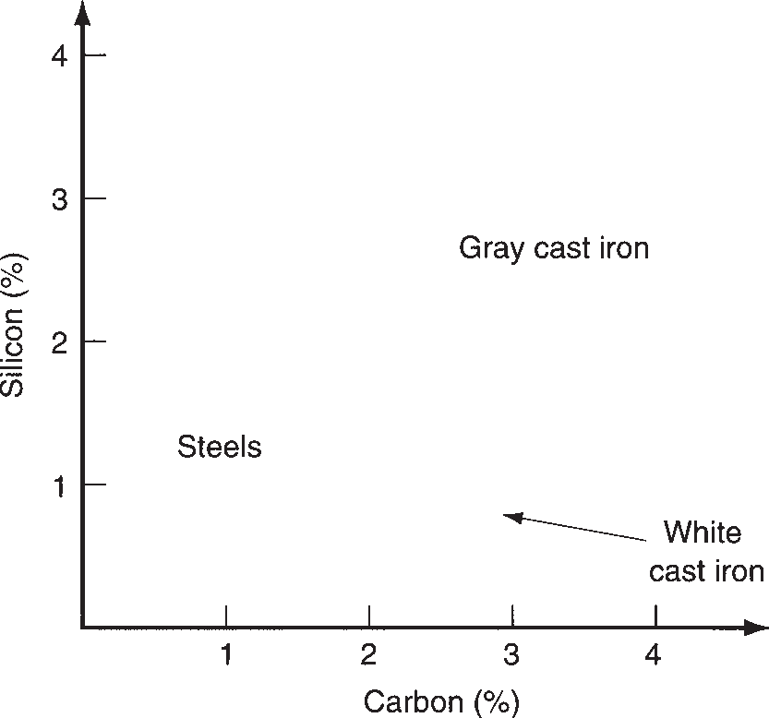

pouring treatment of gray cast iron, and malleable iron is formed by heat treatment of white cast iron.

There are several types of cast iron, the most important being gray cast iron. Other types include ductile iron, white cast iron, malleable iron, and various alloy cast irons. Typical chemical compositions of gray and white cast irons are shown in Figure 6.13, indicating their relationship with cast steel. Ductile and malleable irons possess chemistries similar to the gray and white cast irons, respectively, but result from special treatments to be described in the following. Table 6.6 presents a listing of chemistries for the principal types together with mechanical properties.

|  |  |  |  |  |  |  |  |
| --- | --- | --- | --- | --- | --- | --- | --- |
|  | **Type** | **Fe** | **C** | **Typical Composition**, **%**  **Si Mn Othera** | **MPa** | **Tensile Strength**  **lb/in2 Elongation**, **%** | |
| Gray cast irons |  |  |  |  |  | |
| ASTM Class 20 | 93.0 | 3.5 | 2.5 0.65 | 138 | 20,000 | 0.6 |
| ASTM Class 30 | 93.6 | 3.2 | 2.1 0.75 | 207 | 30,000 | 0.6 |
| ASTM Class 40 | 93.8 | 3.1 | 1.9 0.85 | 276 | 40,000 | 0.6 |
| ASTM Class 50 | 93.5 | 3.0 | 1.6 1.0 0.67 Mo | 345 | 50,000 | 0.6 |
| Ductile irons |  |  |  |  |  | |
| ASTM A395 | 94.4 | 3.0 | 2.5 | 414 | 60,000 | 18 |
| ASTM A476 | 93.8 | 3.0 | 3.0 | 552 | 80,000 | 3 |
| White cast iron |  |  |  |  |  | |
| Low-C | 92.5 | 2.5 | 1.3 0.4 1.5Ni, 1Cr, 0.5Mo | 276 | 40,000 | 0 |
| Malleable irons |  |  |  |  |  | |
| Ferritic | 95.3 | 2.6 | 1.4 0.4 | 345 | 50,000 | 10 |
| Pearlitic | 95.1 | 2.4 | 1.4 0.8 | 414 | 60,000 | 10 |

Compiled from [11]. Cast irons are identified by various systems. This table is an attempt to indicate the particular cast iron grade using the most common identification for each type.



**TABLE** • **6.6** Compositions and mechanical properties of selected cast irons.

aCast irons also contain phosphorus and sulfur usually totaling less than 0.3%.

**Gray Cast Iron** Gray cast iron accounts for the largest tonnage among the cast irons. It has a composition in the range 2.5% to 4% carbon and 1% to 3% sili- con. This chemistry results in the formation of graphite (carbon) flakes distributed throughout the cast product upon solidification. The structure causes the surface of the metal to have a gray color when fractured; hence the name gray cast iron. The dispersion of graphite flakes accounts for two attractive properties: (1) good vibra- tion damping, which is desirable in engines and other machinery; and (2) internal lubricating qualities, which makes the cast metal machinable.

The strength of gray cast iron spans a significant range. The American Society for Testing of Materials (ASTM) uses a classification method for gray cast iron that is intended to provide a minimum tensile strength (*TS*) specification for the various classes: Class 20 gray cast iron has a *TS* of 20,000 lb/in2, Class 30 has a *TS* of 30,000 lb/in2, and so forth, up to around 70,000 lb/in2 (see Table 6.6 for equiva- lent *TS* in metric units). The compressive strength of gray cast iron is significantly greater than its tensile strength. Properties of the casting can be controlled to some extent by heat treatment. Ductility of gray cast iron is very low; it is a relatively brit- tle material. Products made from gray cast iron include automotive engine blocks and heads, motor housings, and machine tool bases.

**Ductile Iron** This is an iron with the composition of gray iron in which the mol- ten metal is chemically treated before pouring to cause the formation of graphite spheroids rather than flakes. This results in a stronger and more ductile iron, hence its name. Applications include machinery components requiring high strength and good wear resistance.

**White Cast Iron** This cast iron has less carbon and silicon than gray cast iron. It is formed by more rapid cooling of the molten metal after pouring, thus causing the carbon to remain chemically combined with iron in the form of cementite (Fe3C), rather than precipitating out of solution in the form of flakes. When fractured, the surface has a white crystalline appearance that gives the iron its name. Owing to the cementite, white cast iron is hard and brittle, and its wear resistance is excellent. Strength is good, with *TS* of 276 MPa (40,000 lb/in2) being typical. These properties make white cast iron suitable for applications in which wear resistance is required. Railway brake shoes are an example.

**Malleable Iron** When castings of white cast iron are heat treated to separate the carbon out of solution and form graphite aggregates, the resulting metal is called malleable iron. The new microstructure can possess substantial ductility (up to 20% elongation)—a significant difference from the metal out of which it was transformed. Typical products made of malleable cast iron include pipe fittings and flanges, certain machine components, and railroad equipment parts.

**Alloy Cast Irons** Cast irons can be alloyed for special properties and applica- tions. These alloy cast irons are classified as follows: (1) heat-treatable types that can be hardened by martensite formation; (2) corrosion-resistant types, whose alloying elements include nickel and chromium; and (3) heat-resistant types containing high proportions of nickel for hot hardness and resistance to high temperature oxidation.

#### Nonferrous Metals

**6.3**

The nonferrous metals include metal elements and alloys not based on iron. The most important engineering metals in the nonferrous group are aluminum, copper, magnesium, nickel, titanium, and zinc, and their alloys.

Although the nonferrous metals as a group cannot match the strength of the steels, certain nonferrous alloys have corrosion resistance and/or strength-to- weight ratios that make them competitive with steels in moderate-to-high stress applications. In addition, many of the nonferrous metals have properties other than mechanical that make them ideal for applications in which steel would be quite unsuitable. For example, copper has one of the lowest electrical resistivities among metals and is widely used for electrical wire. Aluminum is an excellent thermal conductor, and its applications include heat exchangers and cooking pans. It is also one of the most readily formed metals, and is valued for that reason also. Zinc has a relatively low melting point, so zinc is widely used in die casting opera- tions. The common nonferrous metals have their own combination of properties that make them attractive in a variety of applications. The following nine sections cover the nonferrous metals that are the most commercially and technologically important.

* + 1. ALUMINUM AND ITS ALLOYS

Aluminum and magnesium are light metals, and they are often specified in engineer- ing applications for this feature. Both elements are abundant on Earth, aluminum on land and magnesium in the sea, although neither is easily extracted from their natural states.

Properties and other data on aluminum are listed in Table 6.1(b). Among the major metals, it is a relative newcomer, dating only to the late 1800s (Historical Note 6.2). The coverage in this section includes (1) a brief description of how alumi- num is produced and (2) a discussion of the properties and the designation system for the metal and its alloys.

|  |  |
| --- | --- |
|  | **TABLE** • **6.1** (continued): (b) Aluminum. |
|  | Symbol: Al Atomic number: 13  Specific gravity: 2.7 Crystal structure: FCC  Melting temperature: 660°C (1220°F)  Elastic modulus: 69,000 MPa (10 X 106 lb/in2)  Principal ore: Bauxite (impure mix of Al2O3 and Al(OH)3) Alloying elements: Copper, magnesium, manganese, silicon, and zinc  Typical applications: Containers (aluminum cans), wrapping foil, electrical conduc- tors, pots and pans, parts for construction, aerospace, automo- tive, and other uses in which light weight is important |

**Historical Note 6.2** *Aluminum*

In 1807, the English chemist Humphrey Davy, believ- work of Charles Hall in the United States and Paul ing that the mineral ***alumina*** (Al2O3) had a metallic Heroult in France around 1886. In 1888, Hall and a base, attempted to extract the metal. He did not suc- group of businessmen started the Pittsburgh Reduc- ceed but was sufficiently convinced that he proceeded tion Co. The first ingot of aluminum was produced by to name the metal anyway: ***alumium***, later changing the electrolytic smelting process that same year. De- the name to ***aluminum***. In 1825, the Danish physicist/ mand for aluminum grew. The need for large amounts chemist Hans Orsted finally succeeded in separating of electricity in the production process led the com- the metal. He noted that it “resembles tin.” In 1845, pany to relocate in Niagara Falls in 1895 where hydro- the German physicist Friedrich Wohler was the first electric power was becoming available at very low to determine the specific gravity, ductility, and various cost. In 1907, the company changed its name to the other properties of aluminum. Aluminum Company of America (Alcoa). It was the The modern electrolytic process for producing alu- sole producer of aluminum in the United States until

minum was based on the concurrent but independent World War II.

**Aluminum Production** The principal aluminum ore is ***bauxite***, which consists largely of hydrated aluminum oxide (Al2O3-H2O) and other oxides. Extraction of the aluminum from bauxite can be summarized in three steps: (1) washing and crushing the ore into fine powders; (2) the Bayer process, in which the bauxite is converted to pure alumina (Al2O3); and (3) electrolysis, in which the alumina is separated into aluminum and oxygen gas (O2). The ***Bayer process***, named after the German chemist who developed it, involves solution of bauxite powders in aque- ous caustic soda (NaOH) under pressure, followed by precipitation of pure Al2O3 from solution. Alumina is commercially important in its own right as an engineering ceramic (Chapter 7).

***Electrolysis*** to separate Al2O3 into its constituent elements requires dissolving the precipitate in a molten bath of cryolite (Na3AlF6) and subjecting the solution to direct current between the plates of an electrolytic furnace. The electrolyte dissoci- ates to form aluminum at the cathode and oxygen gas at the anode.

**Properties and Designation Scheme** Aluminum has high electrical and ther- mal conductivity, and its resistance to corrosion is excellent because of the forma- tion of a hard, thin oxide surface film. It is a very ductile metal and is noted for its formability. Pure aluminum is relatively low in strength, but it can be alloyed and heat treated to compete with some steels, especially when weight is an important consideration.

The designation system for aluminum alloys is a four-digit code number. The sys- tem has two parts, one for wrought aluminums and the other for cast aluminums. The difference is that a decimal point is used after the third digit for cast aluminums. The designations are presented in Table 6.7(a).

Because properties of aluminum alloys are so influenced by work hardening and heat treatment, the temper (strengthening treatment, if any) must be designated in addition to the composition code. The principal temper designations are presented in Table 6.7(b). This designation is attached to the preceding four-digit number, separated from it by a hyphen, to indicate the treatment or absence thereof; for



|  |  |  |  |
| --- | --- | --- | --- |
|  | **TABLE** • **6.7(a)** Designations of wrought and cast aluminum alloys. | | |
|  | **Alloy Group** | **Wrought Code** | **Cast Code** |
| Aluminum, 99.0% or higher purity | 1XXX | 1XX.X |
| Aluminum alloys, by major element(s): Copper  Manganese  Silicon + copper and/or magnesium Silicon  Magnesium Magnesium and silicon Zinc  Tin Other | 2XXX  3XXX  4XXX  5XXX  6XXX  7XXX  8XXX | 2XX.X  3XX.X  4XX.X  5XX.X  7XX.X  8XX.X  9XX.X |

|  |  |
| --- | --- |
|  | **TABLE** • **6.7(b)** Temper designations for aluminum alloys. |
|  | **Temper Description** |
| F As fabricated—no special treatment.  H Strain hardened (wrought aluminums). H is followed by two digits, the first indicating a heat treatment, if any; and the second indicating the degree of work hardening remaining; for example:  H1X No heat treatment after strain hardening, and X = 1 to 9, indicating degree of work hardening. H2X Partially annealed, and X = degree of work hardening remaining in product.  H3X Stabilized, and X = degree of work hardening remaining. ***Stabilized*** means heating to slightly above service temperature anticipated.  O Annealed to relieve strain hardening and improve ductility; reduces strength to lowest level.  T Thermal treatment to produce stable tempers other than F, H, or O. It is followed by a digit to indicate specific treatments; for example:  T1 = cooled from elevated temperature, naturally aged.  T2 = cooled from elevated temperature, cold worked, naturally aged. T3 = solution heat treated, cold worked, naturally aged.  T4 = solution heat treated and naturally aged.  T5 = cooled from elevated temperature, artificially aged. T6 = solution heat treated and artificially aged.  T7 = solution heat treated and overaged or stabilized. T8 = solution heat treated, cold worked, artificially aged.  T9 = solution heat treated, artificially aged, and cold worked.  T10 = cooled from elevated temperature, cold worked, and artificially aged.  W Solution heat treatment, applied to alloys that age harden in service; it is an unstable temper. |

example, 2024-T3. Of course, temper treatments that specify strain hardening do not apply to the cast alloys. Some examples of the remarkable differences in the mechanical properties of aluminum alloys that result from the different treatments are presented in Table 6.8.

|  |  |  |  |  |  |  |  |  |
| --- | --- | --- | --- | --- | --- | --- | --- | --- |
|  | **TABLE** • **6.8** Compositions and mechanical properties of selected aluminum alloys. | | | | | | | |
|  | **Code** | **Al** | **Typical Composition**, **%a**  **Cu Fe Mg Mn** | **Si** | **Temper** | **MPa** | **Tensile Strength**  **lb/in2 Elongation** | |
| 1050 | 99.5 | 0.4 | 0.3 | O | 76 | 11,000 | 39 |
|  |  |  |  | H18 | 159 | 23,000 | 7 |
| 1100 | 99.0 | 0.6 | 0.3 | O | 90 | 13,000 | 40 |
|  |  |  |  | H18 | 165 | 24,000 | 10 |
| 2024 | 93.5 | 4.4 0.5 1.5 0.6 | 0.5 | O | 185 | 27,000 | 20 |
|  |  |  |  | T3 | 485 | 70,000 | 18 |
| 3004 | 96.5 | 0.3 0.7 1.0 1.2 | 0.3 | O | 180 | 26,000 | 22 |
|  |  |  |  | H36 | 260 | 38,000 | 7 |
| 4043 | 93.5 | 0.3 0.8 | 5.2 | O | 130 | 19,000 | 25 |
|  |  |  |  | H18 | 285 | 41,000 | 1 |
| 5050 | 96.9 | 0.2 0.7 1.4 0.1 | 0.4 | O | 125 | 18,000 | 18 |
|  |  |  |  | H38 | 200 | 29,000 | 3 |
| 6063 | 98.5 | 0.3 0.7 | 0.4 | O | 90 | 13,000 | 25 |
|  |  |  |  | T4 | 172 | 25,000 | 20 |

Compiled from [12].

a In addition to elements listed, alloy may contain trace amounts of other elements such as copper, magnesium, manganese, vanadium, and zinc.

* + 1. MAGNESIUM AND ITS ALLOYS

Magnesium (Mg) is the lightest of the structural metals. Its specific gravity and other basic data are presented in Table 6.1(c). Magnesium and its alloys are avail- able in both wrought and cast forms. It is relatively easy to machine. However, in all processing of magnesium, small particles of the metal (such as small metal cutting chips) oxidize rapidly, and care must be taken to avoid fire hazards.

**Magnesium Production** Sea water contains about 0.13% MgCl2, and this is the source of most commercially produced magnesium. To extract Mg, a batch of sea water is mixed with milk of lime—calcium hydroxide (Ca(OH)2). The resulting reaction pre- cipitates magnesium hydroxide (Mg(OH)2) that settles and is removed as a slurry.

|  |  |
| --- | --- |
|  | **TABLE** • **6.1** (continued): (c) Magnesium. |
|  | Symbol: Mg Atomic number: 12  Specific gravity: 1.74 Crystal structure: HCP  Melting temperature: 650°C (1202°F)  Elastic modulus: 48,000 MPa (7 X 106 lb/in2) Extracted from: MgCl2 in sea water by electrolysis  Alloying elements: See Table 6.9  Typical applications: Aerospace, missiles, bicycles, chain saw housings, luggage, and other applications where light weight is a primary requirement. |



**TABLE** • **6.9** Code letters used to identify alloying elements in magnesium alloys.

Aluminum (Al) Rare earth metals Thorium (Th) Zirconium (Zr) Manganese (Mn) Lead (Pb)

Silver (Ag) Silicon (Si) Tin (Sn)

Zinc (Zn)

A E H K M P Q S T

Z

The slurry is then filtered to increase Mg(OH)2 content and then mixed with hydro- chloric acid (HCl), which reacts with the hydroxide to form concentrated MgCl2— much more concentrated than the original sea water. Electrolysis is used to decompose the salt into magnesium (Mg) and chlorine gas (Cl2). The magnesium is then cast into ingots for subsequent processing. The chlorine is recycled to form more MgCl2.

**Properties and Designation Scheme** As a pure metal, magnesium is relatively soft and lacks sufficient strength for most engineering applications. However, it can be alloyed and heat treated to achieve strengths comparable to aluminum alloys. In par- ticular, its strength-to-weight ratio is an advantage in aircraft and missile components. The designation scheme for magnesium alloys uses a three-to-five-character alphanumeric code. The first two characters are letters that identify the principal alloying elements (up to two elements can be specified in the code, in order of decreasing percentages, or alphabetically if equal percentages). These code letters are listed in Table 6.9. The letters are followed by a two-digit number that indicates, respectively, the amounts of the two alloying ingredients to the nearest percent. Finally, the last symbol is a letter that indicates some variation in composition, or simply the chronological order in which it was standardized for commercial avail- ability. Magnesium alloys also require specification of a temper, and the same basic

scheme presented in Table 6.7(b) for aluminum is used for magnesium alloys.

Some examples of magnesium alloys, illustrating the designation scheme and indicating tensile strength and ductility of these alloys, are presented in Table 6.10.

|  |  |  |  |  |  |  |  |  |  |  |  |
| --- | --- | --- | --- | --- | --- | --- | --- | --- | --- | --- | --- |
|  | **TABLE** • **6.10** Compositions and mechanical properties of selected magnesium alloys. | | | | | | | | | | |
|  |  |  | **Typical Composition**, **%** | | | |  |  | **Tensile Strength** | |  |
| **Code** | **Mg** | **Al** | **Mn** | **Si** | **Zn** | **Other** | **Process** | **MPa** | **lb/in2** | **Elongation** |
| AZ10A | 98.0 | 1.3 | 0.2 | 0.1 | 0.4 |  | Wrought | 240 | 35,000 | 10 |
| AZ80A | 91.0 | 8.5 |  |  | 0.5 |  | Forged | 330 | 48,000 | 11 |
| HM31A | 95.8 | 1.2 | | | | 3.0 Th | Wrought | 283 | 41,000 | 10 |
| ZK21A | 97.1 | 2.3 | | | | 6 Zr | Wrought | 260 | 38,000 | 4 |
| AM60 | 92.8 | 6.0 | 0.1 | 0.5 | 0.2 | 0.3 Cu | Cast | 220 | 32,000 | 6 |
| AZ63A | 91.0 | 6.0 |  |  | 3.0 |  | Cast | 200 | 29,000 | 6 |

Compiled from [12].

|  |  |
| --- | --- |
|  | **TABLE** • **6.1** (continued): (d) Copper. |
|  | Symbol: Cu Atomic number: 29  Specific gravity: 8.96 Crystal structure: FCC  Melting temperature: 1083°C (1981°F)  Elastic modulus: 110,000 MPa (16 X 106 lb/in2)  Ore extracted from: Several: e.g., chalcopyrite (CuFeS2).  Alloying elements: Tin (bronze), zinc (brass), aluminum, silicon, nickel, and beryllium.  Typical applications: Electrical conductors and components, ammunition (brass), pots and pans, jewelry, plumbing, marine applications, heat exchangers, springs (Be-Cu). |

* + 1. COPPER AND ITS ALLOYS

Copper (Cu) is one of the oldest metals known (Historical Note 6.3). Basic data on the element copper are presented in Table 6.1(d).

**Historical Note 6.3** *Copper*

Copper was one of the first metals used by human later found that copper mixed with tin could be more cultures (gold was the other). Discovery of the metal readily cast and worked than the pure metal. This led was probably around 6000 B.C.E. At that time, copper to the widespread use of bronze and the subsequent was found in the free metallic state. Ancient peoples naming of the Bronze Age, dated from about 2000 fashioned implements and weapons out of it by hit- B.C.E. to the time of Christ.

ting the metal (cold forging). Pounding copper made it To the ancient Romans, the island of Cyprus was al- harder (strain hardening); this and its attractive reddish most the only source of copper. They called the metal color made it valuable in early civilizations. ***aes cyprium*** (ore of Cyprus). This was shortened to Around 4000 B.C.E., it was discovered that copper ***Cyprium*** and subsequently renamed ***Cuprium***. From

could be melted and cast into useful shapes. It was this derives the chemical symbol Cu.

**Copper Production** In ancient times, copper was available in nature as a free element. Today these natural deposits are more difficult to find, and copper is now extracted from ores that are mostly sulfides, such as ***chalcopyrite*** (CuFeS2). The ore is crushed (Section 16.1.1), concentrated by flotation, and then ***smelted*** (melted or fused, often with an associated chemical reaction to separate a metal from its ore). The resulting copper is called ***blister copper***, which is between 98% and 99% pure. Electrolysis is used to obtain higher purity levels suitable for commercial use.

**Properties and Designation Scheme** Pure copper has a distinctive reddish- pink color, but its most distinguishing engineering property is its low electrical resistivity— one of the lowest of all elements. Because of this property, and its rela- tive abundance in nature, commercially pure copper is widely used as an electrical conductor. (The conductivity of copper decreases significantly as alloying elements are added.) Cu is also an excellent thermal conductor. Copper is one of the noble

|  |  |  |  |  |  |  |  |
| --- | --- | --- | --- | --- | --- | --- | --- |
|  | **TABLE** • **6.11** Compositions and mechanical properties of selected copper alloys. | | | | | | |
|  |  |  | **Typical Composition**, **%**  **Be Ni Sn** |  | **Tensile Strength** | |  |
| **Code** | **Cu** | **Zn** | **MPa lb/in2** | | **Elongation**, **%** |
| C10100 | 99.99 |  |  | 235 | 34,000 | 45 |
| C11000 | 99.95 |  |  | 220 | 32,000 | 45 |
| C17000 | 98.0 | 1.7 a |  | 500 | 70,000 | 45 |
| C24000 | 80.0 |  | 20.0 | 290 | 42,000 | 52 |
| C26000 | 70.0 |  | 30.0 | 300 | 44,000 | 68 |
| C52100 | 92.0 | 8.0 |  | 380 | 55,000 | 70 |
| C71500 | 70.0 | 30.0 |  | 380 | 55,000 | 45 |
| C71500b | 70.0 | 30.0 |  | 580 | 84,000 | 3 |

Compiled from [12].

aSmall amounts of Ni and Fe + 0.3 Co.

bHeat treated for high strength.

metals (gold and silver are also noble metals), so it is corrosion resistant. All of these properties combine to make copper one of the most important metals.

On the downside, the strength and hardness of copper are relatively low, especially when weight is taken into account. Accordingly, to improve strength (as well as for other reasons), copper is frequently alloyed. ***Bronze*** is an alloy of copper and tin (typi- cally about 90% Cu and 10% Sn), still widely used today despite its ancient ancestry. Additional bronze alloys have been developed, based on other elements than tin; these include aluminum bronzes, and silicon bronzes. ***Brass*** is another familiar copper alloy, composed of copper and zinc (typically around 65% Cu and 35% Zn). The highest strength alloy of copper is beryllium-copper (only about 2% Be). It can be heat treated to tensile strengths of 1035 MPa (150,000 lb/in2). Be-Cu alloys are used for springs.

The designation of copper alloys is based on the Unified Numbering System for Metals and Alloys (UNS), which uses a five-digit number preceded by the letter C (C for copper). The alloys are processed in wrought and cast forms, and the designa- tion system includes both. Some copper alloys with compositions and mechanical properties are presented in Table 6.11.

* + 1. NICKEL AND ITS ALLOYS

Nickel (Ni) is similar to iron in many respects. It is magnetic, and its modulus of elasticity is virtually the same as that of iron and steel. However, it is much more corrosion resistant, and the high temperature properties of its alloys are generally superior. Because of its corrosion-resistant characteristics, it is widely used as an alloying element in steel, such as stainless steel, and as a plating metal on other met- als such as plain carbon steel.

**Nickel Production** The most important ore of nickel is ***pentlandite*** ((Ni, Fe)9S8).To extract the nickel, the ore is first crushed and ground with water. Flotation techniques are used to separate the sulfides from other minerals mixed with the ore. The nickel sulfide is then heated to burn off some of the sulfur, followed by smelting to remove iron and silicon. Further refinement is accomplished in a Bessemer-style converter

|  |  |
| --- | --- |
|  | **TABLE** • **6.1** (continued): (e) Nickel. |
|  | Symbol: Ni Atomic number: 28  Specific gravity: 8.90 Crystal structure: FCC  Melting temperature: 1453°C (2647°F)  Elastic Modulus: 209,000 MPa (30 X 106 lb/in2) Ore extracted from: Pentlandite ((Fe, Ni)9S8)  Alloying elements: Copper, chromium, iron, aluminum.  Typical applications: Stainless steel alloying ingredient, plating metal for steel, applications requiring high temperature and corrosion resistance. |

to yield high-concentration nickel sulfide (NiS). Electrolysis is then used to recover high-purity nickel from the compound. Ores of nickel are sometimes mixed with cop- per ores, and the recovery technique described here also yields copper in these cases.

**Nickel Alloys** Alloys of nickel are commercially important in their own right and are noted for corrosion resistance and high temperature performance. Composition, tensile strength, and ductility of some of the nickel alloys are given in Table 6.12. In addition, a number of superalloys are based on nickel (Section 6.4).

* + 1. TITANIUM AND ITS ALLOYS

Titanium (Ti) is fairly abundant in nature, constituting about 1% of Earth’s crust (aluminum, the most abundant, is about 8%). The density of Ti is between alumi- num and iron. Data for Ti are presented in Table 6.1(f). Its importance has grown in recent decades due to its aerospace applications where its light weight and good strength-to-weight ratio are exploited.

**Titanium Production** The principal ores of titanium are ***rutile***, which is 98 to 99% TiO2, and ***ilmenite***, which is a combination of FeO and TiO2. Rutile is preferred

|  |  |  |  |  |  |  |  |  |  |  |  |
| --- | --- | --- | --- | --- | --- | --- | --- | --- | --- | --- | --- |
|  | **TABLE** • **6.12** Compositions and mechanical properties of selected nickel alloys. | | | | | | | | | | |
|  |  |  |  | **Typical Composition**, **%** | | |  |  | **Tensile Strength** | |  |
| **Code** | **Ni** | **Cr** | **Cu Fe Mn** | | | **Si** | **Other** | **MPa lb/in2** | | **Elongation**, **%** |
| 270 | 99.9 |  | a | a |  |  |  | 345 | 50,000 | 50 |
| 200 | 99.0 |  | 0.2 | 0.3 | 0.2 | 0.2 | C, S | 462 | 67,000 | 47 |
| 400 | 66.8 |  | 30.0 | 2.5 | 0.2 | 0.5 | C | 550 | 80,000 | 40 |
| 600 | 74.0 | 16.0 | 0.5 | 8.0 | 1.0 | 0.5 |  | 655 | 95,000 | 40 |
| 230 | 52.8 | 22.0 |  | 3.0 | 0.4 | 0.4 | b | 860 | 125,000 | 47 |

Compiled from [12].

aTrace amounts.

bOther alloying ingredients in Grade 230: 5% Co, 2% Mo, 14% W, 0.3% Al, 0.1% C.

|  |  |
| --- | --- |
|  | **TABLE** • **6.1** (continued): (f) Titanium. |
|  | Symbol: Ti Atomic number: 22  Specific gravity: 4.51 Crystal structure: HCP  Melting temperature: 1668°C (3034°F)  Elastic modulus: 117,000 MPa (17 X 106 lb/in2)  Ores extracted from: Rutile (TiO2) and Ilmenite (FeTiO3)  Alloying elements: Aluminum, tin, vanadium, copper, and magnesium.  Typical applications: Jet engine components, other aerospace applications, prosthetic implants. |

as an ore because of its higher Ti content. In recovery of the metal from its ores, the TiO2 is converted to titanium tetrachloride (TiCl4) by reacting the compound with chlorine gas. This is followed by a sequence of distillation steps to remove impurities. The highly concentrated TiCl4 is then reduced to metallic titanium by reaction with magnesium; this is known as the ***Kroll process***. Sodium can also be used as a reduc- ing agent. In either case, an inert atmosphere must be maintained to prevent O2, N2, or H2 from contaminating the Ti, owing to its chemical affinity for these gases. The resulting metal is used to cast ingots of titanium and its alloys.

**Properties of Titanium** Ti’s coefficient of thermal expansion is relatively low among metals. It is stiffer and stronger than aluminum, and it retains good strength at elevated temperatures. Pure titanium is reactive, which presents problems in processing, especially in the molten state. However, at room temperature it forms a thin adherent oxide coating (TiO2) that provides excellent corrosion resistance.

These properties give rise to two principal application areas for titanium: (1) in the commercially pure state, Ti is used for corrosion resistant components, such as marine components and prosthetic implants; and (2) titanium alloys are used as high-strength components in temperatures ranging from ambient to above 550°C (1000°F), especially where its excellent strength-to-weight ratio is exploited. These latter applications include aircraft and missile components. Some of the alloying elements used with titanium include aluminum, manganese, tin, and vanadium. Some compositions and mechanical properties for several alloys are presented in Table 6.13.

|  |  |  |  |  |  |  |  |  |  |
| --- | --- | --- | --- | --- | --- | --- | --- | --- | --- |
|  | **TABLE** • **6.13** Compositions and mechanical properties of selected titanium alloys. | | | | | | | | |
|  |  |  |  | **Typical Composition**, **%** |  |  | **Tensile Strength** | |  |
| **Codea** | **Ti** | **Al** | **Cu Fe** | **V** | **Other** | **MPa lb/in2** | | **Elongation**, **%** |
| R50250 | 99.8 |  | 0.2 |  |  | 240 | 35,000 | 24 |
| R56400 | 89.6 | 6.0 | 0.3 | 4.0 | b | 1000 | 145,000 | 12 |
| R54810 | 90.0 | 8.0 |  | 1.0 | 1 Mo,b | 985 | 143,000 | 15 |
| R56620 | 84.3 | 6.0 | 0.8 0.8 | 6.0 | 2 Sn,b | 1030 | 150,000 | 14 |

Compiled from [1] and [12]. aUnited Numbering System (UNS). bTraces of C, H, O.

|  |  |
| --- | --- |
|  | **TABLE** • **6.1** (continued): (g) zinc. |
|  | Symbol: Zn Atomic number: 30  Specific gravity: 7.13 Crystal structure: HCP  Melting temperature: 419°C (786°F)  Elastic modulus: 90,000 MPa (13 X 106 lb/in2)a Ore extracted from: Sphalerite (ZnS)  Alloying elements: Aluminum, magnesium, copper  Typical applications: Galvanized steel and iron, die castings, alloying element in brass |

aZinc creeps, which makes it difficult to measure modulus of elasticity; some tables of properties omit *E* for zinc for this reason.

* + 1. ZINC AND ITS ALLOYS

Table 6.1(g) lists basic data on zinc. Its low melting point makes it attractive as a casting metal. It also provides corrosion protection when coated onto steel or iron; ***galvanized steel*** is steel that has been coated with zinc.

**Production of Zinc** Zinc blende or ***sphalerite*** is the principal ore of zinc; it contains zinc sulfide (ZnS). Other important ores include ***smithsonite***, which is zinc carbonate (ZnCO3), and ***hemimorphate***, which is hydrous zinc silicate (Zn4Si2O7OH- H2O).

Sphalerite must be concentrated (***beneficiated***, as it is called) because of the small fraction of zinc sulfide present in the ore. This is accomplished by first crushing the ore, then grinding with water in a ball mill (Section 16.1.1) to create a slurry. In the presence of a frothing agent, the slurry is agitated so that the mineral particles float to the top and can be skimmed off (separated from the lower grade minerals). The concentrated zinc sulfide is then roasted at around 1260°C (2300°F), so that zinc oxide (ZnO) is formed from the reaction.

There are various thermochemical processes for recovering zinc from this oxide, all of which reduce zinc oxide by means of carbon. The carbon combines with oxy- gen in ZnO to form CO and/or CO2, thus freeing Zn in the form of vapor that is condensed to yield the desired metal.

An electrolytic process is also widely used, accounting for about half the world’s production of zinc. This process also begins with the preparation of ZnO, which is mixed with dilute sulfuric acid (H2SO4), followed by electrolysis to separate the resulting zinc sulfate (ZnSO4) solution to yield the pure metal.

**Zinc Alloys and Applications** Several alloys of zinc are listed in Table 6.14, with data on composition, tensile strength, and applications. Zinc alloys are widely used in die casting to mass produce components for the automotive and appliance industries. Another major application of zinc is in galvanized steel. As the name suggests, a galvanic cell is created in galvanized steel (Zn is the anode and steel is the cathode) that protects the steel from corrosive attack. A third important use of zinc is in brass. As previously indicated in the discussion of copper, this alloy

|  |  |  |  |  |  |  |  |  |  |
| --- | --- | --- | --- | --- | --- | --- | --- | --- | --- |
|  | **TABLE** • **6.14** Compositions, tensile strength, and applications of selected zinc alloys. | | | | | | | | |
|  |  |  | **Typical Composition**, **%** | | |  | **Tensile Strength** | |  |
| **Code** | **Zn** | **Al Cu Mg** | | | **Fe** | **MPa lb/in2** | | **Application** |
| Z33520 | 95.6 | 4.0 | 0.25 | 0.04 | 0.1 | 283 | 41,000 | Die casting |
| Z35540 | 93.4 | 4.0 | 2.5 | 0.04 | 0.1 | 359 | 52,000 | Die casting |
| Z35635 | 91.0 | 8.0 | 1.0 | 0.02 | 0.06 | 374 | 54,000 | Foundry alloy |
| Z35840 | 70.9 | 27.0 | 2.0 | 0.02 | 0.07 | 425 | 62,000 | Foundry alloy |
| Z45330 | 98.9 |  | 1.0 | 0.01 |  | 227 | 33,000 | Rolled alloy |

Compiled from [12].

aUNS - Unified Numbering System for metals.

consists of copper and zinc, in the ratio of about 2/3 Cu to 1/3 Zn. Finally, readers may be interested to know that the U.S. one-cent coin is mostly zinc. The penny is coined out of zinc and then electroplated with copper, so that the final propor- tions are 97.5% Zn and 2.5% Cu. It costs the U.S. Mint about 1.5 cents to produce each penny.

* + 1. LEAD AND TIN

Lead (Pb) and tin (Sn) are often considered together because of their low melting temperatures, and because they are used in soldering alloys to make electrical con- nections. The phase diagram for the tin–lead alloy system is depicted in Figure 6.3. Basic data for lead and tin are presented in Table 6.1(h).

Lead is a dense metal with a low melting point; other properties include low strength, low hardness (the word “soft” is appropriate), high ductility, and good cor- rosion resistance. In addition to its use in solder, applications of lead and its alloys include ammunition, type metals, x-ray shielding, storage batteries, bearings, and vibration damping. It has also been widely used in chemicals and paints. Principal alloying elements with lead are tin and antimony.

|  |  |  |  |
| --- | --- | --- | --- |
|  | **TABLE** • **6.1** (continued): (h) lead and tin. | | |
|  |  | **Lead** | **Tin** |
| Symbol: | Pb | Sn |
| Atomic number: | 82 | 50 |
| Specific gravity: | 11.35 | 7.30 |
| Crystal structure: | FCC | HCP |
| Melting temperature: | 327°C (621°F) | 232°C (449°F) |
| Modulus of elasticity: | 21,000 MPa (3 X 106 lb/in2) | 42,000 MPa (6 X 106 lb/in2) |
| Ore from which extracted: | Galena (PbS) | Cassiterite (SnO2) |
| Typical alloying elements: | Tin, antimony | Lead, copper |
| Typical applications: | See text | Bronze, solder, tin cans |

|  |  |  |  |
| --- | --- | --- | --- |
|  | **TABLE** • **6.1** (continued): (i) refractory metals. | | |
|  |  | **Molybdenum** | **Tungsten** |
| Symbol: | Mo | W 74  19.3  BCC  3400°C (6150°F)  407,000 MPa (59 X 106 lb/in3)  Scheelite (CaWO4), Wolframite ((Fe,Mn)WO4)  a  Light filaments, rocket engine parts, WC tools. |
| Atomic number: | 42 |
| Specific gravity: | 10.2 |
| Crystal structure: | BCC |
| Melting point: | 2619°C (4730°F) |
| Elastic modulus: | 324,000 MPa (47 X 106 lb/in2) |
| Principal ores: | Molybdenite (MoS2) |
| Alloying elements: | See text |
| Applications: | See text |

aTungsten is used as a pure metal and as an alloying ingredient, but few alloys are based on W.

Tin has an even lower melting point than lead; other properties include low strength, low hardness, and good ductility. The earliest use of tin was in bronze, the alloy consisting of copper and tin developed around 3000 B.C. in Mesopotamia and Egypt. Bronze is still an important commercial alloy (although its relative impor- tance has declined during 5000 years). Other uses of tin include tin-coated sheet steel containers (“tin cans”) for storing food and, of course, solder metal.

* + 1. REFRACTORY METALS

The refractory metals are metals capable of enduring high temperatures. The most important metals in this group are molybdenum and tungsten; see Table 6.1(i). Other refractory metals are columbium (Cb) and tantalum (Ta). In general, these metals and their alloys are capable of maintaining high strength and hardness at elevated temperatures.

Molybdenum has a high melting point and is relatively dense, stiff, and strong. It is used both as a pure metal (99.9+% Mo) and as an alloy. The principal alloy is TZM, which contains small amounts of titanium and zirconium (less than 1% total). Mo and its alloys possess good high temperature strength, and this accounts for many of its applications, which include heat shields, heating elements, elec- trodes for resistance welding, dies for high temperature work (e.g., die casting molds), and parts for rocket and jet engines. In addition to these applications, molybdenum is also widely used as an alloying ingredient in other metals, such as steels and superalloys.

Tungsten (W) has the highest melting point among metals and is one of the dens- est. It is also the stiffest and hardest of all pure metals. Its most familiar application is filament wire in incandescent light bulbs. Applications of tungsten are typically char- acterized by high operating temperatures, such as parts for rocket and jet engines and electrodes for arc welding. W is also widely used as an element in tool steels, heat resistant alloys, and tungsten carbide (Section 7.3.2).

|  |  |  |  |  |
| --- | --- | --- | --- | --- |
|  | **TABLE** • **6.1** (continued): (j) the precious metals | | | |
|  |  | **Gold** | **Platinum** | **Silver** |
| Symbol: | Au | Pt | Ag |
| Atomic number: | 79 | 78 | 47 |
| Specific gravity: | 19.3 | 21.5 | 10.5 |
| Crystal structure: | FCC | FCC | FCC |
| Melting temperature: | 1063°C (1945°F) | 1769°C (3216°F) | 961°C (1762°F) |
| Principal ores: | a | a | a |
| Applications: | See text | See text | See text |

aAll three precious metals are mined from deposits in which the pure metal is mixed with other ores and metals. Silver is also mined from the ore ***Argentite*** (Ag2S).

A major disadvantage of both Mo and W is their propensity to oxidize at high temperatures, above about 600°C (1000°F), thus detracting from their high tempera- ture properties. To overcome this deficiency, either protective coatings must be used on these metals in high temperature applications or the metal parts must operate in a vacuum. For example, the tungsten filament must be energized in a vacuum inside the glass light bulb.

* + 1. PRECIOUS METALS

The precious metals, also called the ***noble metals*** because they are chemically inac- tive, include silver, gold, and platinum. They are attractive metals, available in lim- ited supply, and have been used throughout civilized history for coinage and to underwrite paper currency. They are also widely used in jewelry and similar appli- cations that exploit their high value. As a group, these precious metals possess high density, good ductility, high electrical conductivity, and good corrosion resistance; see Table 6.1(j).

***Silver*** (Ag) is less expensive per unit weight than gold or platinum. Nevertheless, its attractive “silvery” luster makes it a highly valued metal in coins, jewelry, and tableware (which even assumes the name of the metal: “silverware”). It is also used for fillings in dental work. Silver has the highest electrical conductivity of any metal, which makes it useful for contacts in electronics applications. Finally, it should be mentioned that light-sensitive silver chloride and other silver halides are the basis for photography.

***Gold*** (Au) is one of the heaviest metals; it is soft and easily formed, and possesses a distinctive yellow color that adds to its value. In addition to currency and jewelry, its applications include electrical contacts (owing to its good electrical conductivity and corrosion resistance), dental work, and plating onto other metals for decorative purposes.

***Platinum*** (Pt) is also used in jewelry and is in fact more expensive than gold. It is the most important of six precious metals known as the platinum group met- als, which consists of Ruthenium (Ru), Rhodium (Rh), Palladium (Pd), Osmium (Os), and Iridium (Ir), in addition to Pt. They are clustered in a rectangle in the

periodic table (Figure 2.1). Osmium, Iridium, and Platinum are all denser than gold (Ir is the densest material known, at 22.65 g/cm3). Because the platinum group metals are all scarce and very expensive, their applications are generally limited to situations in which only small amounts are needed and their unique properties are required (e.g., high melting temperatures, corrosion resistance, and catalytic characteristics). The applications include thermocouples, electrical contacts, spark plugs, corrosion resistant devices, and catalytic pollution control equipment for automobiles.

#### Superalloys

**6.4**

Superalloys constitute a category that straddles the ferrous and nonferrous metals. Some of them are based on iron, whereas others are based on nickel and cobalt. In fact, many of the superalloys contain substantial amounts of three or more met- als, rather than consisting of one base metal plus alloying elements. Although the tonnage of these metals is not significant compared with most of the other metals discussed in this chapter, they are nevertheless commercially important because they are very expensive; and they are technologically important because of what they can do.

The ***superalloys*** are a group of high-performance alloys designed to meet very demanding requirements for strength and resistance to surface degradation (corro- sion and oxidation) at high service temperatures. Conventional room temperature strength is usually not the important criterion for these metals, and most of them possess room temperature strength properties that are good but not outstanding. Their high temperature performance is what distinguishes them; tensile strength, hot hardness, creep resistance, and corrosion resistance at very elevated tempera- tures are the mechanical properties of interest. Operating temperatures are often in the vicinity of 1100°C (2000°F). These metals are widely used in gas turbines— jet and rocket engines, steam turbines, and nuclear power plants—systems in which operating efficiency increases with higher temperatures.

The superalloys are usually divided into three groups, according to their principal constituent: iron, nickel, or cobalt:

* ***Iron-based alloys*** have iron as the main ingredient, although in some cases the iron is less than 50% of the total composition.
* ***Nickel-based alloys*** generally have better high temperature strength than alloy steels. Nickel is the base metal. The principal alloying elements are chromium

and cobalt; lesser elements include aluminum, titanium, molybdenum, niobium (Nb), and iron. Some familiar names in this group include Inconel, Hastelloy, and Rene 41.

* ***Cobalt-based alloys*** consist of cobalt (around 40%) and chromium (perhaps 20%) as their main components. Other alloying elements include nickel, molyb- denum, and tungsten.

In virtually all of the superalloys, including those based on iron, strengthening is accomplished by precipitation hardening. The iron-based superalloys do not use martensite formation for strengthening. Typical compositions and strength prop- erties at room temperature and elevated temperature for some of the alloys are presented in Table 6.15.

Section 5.4/Measurement of Surfaces

**156**

|  |  |  |  |  |  |  |  |  |  |  |  |  |
| --- | --- | --- | --- | --- | --- | --- | --- | --- | --- | --- | --- | --- |
|  | **TABLE** • **6.15** Some typical superalloy compositions together with strength properties at room temperature and elevated temperature. | | | | | | | | | | | |
|  | **Superalloy** | **Fe** | **Ni** | **Chemical Analysis**, **%a Co Cr Mo W** | | | | **Otherb** | **Tensile Strength at Room Temperature**  **MPa lb/in2** | | **Tensile Strength at 870°C (1600°F)**  **MPa lb/in2** | |
| Iron-based |  |  |  | | | |  |  | |  | |
| Incoloy 802 | 46 | 32 | 21 | | | | <2 | 690 | 100,000 | 195 | 28,000 |
| Haynes 556 | 29 | 20 | 20 | 22 | 3 |  | 6 | 815 | 118,000 | 330 | 48,000 |
| Nickel-based |  |  |  | | | |  |  | |  | |
| Incoloy 807 | 25 | 40 | 8 | 21 |  | 5 | 1 | 655 | 95,000 | 220 | 32,000 |
| Inconel 718 | 18 | 53 |  | 19 | 3 |  | 6 | 1435 | 208,000 | 340 | 49,000 |
| Rene 41 |  | 55 | 11 | 19 | 1 |  | 5 | 1420 | 206,000 | 620 | 90,000 |
| Hastelloy S | 1 | 67 |  | 16 | 15 |  | 1 | 845 | 130,000 | 340 | 50,000 |
| Nimonic 75 | 3 | 76 | 20 | | | | <2 | 745 | 108,000 | 150 | 22,000 |
| Cobalt-based |  |  |  | | | |  |  | |  | |
| Stellite 6B | 3 | 3 | 53 | 30 | 2 | 5 | 4 | 1010 | 146,000 | 385 | 56,000 |
| Haynes 188 | 3 | 22 | 39 | 22 |  | 14 |  | 960 | 139,000 | 420 | 61,000 |
| L-605 |  | 10 | 53 | 20 |  | 15 | 2 | 1005 | 146,000 | 325 | 47,000 |

Compiled from [11] and [12].

aCompositions to nearest percent.

bOther elements include carbon, niobium, titanium, tungsten, manganese, and silicon.